GANTTOWN GANT FAMILY GENEALOGY: THE DESCENDANTS

OF SAMUEL GANT FROM WASHINGTON TOWNSHIP,

GLOUCESTER COUNTY, NEW JERSEY

by

Karen L. Heiser

A Thesis

Submitted in partial fulfillment of the requirements of the
Master of Arts Degree
of
The Graduate School
at
Rowan University
May 2002

Approved by _____________________________
Professor

Date Approved ___________________________

ABSTRACT

Karen L. Heiser
Ganttown Gant Family Genealogy: The Descendants
of Samuel Gant from Washington Township,
Gloucester County, New Jersey
2002
Dr. Diane Penrod, Academic Adviser
Dr. Richard Grupenhoff, Thesis Adviser
Master of Arts in Writing

Although this study begins with Richard Gaunt from Absecon, New Jersey, it focuses on his descendant, Samuel Gant, who was born in 1790 and lived in Washington Township, Gloucester County, New Jersey, and Samuel’s descendants through the birth of Samuel’s third great-grandchild in 1946. The author obtained information from interviews with Howard Underwood Gant who is a Gant family genealogist, and researched data from the Gloucester County Historical Society, Gloucester County Surrogate Office, the New Jersey State Archives, local libraries, and online genealogical homepages, such as Genealogy.com and Ancestry.com, for genealogical format and copyright information. The thesis explains the change in the spelling of the last name and the importance of the Gant family in the development of Ganttown and Washington Township, Gloucester County, New Jersey. Samuel Gant’s family line and detail about his 10 children and 63 grandchildren are mentioned in this thesis; however, Samuel’s direct line to Howard Underwood Gant includes more detail and biographical information. Appendixes include pictures of prominent members of the Gant family.

MINI-ABSTRACT

Karen L. Heiser
Ganttown Gant Family Genealogy: The Descendants
of Samuel Gant from Washington Township,
Gloucester County, New Jersey
2002
Dr. Diane Penrod, Academic Program Adviser
Dr. Richard Grupenhoff, Academic Thesis Adviser
Master of Arts in Writing

This study focuses on Samuel Gant and his descendants, covering the years between 1790 and 1946. The study includes narration, a family chart, biographical data, and pictures. This thesis reveals the importance of the Gant family to the development of Washington Township, Gloucester County, New Jersey.

DEDICATION

To my father,
Howard Underwood Gant, the Ganttown Gant family historian:
As in all genealogical studies, there is no beginning and there is no end—
only a middle.

ACKNOWLEDGMENTS

I thank God the Father, the Son, and the Holy Ghost for everything—love, good health, patience, and wisdom—for through Him, all things are possible.
I thank my father, Howard Underwood Gant, the Ganttown Gant historian who said this information should be written. He instilled in me the desire to do so and was essential throughout the process. I thank the descendants of Samuel Gant—Lois Mick, Ruth A. Gibe (Gehring), Ella Rae Harrell; and I am indebted to Virginia Minotty (deceased), and Gertrude Craver (deceased)—the five women who began the research and who were willing to share their knowledge and information with Howard Underwood Gant when he began his research.
I thank the following for their support and understanding: my husband, Steve, and children, Stephanie and Steven; my parents, Howard and Cecelia Gant; siblings, Chuck, Bob, Sue; close friends, Sherry Arico, Ginny Bardsley, Pat Jenkins; The Rowan University Graduate School staff—former Dean Marion Rilling, Interim Dean S. Jay Kuder, Dorie Gilchrist, Brenda Marlin, Karen Haynes, Carol Cope; and my Aunt Christabelle Eckard for her patience and knowledge of Family Tree Maker.
I appreciate the time and effort of academic program adviser, Dr. Diane Penrod. Without her expertise, patience, and firm deadlines, this thesis would not be finished. Also, I thank academic thesis adviser, Dr. Richard Grupenhoff, who willingly gave his time to review this thesis and gave some helpful suggestions.

TABLE OF CONTENTS
Page
Dedication i
Acknowledgments ii
Table of Contents iii
Preface vi
Introduction xi
Foreword xviii
Family Lineage xxiii
Chapter I: Samuel Gant and his Descendants 1
Chapter II: Richard M. Gant, Son of Samuel Gant 25
Chapter III: Robert Gant, Grandson of Samuel Gant 41
Chapter IV: Synott Gant, Great-Grandson of Samuel Gant 46
Chapter V: Jesse Gant, Great, Great-Grandson of Samuel Gant 62
Chapter VI: Conclusion 73
References 77

Appendixes 85
Appendix A: Photo: Fifth great-grandchildren (Stephanie and Steven Heiser)
in back of Samuel Gant’s original 1822 homestead (1992) 86
Appendix B: Map of Ganttown in 1845 (Courtesy of the Gloucester County
Historical Society) 87
Appendix C: Institutional Research Board approval (2001) 88
Appendix D: Permission form for interview (2001) 89
Appendix E: Permission form for use of name (2001) 90
Appendix F: Maps of Gloucester County and Camden County in the 1700s
(Courtesy of the Gloucester County Historical Society) 91
Appendix G: Gloucester County Historical Society publishing
guidelines (2001) 92
Appendix H: Photo of Samuel Gant’s Fifth great-grandchild (Steven Heiser)
in back of Samuel Gant’s homestead and farm (1992) 93
Appendix I: Photo of Edmund Brewer Gant and Carolyn Scott (1935) 94
Appendix J: Photo of Eli Gant (1870) 95
Appendix K: Photo of Charles Flexon (1908) 96
Appendix L: Photo of Flexon family picnic (1908) 97
Appendix M: Photo of Downer School House (1897) 98
Appendix N: Photo of school children at the Flexon farm (1897) 99
Appendix O: Photo of Flexon family reunion (1908) 100
Appendix P: The constitution, Twelfth N. J. Enlistment Members
(16 Sept 1862) 101
Appendix Q: Photo of Robert H. Gant, Samuel Gant’s grandson (1862) 102
Appendix R: Photo of Steven Heiser standing in front of 12th NJ Regiment
Volunteers Monument at Gettysburg, Pennsylvania (1994) 103
Appendix S: Photo of Synott H. Gant and the Little Mill Deer
Hunting Club (1931) 104
Appendix T: Photo of Synott H. Gant, Estella Currington (Gant),
and William Gant (1925) 105
Appendix U: Photo of Jesse R. Gant’s 1905 birthplace (1999) 106
Appendix V: Photo of Almon D. Page (1930) 107
Appendix W: Photo of Bella Page (Sawyer) (1920) 108
Appendix X: Photo of Jesse and Beatrice Yvonne Gant (Page) (1975) 109
Appendix Y: Howard and Cecelia Elizabeth Gant (Jillard) (1945) 110
Appendix Z: Letter to Richard Grupenhoff, academic thesis
adviser (2002) 111
Vita 112
Name Index 114
Place Index

PREFACE

When my children were young, my father took them and a few of their cousins to see an old house in Washington Township that was soon to be demolished. At the time, I didn’t see any reason to leave the comfort of a wood-burning stove to see an old farmhouse. Good riddance, I thought. From my father’s description, the place should have been demolished years before.
At the time, I didn’t realize how important that house was to the Gant family or of its history. Luckily my father, Howard Underwood Gant took pictures of some of his grandchildren in front of the house that cold December day (See Appendix A), five months before it was demolished on 15 May 1993. Regretfully, I wish I had left that warm stove.
That old farmhouse belonged to Samuel Gant, my fourth great-grandfather. Mr. Parker sold the former William’s land (103 acres) to Samuel Gant and Anna Mariah (King) Gant on 22 Jan 1822, and Samuel and Anna Mariah built their farmhouse (Gant, 1822, Deed Book II, p. 165). They raised 10 children there and most of them were given land to build upon when they married. This area of Washington Township was known as Ganttown in the 1800s (See Appendix B).
The Ganttown Gant Family Genealogy is the beginning of documenting the Samuel Gant lineage and the Ganttown Gant family history. Genealogy is the study of family histories and genealogists are people who research and put the family puzzle pieces together.

Howard Underwood Gant is the genealogist of the southern New Jersey Gant family, who for the past 13 years has researched the Gloucester County, New Jersey, Gant family’s history. He has a genealogical chart listing the lineage of the Gant family that dates back to the late 1700s. However, there is no text of the family. A small town named after the Gant family existed between approximately 1844-1880 in Gloucester County, New Jersey (Sparks, 1921, Vol. II, pp. 41-51). I believe it is important that a Ganttown Gant genealogy be developed and written to add to the existing information about the Gant family and Ganttown.
Genealogical texts, including the Gauntt, Gaunt, Gantt, and Gant families, are available in the Gloucester County Historical Society in Woodbury, New Jersey. However, few include the Gants of Ganttown, Gloucester County, New Jersey. It is as though they did not exist or never made a mark in history. Yet, family stories tell a different tale.
These genealogical texts list facts and the family tree, but nothing about the time, place, or the people—losing a piece of history. Furthermore, a road in Turnersville, Washington Township, Gloucester County, New Jersey is named Ganttown Road, which begins at Egg Harbor Road and ends at the Black Horse Pike. The Ganttown Plaza is across the Black Horse Pike from Ganttown Road. Some people do not know where the name “Ganttown” comes from or its importance to the history of Turnersville.
There are no texts written on the 10 children of Samuel Gant. Most of his children were raised, married, bore children, and died in South Jersey. Samuel had 63 grandchildren, who had children of their own. All these children are dispersed throughout the country. A verified record of these ancestors would be valuable to all living descendants.
There is a Gant/Scott reunion held every October at Richwood Manor in Richwood, New Jersey. Most of the attendees do not have a complete listing of their ancestors. Only a few of Samuel’s family lineage attend the reunion; perhaps more of Samuel’s families will recognize their lineage and connection to the Gaunt/Gant family and be interested in attending the reunions and sharing their family histories.
The Ganttown Gant family genealogy: Descendants of Samuel Gant from Washington Township, Gloucester County, New Jersey could be a resource for texts about Gloucester County, New Jersey or for other books that would be written to continue the lineage of the Gant families. This thesis fills a hole in the Gant family history and can be passed down to future generations to add their history. Also, other family genealogists may read this and be able to verify the connection between Richard and James Gant from Absecon, Atlantic County, New Jersey, the Gant families in southern and central New Jersey, and possible connections to the Gaunt surname.
Equally important, personal information on the lives and deaths of ancestors could be noted to help future generations. Health information and illnesses already known, such as heart disease, cancer, and depression, could be medically checked throughout future generations. If not recorded, some of this personal data may be forgotten since this information is not written in censuses or county histories.
Local Gant genealogical texts include distant relatives, but few list any Gant family names from Ganttown, Gloucester County, New Jersey. Once this thesis is written, other texts may follow. Therefore, the purposes of this thesis are to:
- show the lineage of the Gloucester County Gant family
- narrate the lineage of the Gloucester County Gant family
- briefly describe Ganttown, New Jersey (during its existence approximately 1844-1890), and early Turnersville
- record related geographical data and name changes
- record relevant local history
- display historical pictures
There are many Samuel Gant descendants. Many people in New Jersey do not know they are a descendant of or related to the Gant/Gaunt family. Also, there is no longer a town named Ganttown in Gloucester County, New Jersey. Before Samuel Gant and Ganttown are forgotten completely, it is important that the history of the Gant family and the history of Ganttown are compiled and recorded.
Although important, all of the above reasons that explain why this thesis is written do not come close to the valuable time spent with my father. He has taught me how to research genealogical information, where family graveyards are, how important historical societies and state archives are, and the importance of documenting sources. The Composition and Rhetoric/Creative Writing teachers and classmates whom I have had the privilege to meet in the MA in Writing program at Rowan University have helped me to improve my writing, express my ideas, and continue when I wanted to give up, keep on track, and break the thesis into parts so it wasn’t overwhelming.
The genealogical information that was compiled to complete this thesis is all the known information that was collected until May 2002. Any information that is unknown does not mean the information does not exist; it is just unknown at the cut-off date. However, genealogy is a continuous process—there is no beginning and no end, only temporary dead ends. Hopefully, the information that is missing will be found and documented in subsequent texts and housed in the Gloucester County Historical Society, so others can appreciate this family’s history and will continue the family line.

GANTTOWN GANT FAMILY GENEALOGY: THE DESCENDANTS
OF SAMUEL GANT FROM WASHINGTON TOWNSHIP
GLOUCESTER COUNTY, NEW JERSEY
In the Ganttown Gant Family Genealogy: The Descendants of Samuel Gant from Washington Township, Gloucester County, New Jersey begins with Samuel Gant, the founder of Ganttown, New Jersey. However, speculative information is available about his father, Richard Gant, and his grandfather, Richard Gaunt. This introduction will provide information on the background, organization, research design, and resources used for this thesis.

Background
The first known information about Samuel Gant is about his grandfather, Richard Gaunt, Sr. Richard married Phebe Ireland and they had a son, Richard Gaunt, Jr. (no dates available for marriage and birth). In the late 1700s most Gaunts in southern and central New Jersey changed their name to Gant, including Richard. Because everything before Samuel Gant is interesting, but speculative, the Ganttown Gant Family Genealogy details six generations from the grandson of Richard Gaunt, Sr. (Samuel Gant, born in 1790) through to the birth of his fifth great-granddaughter (Mary Elizabeth Gant, born in 1946). Descendants before this time frame will be briefly noted, because available information is not verifiable. Descendants after 1946 will not be mentioned because of legal issues, such as the need to obtain permission to print the identification of living persons.

Organization

Ganttown Gant Family Genealogy includes a table of contents, a preface, an introduction, a foreword, a lineage chart indicating the person’s number in the lineage so people are easier to find, five chapters, a conclusion, and appendixes. Each chapter begins with biographical data of the family members under review, a short story of the time, place, and the historical importance of the family. The narration of the thesis will personalize the family and make them more real, rather than just listed names.

Research Design

Most of the documents, such as county and town maps, and texts written by residents in the county used to obtain and verify data, were found in the Gloucester County Historical Society and archives, located in Woodbury, New Jersey and the New Jersey State Archives in Trenton. The Gloucester County Surrogate Office holds wills that give information about family history. The County Clerk’s office in Camden and Gloucester Counties hold deed records that are essential when compiling family history. Besides the New Jersey State Archives, the Gloucester and Camden County courthouses contain birth, marriage, and death records. War records, family ethnography research, newspaper articles, and census data were gathered and reviewed. Face-to-face interviews with Gant family members were conducted for family stories.
There were few problems gathering a portion of historical information because records over 50 years are available to everyone. Privacy acts prevent researchers from gathering information that is less than 50 years old (unless closely related, such as a dependent or next of kin) or from gathering information about people who served in WWI (1918) and WWII (1945). However, personal interviews and documents will help verify these entries. Information is available about people who served in the Civil War and the Spanish-American War.
Problems writing this thesis included lack of records in 1700 and early 1800, copyright limitations, no access to records within the last 50 years, and census records not being available after 1920. The author planned to write the genealogical line to her family, but gathering permission to print names and photos was an almost impossible task and involved legal issues. The Rowan University Institutional Research Board gave an exemption for interviewing family members (See Appendix C). Interviewed family and friends signed a permission form for use of material (See Appendix D). The people mentioned in the thesis that are still living signed a permission form for use of their name (See Appendix E).
Washington Township was part of Gloucester County until 1844 when it was placed in Camden County. Washington Township was divided again in 1859 forming Monroe Township, but still located in Camden County. In 1871, Washington Township and Monroe Township became part of Gloucester County (See Appendix F). This switching made it difficult to find deeds and wills because they could be located in either Gloucester County or Camden County.
A name index was not written because the word document could not distinguish between the many versions of family names and maiden names. Time restraints hindered writing the names manually or numbering the descendants for distinction.
Despite these limitations, the author made significant progress in completing a portion of the Ganttown Gant family history. As noted in the dedication, this thesis is the middle of written documentation of the Ganttown history and Ganttown families. This thesis is narrowed to Samuel Gant and his direct line to Howard Underwood Gant. Another text is planned that will include more detail on the other family members.

Resources
Research materials include family genealogical texts, some town biographies and newspapers, and books written by local genealogists. Some of these texts were written long ago and have been revised, and some are historical documents. This research consists of:
- genealogical family trees, county maps, records, censuses, deeds, and wills
- numerous “how to” texts to get ideas of how to combine the Gant family records with historical geographical data
- style, form, content texts and articles, and copyright laws
- publishing criteria texts and articles (including Web sites) to understand how genealogical texts are written and how to get one published
Resources for Gant Genealogy
The author researched texts, articles, and documents to record information about the Gant family. These included history, personal information, and land transactions from books such as: Ewing & McMullin (1965), Gauntt (1989), and the Sparks Collection (1921), which are located in the Gloucester County Historical Society, Woodbury, New Jersey. The most important resources for genealogists are deed books because the deed books list all land transactions of all parties involved. The deed books used for this research of Gloucester County are kept in the Gloucester County Court House (old section) located in Woodbury, New Jersey. Other resources included marriage records and death records obtained from the New Jersey State Archives located in Trenton, New Jersey.
Also, the author interviewed members of the Gant family and gained permission to use information extended family gave to Howard Underwood Gant. This information gave insightful, personal stories that were recorded in the thesis.

Resources for Style, Form, Content, and Copyright Laws
Three different styles of genealogical texts were studied for format: Chew (1982); Eastlack (1982); and Sawyer (1985). Genealogy of the Chew family combines a narrative of the historical time, place, and background of the people, a genealogical chart, and photos. It is written in two forms: narrative and listing of names. Charts of the Chew family lineage run through the paperback book and intertwine with copies of last wills and testaments. This text includes a “Surname Index,” a “Catalog of Chew Names” including names, numbers, and references. This narrative documents family and part of America’s history, explains family stories, and includes detailed charts. The Eastlack family is written in complete sentence form, but separates each person by bullets. The “Foreword” explains the ancestry, how the data was collected, and a table of contents. A list of first names with pertinent genealogical information follows (year of birth, marriage, death, etc.), which is uncommon for genealogical texts. The text also includes letters, pictures, wills, a genealogical chart, and an index that included lineage chart number as well as the page number of each name listed. The Sawyer families of New England: 1636-1900 list names alphabetically by the husband’s last name followed by the wife’s maiden name (if available), marriage date, town, and children. The genealogical numbering system is used for family research followed by an index.
Hatcher (1996), Platt (1996), and Przecha (1997) wrote several other books/articles that were researched to learn how to write a genealogical text: Hatcher’s Producing a quality family history (1996) is a stylebook that explains step-by-step instructions from the idea of writing a family history to self-publishing, including allowing extra time for printing pictures. Platt (1996) suggests labeling photographs by listing dates, names, ages, and picture circumstances, as well as including the photographer’s name and the person who has the negatives or the original pictures. He mentions pictures should show what it was like at the time, including clothing styles, occupations, houses, etc., instead of only mug shots. Przecha (1997) described the importance of planning, documenting, indexing, using photographs, and proofreading.
Hoffman (1997) explained copyright information that is important to know when writing a genealogical text and publishing historical information. According to Hoffman, most historical information is not copyrighted. However, Hoffman mentioned “computerized family trees . . . are subject to the same laws of copyright as are printed genealogies” (Hoffman, 1997, p. 3). Hoffman stated that if the work is written prior to 1950, then the work is copyrighted for 75 years; for works published between 1950 and 1977 copyright laws are valid for 56 years; and after 1978, throughout the author’s life and 50 years beyond his/her death (Hoffman, 1997, p. 3).

Resources for Publication
Henson’s text (1995), Writing for professional publication, was an excellent source for combining writing style and writing for publication. Henson suggested writing clearly
(p. 48), concisely (p. 49), and positively (p. 50), as well as using plural pronouns (p. 57) and simplifying word usage (p. 58).
Publishing companies were contacted by telephone or e-mail to gather information on how to publish a genealogical text. Gateway Press sent an e-mail stating, “commercial publishers do not publish individual family genealogies—unless the family name has some broad appeal or historical significance” (J. Kratfel, personal communication, 18 Jul 2001). Kratfel mailed the following submission and publication booklets: Book publishing timetable & request for price quotation (2001) and Guide for authors (2001).
At Kratfel’s recommendation, the author arranged a telephone interview with J. Garonzi of Genealogy Publishing. Garonzi explained submissions should be camera-ready copy on good bond paper with common typeface, size and leading, and double-spaced on one side of the paper (J. Garonzi, personal communication, 19 Jul 2001). Garonzi mentioned the types of historical books his company publishes (genealogies of famous people) and suggested contacting self-publishing companies, such as Gateway Press, to be guided step-by-step through the writing and publishing process.
B. Price from the Gloucester County Historical Society mailed “Publishing guidelines and requirements” which indicated that the work should be original, related to South Jersey, cited, and indexed. It also gave author’s copyright responsibilities, but this document did not elaborate on those responsibilities (See Appendix G).

Other Resources
Online information was helpful, such as http://www.genealogy.com, which offers articles written by family genealogists. These such articles possibly saved hours of time spent on research: “Time saving tips for genealogists” (Neill, 2000); “The secret to writing a compelling family history” (DeBartolo Carmack, 2000); and “Creating a family history book” (Przecha, 1996). Family Tree Maker [Computer Software] (Genealogy.com, LLC, 2001) was used to observe how a family tree is organized.

FOREWORD
The story of the Gant family and Ganttown may not begin with Samuel Gant. According to David Gauntt (1989), Richard and James Gaunt lived in Absecon, Egg Harbor Township in 1773-1774. It’s possible that Richard and James were brothers who were disowned by their Quaker parents when they “chose to abandon the Quaker faith” (Gauntt, 1989, p. 33). This theory is acceptable because Hananiah Gaunt and Ann (Ridgway) Gaunt, a Quaker preacher, had a six-year gap between children (1734 and 1740) and a five-year gap (1740 and 1745). Gauntt noted that, “Ann Ridgway’s grandparents (the pioneer immigrants) were named Richard and Elizabeth, and James and Ann. The established daughters of Ann and Hananiah were Ann and Elizabeth” (Gauntt, p. 33). If this is indeed true (and not yet proven), the Gant family line could continue back to Peter Gaunt who was born in Lincolnshire, England in 1610 and came to America in 1636 and settled in Sandwich, Massachusetts (Gauntt, p. 1).
The first record of Richard Gaunt is noted on an unrecorded deed when he buys land on Absecon Island in 1762 from Samuel Samson and sells it to Nehemiah Bebe [Bebee] in 1765 (Carpenter, 1762). The next tidbit known about Richard is that on Jun 1, 1767, he is inventorying the estate of Richard Risley (Risley, 1767, p. 121). Because a person is usually 21 before buying property or writing inventory of an estate, Richard was probably born before 1741. Family legend claimed Richard married Phebe Ireland. They had one son, also named Richard. (Note: The following facts are believed to be about Richard and Phebe’s son, although there are no documents indicating the death dates of the first Richard and his wife, Phebe.) A Richard Gant applied for a tavern license in 1784 and obtained petition signatures of prominent people in the Absecon area in Galloway Township (Gloucester County Court Records, 1784). There is no record of the license being granted and no record of a tavern on file for 10 years after Ann Risley’s tavern closed in Absecon.
In 1786 Richard Gaunt was selling his land in Absecon and no longer verified living in Absecon, Gloucester County (Gant, Deed Book EE, p. 200). Many of the shore families were moving north to Deptford Township. In 1789 a Richard Gant was listed on the Deptford Township tax lists. In 1793, Deptford Township, Richard Gant was exempt from the Militia Exempt List (Norton, 1793, p. 306). (Jesse King was also on this list next to Richard Gant. Later, Richard and Jesse’s children marry.) In 1797, Richard Gant bought 48 acres in Deptford Township (Gant, 1808, Deed Book N, p. 99).
When Phebe’s brother (Joseph Ireland) died in 1796, he left a portion of his estate by heirship to his nephew, Richard Gant, Jr. (Ireland, Deed Book M, 1808, p. 415). Because this portion of the estate was left to Ireland’s nephew (Richard Gant, Jr.) and according to the calculations of Phebe and Richard’s ages, it is assumed that Phebe and Richard died. Richard sold the inherited land to his cousin, Aaron Ireland, and remained in Deptford Township. In 1804, Richard gave 44 cents to Squankum (Williamstown) Methodist Episcopal Church (Sparks, 1921, Vol. II-Part I, p. 20). Richard, Jr. died on 7 Apr 1805 (Sparks, 1921, Vol. I, p. 100). In 1808, Richard’s farm is sold to pay off his debts (Gant, 1808, Deed Book N, p. 99).
Legend noted that Richard, Jr., had a wife named Abigail. Her maiden name and where she is from is still a mystery. There was an Abigail Gant buried at Chews Landing St. John’s Episcopal Cemetery on 16 Feb 1825 (Hammell, 1999, p. 110). It is unknown whether this is Richard’s wife’s burial record or an undocumented child. Also, in 1850 there was an Abigail Gant living in the County Alms House, near Grenloch, New Jersey, not far from Ganttown. She was 95 and listed as a pauper. No one knows if she was Richard’s wife or whether she was even related to the Ganttown Gant family.
Robert, William, and Samuel were traditional Gaunt/Gant names. Richard and Abigail had one son in 1790 and named him Samuel.
Richard Gaunt’s Timeline
The following is a timeline that is known of Richard Gaunt:
1762 – Richard Gaunt bought land from Samuel Samson (unrecorded deed). The Samson family is related to the Ireland family (Samson, 1824, Deed Book, MM, p. 297).
1764 – Richard Gaunt sold land to Nehemiah Bebee on Absecon Island (unrecorded deed).
1767 – Richard Gaunt inventoried the will of Richard Risley in Great Egg Harbor, Galloway Township (Risley, 1767, p. 121).
1773 – Richard Gaunt is named in the Revolutionary Census in Great Egg Harbor.
1780 – Richard Gaunt is listed on Galloway Township tax rate list.
Richard Gaunt’s Timeline (Richard Gaunt’s son)
It is believed Richard Gant is the son of Richard Gaunt because of his age and a will left by his uncle. The Gaunt named was changed to Gant at this time. The following is a timeline of Richard Gant.
1783 – Richard Gant of Galloway Township, Gloucester County, bought 216 acres of land from Thomas Rennard of Galloway Township for 110 lbs. (Gant, 1783, Deed Book A,
p.150).
1784 – Richard Gant applied for a tavern license for his home in Absecon, Galloway Township, Gloucester County and 14 prominent citizens signed petition approval (Gloucester County Court Records, Court of Quarter Sessions, 1784).
1786 – Richard Gant sold 25 acres in Absecon, Galloway Township Gloucester County to Absalom Higbee on 1786 Dec 04 (Gant, 1786, Deed Book EE, p. 200).
1789 – Richard Gant is listed on the tax rate list of Deptford Township.
1790 – Son, Samuel Gant, was born most probably in Deptford Township, Gloucester County to Richard and Abigail Gant.
1793 – Richard Gant of Deptford Township is listed on the County’s Military Exempt List (Norton, 1793, p. 306).
1796 – Richard Gant’s uncle, Joseph Ireland died and listed Richard Gant (and others) as heir (Ireland, 1796, p. 20); (Ireland, 1803, p. 288); and (Ireland, 1808, p. 415).
1797 – Richard Gant bought 48 acres in Deptford Township from the Williams’ family (deed not found; however, when he died on 4 Apr 1808, the land was under the control of the county and described in the settlement of Richard Gant’s estate, (Gant, 1808, Deed Book N, p. 99).
7 Apr 1805 – Richard died (Sparks, 1921, Vol I, p. 100) and his farm was sold to John Coleman to cover his debts, (Gant, 1808, Deed Book N, p. 99).
Richard Gant bought 48 acres in Deptford Township in 1797 to build a homestead for his wife, Abigail, and seven year-old-son, Samuel (Gant, 1808, Deed Book N, p. 99). When Richard died on 7 Apr 1805 in Williamstown, there was no mention of his family, Abigail or Samuel, when his land was sold to cover his debts in 1808. Because Richard was a member of the Methodist Society [Methodist Church] in Williamstown, it is possible that he was buried in the old Methodist Cemetery next to the present day, Williamstown Methodist Church. Chapter One will explain Samuel’s life, as the founder of Ganttown, Gloucester County, New Jersey.

THE DESCENDANTS OF SAMUEL GANT
1 2 3 4 5 (Generation)
1 Samuel Gant, b 15 Jan 1790, d 17 Sep 1874
+ Anna Mariah Gant (King), b 26 Jun 1797, d 25 Aug 1860
+ Mary A. (Wallace) LeCroy, b (no record found), d 22 Apr 1897
2 Richard M. Gant, b Feb 1816, (no further record found), d 17 Nov 1870
+ Margaretta Gant (Dehart), b 1814 (no further record found), d 5 Feb 1878
3 Priscilla Gant, b 21 Jul 1833, d 2 Apr 1919
3 Abigail Gant, b 21 Feb 1836; d 17 Aug 1916
3 William DeHart Gant, b 31 Oct 1838, d 29 Oct 1860
3 Robert H. Gant, b 31 Jul 1841, d 8 Jul 1863
+ Abigail K. (Hewitt), b 9 Apr 1843, d 10 Feb 1899 (no record of marriage)
4 o/w Synott H. Gant, b 12 Feb 1862, d 19 Jan 1944
+ Mattie Gant (Crane), b 16 Mar 1870, d 30 Sep 1947
5 Estella S. Gant, b 21 Sep 1891, d Sep 1983 (no further record found)
+ William Baldwin Currington, b 1891 (no further record found), d 1959 (no further record found)
5 Henry Gant, b 5 Mar 1893, d Aug 1910 (no further record found)
5 William Gant, b 1894 (no further record found), d Nov 1981 (no further record found)
+ Clara (Magin) (no further record found)
5 Earl L. Gant, b 27 Jun 1896, d (before 1900 U. S. Census, no further record found)
5 Louis Gant, b Aug 1897 (no further record found), d 1974 (no further record found)
+ Dorothy (Schwartz), b 1894 (no further record found), d 1964 (no further record found)
5 Samuel Bates Gant, b Jul 1898 (no further record found), d 1942 (no further record found)
+ Mrs. Florence Geist (no further record found)
5 Earl Gant, b1900, d 1967 (no further record found)
+ Anna B (Erdwein), b 1906 (no further record found), d 1987 (no further record found)
5 Carl Gant, b 1904 (no further record found), d 1948 (no further record found)
+ Elizabeth Allen (Butcher), b 1905 (no further record found), d 1942 (no further record found)

5 Jesse Robert Gant, b 15 Mar 1905, d 3 May 1982
+ Beatrice Yvonne Gant (Page), b 28 Jan 1907, d 8 Mar 1985
6 Jesse Robert Gant, Jr., b 10 Jun 1926, d 16 May 1996
6 Isabel Kathleen Gant, b 16 May 1927

6 Howard Underwood Gant, b 23 Sep 1928
6 Donald Francis Gant, b 5 Sep 1930, d 17 Jan 1995
6 Gerald Gant, b 1934 (no further record found), d 1934 (no further record found)
6 Edwin Page Gant, b 29 Jul 1935
6 Carol Beatrice Gant, b 22 May 1939
6 Mary Elizabeth Gant, b 7 Jun 1946, d 16 Oct 1947
5 Mary Mildred Gant, b 1907 (no further record found), d 1973 (no further record found)
+ Earl Spofford b (1901, no further record found), d (no further record found)
3 Richard Gant, b 24 Jul 1845, d 27 Jul 1934
3 Peter DeHart Gant, b 13 Aug 1848, d 11 Mar 1923
3 Samuel Edward Gant, b 13 Aug 1848, d 1 Jan 1917
3 Margaret A. Gant, b 9 Dec 1850, d 25 Apr 1922
3 Amanda Priscilla Gant, b 14 Nov 1854, d 3 Dec 1870
- William Gant, b 26 Nov 1817, d 24 Apr 1903
+ Elizabeth Scott (Gardner), b 21 Oct 1822, d 27 May 1873
3 Harriet Gant, b 18 May 1842, d 22 Jul 1897
3 Joseph A. Gant, b 10 Dec 1843, d 11 May 1920
3 Caroline Zane Gant, b 18 Nov 1845, d 9 Feb 1921
3 Mary Ann Gant, b 20 Dec 1847, d 5 Dec 1922
3 Elizabeth Gant, b 2 Nov 1849, d 25 Jul 1861
3 Eli King Gant, b 10 Sep 1851, d 18 Dec 1927
3 Annamariah Gant, b 23 Nov 1853, d 18 Feb 1860
3 Henrietta Gant, b 5 Jan 1855, d 19 Jun 1882
3 William Gant, Jr., b 10 Dec 1860, d (no further record found)
3 Howard Gant, b 30 Sep 1862, d (no further record found)
2 Anna Maria Gant, b 1821 (no further record found), d 29 Oct 1890
+ George B Richman, b 30 Jun 1817, d 29 Jan 1896
3 unnamed female, b 11 Jan 1860, d 11 Jan 1860
3 Priscilla B. Richman, b Aug 1848 (no further record found), d (no further record found)
3 Adaline F. Richman, b May 1850 (no further record found), d (no further record found)
3 Elwood H. Richman, b 26 Jun 1854, d 21 Mar 1890
3 unnamed male, b 1 Aug 1852, d 5 Aug 1852
2 Bathsheba Gant, b 12 May 1822, d 14 Dec 1901
+ Rev. William V. Darrow, b 19 Jun 1842, d 24 Jan 1856
3 Samuel G. Darrow, b Jun 1845 (no further record found), d 26 Oct 1864
3 Lucas M. Darrow, b 1847 (no further record found) d 4 Sep 1905
3 Anna Maria Darrow, b 1848 (no further record found), d 20 Oct 1899
3 Mary A. Darrow, b 1851 (no further record found), d 28 Dec 1912
3 William Darrow, b 1854 (no further record found), d 6 Sep 1856
+ Peter S. Owen, b 1820 (no further record found), d 1 Jan 1874
3 Edward Owen, b 13 Jun 1862 d 1945
2 Samuel Gant, Jr., b 8 Apr 1825, d 16 Jun 1900
+ Hannah (Craver), b 8 Aug 1830, d 14 Mar 1886
3 Priscilla Gant, b 1853 (no further record found), d (no further record found)
3 Mary A. Gant, b 18 Jul 1855, d 13 Apr 1858
3 Sarah Elizabeth Gant, b 1857 (no further record found), d 1883 (no further record found)
3 David H. Gant, b 31 Jan 1859, d 29 Aug 1926
3 Anna Maria Gant, b 18 Sep 1860, d 13 Oct 1932
3 Henry Craver Gant, b 12 Nov 1862, d 2 Aug 1891
3 Ella Gant, b Nov 1871 (no further record found), d Jan 1872 (no further record found)
+ Mrs. Mary Jane Craver, b 6 Aug 1842, d 2 Jul 1921
2 Jesse King (Gaunt), b 28 Nov 1828, d 26 Sep 1895
+ Hannah J. Casperson, b 15 Jan 1828, d 13 Feb 1923
3 Fanny P. Gaunt, b 29 Oct 1853, d 16 Dec 1861
3 Mary J. Gaunt, b 24 Mar 1856, d 1930 (no further record found)
3 Clara Viola Gaunt, b 20 Oct 1858, d 3 Feb 1862
3 Eva Linda Gaunt, b 1861(no further record found), d 1929 (no further record found)
3 Clement Lee Gaunt, b 11 Jul 1863, d 22 Feb 1904
2 Rebecca Ann Gant, b 1830 (no further record found), d 29 Jan 1894
+ William M. Manks, b 1829(no further record found), d 22 Dec 1893
3 Lucy B. Manks b 25 Aug 1853, d 30 Jun 1869
3 Eva Manks, b 1855 (no further record found) d (no further record found)
3 William B. Manks, b 1858 b (no further record found), d (no further record found)
3 Annie Manks, b 1860(no further record found), d (no further record found)
3 Carrie R. Manks, b 1852 (no further record found), d (no further record found)
3 Emma Manks (known as Della), b 1866 (no further record found), d (no further record found)
3 William M. Manks, b Jul 1870 (no further record found), d Aug 1870 (no further record found)
2 Eli Gant, b 10 Oct 1832, d 30 Jun 1902
+ Amy Collins (Nicholson), b 1837 (no further record found), d 19 May 1899
3 Mary Ella Gant, b 26 Nov 1858, d 26 Feb 1866
3 Annabel M. Gant, b 16 May 1861, d 7 Nov 1947
3 Lizzie S. Gant, b 9 Sep 1862, d 1936 (no further record found)
3 Edmund Brewer Gant, b 18 Jan 1868, d 12 Jan 1944
3 Charles Stewart Gant, b 8 Dec 1870, d 20 Aug 1922
2 David Gant, b 1833 (no further record found), d 25 Aug 1856
2 Mary Jane Gant, b Jan 1839 (no further record found), d 17 Oct 1922
+ George A. Beebe, b 1837 (no further record found), d 14 Jan 1915
3 Anna Marie Beebe, b 1866 (no further record found), d (no further record found)
3 Arthur E. Beebe, b 30 Nov 1861, d 8 Jun 1880
3 William Beebe, b 1869 (no further record found), d (no further record found)
3 Ira J. Beebe, b 9 Mar 1870, d 25 Sep 1890
3 George A. Beebe, b 1879 (no further record found), d 1959 (no further record found)

CHAPTER ONE
Samuel Gant and his Descendants
On 15 Jan 1790, Samuel Gant was born to Richard and Abigail Gant soon after they moved from Absecon, New Jersey, to live in Squankum (Williamstown), New Jersey. In 1797 Richard bought 48 acres and farmed his land in Deptford Township, which at the time was part of Gloucester County (Gant, 1808, Deed Book N, p. 99). Samuel Gant was 15 years old when his father died in 1805. At the time of his death, Richard Gant did not leave a will, and the farm and home were sold to cover debts. Abigail and Samuel were not mentioned in court documents receiving any property or money.
Ten years later on 1 Apr 1815, Samuel Gant married [Anna] Mariah King, the daughter of Jesse King (Anna Mariah’s mother is unknown) from Prosser’s Mill (now known as Grenloch, New Jersey). Anna Mariah Gant was sometimes noted as Maria. For example, she was listed as Maria Gaunt in her father’s will. Anna Mariah Gant was born on 26 Jun 1797. John Edwards, Justice of the Peace in Gloucester County, performed the ceremony (Craig, 1930, p. 89). Samuel and Anna Mariah Gant lived in Deptford Township and had 10 children. Their first child, Richard M. Gant, was born in Feb 1816 (no further record found). William Gant was born on 26 Nov 1817; Anna Maria Gant was born in 1821 (no further record found); Bathsheba Ann Gant on 12 May 1822; Samuel Gant, Jr. on 8 Apr 1825; Jesse King (Gaunt) on 28 Nov 1828; Rebecca Ann Gant in 1830 (no further record found); Eli A. Gant on 10 Oct 1832; David Gant in 1835 (no further record found); and Mary Jane Gant in Jan 1839 (day no further record found). Jesse was the only child who kept the former name, Gaunt; his descendants use “Gaunt” still.
After the first four children were born, Samuel Gant bought 103 acres for $71.33 from Edward Parker (purchased from John Williams and his wife in 1794) in Deptford Township (Gant, 1822, Deed Book II, p. 165). The land is located on what is now the Bell’s Lake and Ganttown Roads intersection, on the Eastern side of Stephen’s Branch, in Washington Township, Gloucester County, New Jersey (See Appendix H). Samuel Gant and his family farmed this land, which was near gristmills and sawmills owned by the Prosser, Turner, and the Cheeseman families. The Gant homestead was built in 1822 and remained standing until May 1993 when the house and barn were demolished. A housing development presently occupies the land.
Throughout his life Samuel Gant was well known and respected in the community, perhaps because of his land holdings, his involvement with church, and through his children. Samuel’s land holdings in particular made him well known in the region. On 5 Apr1822, along with George Hurff and Jonathan Williams, Samuel and Anna Mariah bought 105 acres from David and Ann Wolf for $640.70 on Blackwoodtown Road (“ . . . the road leading from Blackwood to Freezes [Fries] Mill Corner”) bordered by the properties of Samuel Hewitt, Michael Simmermon, and Johnson Beckett (Gant, 1822, Deed Book II, p. 300).

Samuel Gant purchased and sold land throughout his life (Sparks, 1921, Vol. 2, pp. 41-51, 144, 147-149, 152-157). In 1828, he and three other prominent citizens, Major Peter Cheeseman, Daniel Prosser, and George Hurff, bought four acres at $1 per acre to construct a building for use as a school and a Methodist meeting house (Gant, 1828, Deed Book L3,
p. 6). On 10 Dec 1831, Samuel bought five acres from Thomas Evans and his wife (Gant, 1831, p. 129). Almost three years later on 11 Sep 1834, Samuel Gant bought 95 acres for $213 from George and Tamzon Hurff and Jonathan and Hannah Williams—their share of the partnership of the Blackwoodtown Road property they purchased in 1822 (Gant, 1834, Deed Book K3, p.483). Some of this land went to Samuel Gant, Jr., which he sold before moving to Bridgeton, New Jersey.
Anna Mariah Gant’s father, Jesse King, lived until 1834 (no further record known). Upon his death, Jesse King left a will leaving his property, 30 acres in Deptford Township (King, 1798, Deed Book RR, p. 50), to his second wife, Mrs. Mary King (Day), and his four children, Priscilla Hutchinson (King), Mariah Gaunt [Gant] (King), Abenezer [Ebenezer] King, and Wesley King (King, 1834, Will Book C, p. 582). Since the husband controlled the wife’s assets, Samuel handled Anna Mariah’s inheritance. Priscilla Hutchinson (King), Anna Mariah’s sister, enlisted Samuel’s help in purchasing more of her father’s land. On 1 Oct. 1835, Samuel bought an additional lot that belonged to Jesse King (Gant, 1835, Deed Book P3, p. 171). On 24 Feb 1840, Samuel and his sister-in-law, Priscilla Hutchinson (King), bought her father’s available property through the Executor [and] Friend, Arthur Brown (Gant, 1840, Deed Book X3, p. 494). In 1840, (no further record found) Mary King (Day) left the homestead, either by marriage or death and Samuel bought more of Jesse King’s estate in 1840 (no further record found) and sold it to Benjamin Tomlinson in 1841 (Gant, 1841, Deed Book X3, p. 495, and Gant, 1841, Deed Book Z3, p. 228).
Samuel Gant was an upstanding citizen in Washington Township. There are no facts or records about Samuel that detriments his character. The early Christians gathered often, and Samuel and his wife were members of the Bethel Methodist Church in Hurffville, New Jersey (Simpson, 1945, p. 218). The Gant family may have known Bishop Francis Asbury, a “traveling preacher between 1767-1771,” who became Bishop of the Methodist Church in America in 1784, and until 1815, continued to travel and “expand the Methodist technique of enlisting laymen to lead local congregations” (World Book, 2002, p. 766). Asbury visited the local families and community churches, including Bethel Methodist Church in Hurfville, New Jersey (Simpson, 1945, pp. 9-10). The Simpson text documents many religious notations on the Gant families.
Traditionally, the Gant family members were carpenters and farmers. Samuel was a farmer, and as such, traded daily with many people in and out of the surrounding area. He also bought and sold land on his own, as well as with others, throughout his life (Gant, 1875, Deed Book R5, pp. 631-634) and (Gant, 1875, Deed Book U5, p. 24). But most of all, Samuel was known and respected by his 10 children and 63 grandchildren. At a time when most children moved South or West, Samuel’s families stayed in the Southern New Jersey area. They married into local, also respected, families. Samuel died at an old age for the 1800s. At a time of deadly diseases, such as Scarlet Fever and Typhoid Fever, as well as war, Samuel lived to know his great-grandchildren before he died and vice-versa.

The Children and Grandchildren of Samuel and Anna Mariah Gant
The following is a list of Samuel and Anna Mariah’s 10 children and 63 grandchildren. Death certificates are available at the State Archives in Trenton, New Jersey for all of their children, except Richard. Because work on genealogy never ends, the death certificate for Richard may be found later.
Richard M. Gant (middle name is not yet known)
Richard M. was born in 1816 in Deptford Township, Gloucester County, New Jersey. He was 17 when he married Margaretta DeHart on Jun 12, 1833, in Gloucester County. Rev. Jacob Fisler performed the ceremony. Margaretta was born around 1814 in Clayton, New Jersey. She is the daughter of Peter and Prudence (Abbott) DeHart. Richard and Margaretta had nine children: Priscilla Gant (b 21 Jul 1833, d 2 Apr 1919); Abigail Gant (b 21 Feb 1836, d 17 Aug 1916); William DeHart Gant (b 31 Oct 1838, d 29 Oct 1860); Robert H. Gant (b 31 Jul 1841, d 8 Jul 1863); Richard Gant (b 24 Jul 1845, d 2 Jul 1934); Peter DeHart Gant (b 13 Aug 1848, d 11 Mar 1923); Samuel Edward Gant, a twin (b 13 Aug 1848, d 1 Jan 1917); Margaret A. Gant (b 9 Dec 1850, d 25 Apr 1922); and Amanda Priscilla Gant (b 14 Nov 1854, d 3 Dec 1870).
Richard Gant served as Town Clerk of Washington Township from 1845-1847 and again from 1863-1864 (Cushing & Sheppard, 1875, p. 283). Information about Richard, including these positions, will be included in Chapter Two.
Richard M. Gant died on 17 Nov 1870 in Ganttown, New Jersey. Margaretta Gant (DeHart) died on 5 Feb 1878, also in Ganttown, New Jersey. Margaretta’s death certificate does not include her parents’ names.

William Gant
William Gant was born on 25 Nov 1817, in Washington Township. He married Elizabeth Scott Gardner who was born on 21 Oct 1822, in Gloucester County. They had 10 children: Harriet Gant (b 18 May 1842, d 22 Jul 1897); Joseph A. Gant (b 10 Dec 1843, d 11 May 1920); Caroline Zane Gant (b 18 Nov 1845, d 9 Feb 1921); Mary Ann Gant (b 20 Dec 1847; d 5 Dec 1922); Elizabeth Gant (b 2 Nov 1849, d 25 Jul 1861—at age 12 of Scarlet Fever); Eli King Gant (b 10 Sep 1851, d 18 Dec 1927); Annamariah Gant (b 23 Nov 1853, d 18 Feb 1860—at age 6 of Scarlet Fever) Henrietta Gant (b 5 Jan 1855, d 19 Jun 1882); William Gant, Jr. (b 10 Dec 1860, d (no further record found); and Howard W. Gant (b 30 Sep 1862, d (no further record found). Although death certificates are not yet found for William Gant, Jr., and Howard Gant, they both were married and had children; they did not die young.
Elizabeth Scott Gant (Gardner) died on 27 May 1873 (gravestone). She is buried at St. John’s Methodist Cemetery, Turnersville, Gloucester County, New Jersey. According to the 1880 U. S. Census of Washington Township, Gloucester County, New Jersey, William Gant is listed as 52 years old, a white male farmer. William Gant’s second wife was listed, Elizabeth Shaw (Quigley), 52 years old who was born in Pennsylvania. Elizabeth Shaw Gant (Quigley) died on 4 Nov 1892. She was buried in St. John’s Methodist Cemetery in Turnersville, New Jersey (death certificate), however, her stone is not yet found. William Gant died on 24 Apr 1903 (gravestone, death certificate). He left a will naming his surviving six children, heirs to his estate (Gant, 1903, Will Book K, p. 586).
Anna Maria Gant
Anna Maria Gant was born 29 Aug 1821 (death certificate). She married George B. Richman, a tailor, on 25 May 1845. They had five children: unnamed female, b 11 Jan 1860—infant death); Priscilla B. Richman, b Aug 1848 (no further record found), d 3 Sep 1875; Adaline F. Richman, b May 1850 (no further record found), d (no further record found); Elwood H. Richman, b 26 Jun 1854, d 21 Mar 1890; and an unnamed male, b 1 Aug 1852, d 5 Aug 1852—infant death).
Anna Maria Richman (Gant) died on 29 Oct 1890. George B. Richman died on 29 Jan 1896. They are both buried at Green Cemetery, Woodbury, Gloucester County, New Jersey.

Bathsheba Ann Gant
Bathsheba Gant (known as Sheba) was born on 12 May 1822, in Deptford Township, New Jersey. She married William V. Darrow on 19 Jun 1842 in Washington Township. The 1850 U. S. Census listed William V. Darrow as a coal dealer, but he also became a Methodist minister. They had four children: Samuel G. Darrow (b Jun 1845 (no further record found), d 26 Oct 1864—killed in the Civil War); Lucas M. Darrow (b 1847 (no further record found), d 4 Sep 1905); Anna Maria Darrow (b 1848 (no further record found), d 20 Oct 1899); Mary A. Darrow (b 1851 (no further record found), d 28 Dec 1912); and William Darrow (b 1854, d 6 Sep 1856—at age 2 of Scarlet Fever).
Bathsheba Darrow (Gant)’s husband, Rev. William Darrow, a Methodist Minister, died on 24 Jan 1856, at Ganttown, New Jersey. He was buried at Bethel Methodist Cemetery, Hurffville, New Jersey. Bathsheba Darrow (Gant) married second Peter S. Owens on 23 May 1861, in Philadelphia, Pennsylvania. Peter S. Owens was born in Accomac County, Virginia, around 1820 (no further record found). Sheba and Peter had one child, Edward Owens. Peter S. Owens died on 1 Apr 1874, in Turnersville, New Jersey. He was buried in St. John’s Methodist Cemetery, Turnersville, New Jersey (gravestone). Bathsheba Darrow Owens (Gant) died on Dec 14, 1901, at Pitman Grove, Pitman, New Jersey. She was buried in St. John’s Methodist Cemetery, Turnersville, New Jersey (death certificate). No gravestone was located; however, there presently is a space between the graves of her son, Samuel G. Darrow, and her husband, Peter S. Owens. Bathsheba Darrow Owens (Gant) may have been buried there had a wooden cross, which deteriorated and wasn’t replaced.
Samuel Gant, Jr.
Samuel Gant, Jr. was born on 8 Apr 1825. He married Hannah Craver on 2 May1852, in Williamstown, New Jersey. She was born on 8 Aug 1830. They had seven children: Priscilla Gant, b 1853 (no further record found), d (no further record found); Mary A. Gant, (b 18 Jul 1855, d 13 Apr 1858—at age 2 years, 9 months); Sarah Elizabeth Gant, b 1857 (no further record found), d 1883 (no further record found); David H. Gant, b 31 Jan 1859, d 29 Aug 1926; Anna Maria Gant, b 18 Sep 1860, d 13 Oct 1932; Henry Craver Gant, b 12 Nov 1862, d 2 Aug. 1891; and Ella Gant, b Nov 1871 (no further record found), d Jan 1872—at age 2 months (no further record found).
Samuel Gant, Jr., received eight acres from his father, which he sold on 23 Jan 1878 to Alexander Cassaday, Jr. (Gant, 1878, Deed Book W5, p. 309). Samuel Gant, Jr. and his family moved to Bridgeton to be closer to Hannah’s family, who owned a general store on Penn and Pearl Streets, where Samuel Gant, Jr. “worked as an old man with a white beard” (Howard Underwood Gant personal interview with Ruth A. Gehring Gibe in 1999).
Hannah Gant (Craver) died on 14 Mar 1886. Samuel Gant, Jr., married second Mrs. Mary Jane Craver (Whiticar), his sister-in-law on 2 Mar 1889 at Trinity Methodist Church, Bridgeton, New Jersey. They had no children. Mary Jane Craver Gant (Whiticar) was born on 6 Aug 1842, in Williamstown, New Jersey. Samuel Gant, Jr. died on 16 Jun 1900, in Bridgeton, New Jersey and was buried in St. John’s Methodist Cemetery, Turnersville, New Jersey. Mary Jane Craver Gant (Whiticar) died 2 Jul 1921, and was buried in Williamstown Methodist Cemetery, Williamstown, New Jersey.

Jesse King Gaunt
Jesse King Gaunt was born on 28 Nov 1828. He was the only child of Samuel and Anna Mariah Gant (King) that kept the Gaunt spelling of the name. His descendants still use the Gaunt name. He married Hannah J. Casperson on 7 May 1853, in Gloucester County, New Jersey. Hannah J. Casperson was born 15 Jan 1828. Jesse and Hannah Gaunt had six children: Fanny P. Gaunt, b 29 Oct 1853, d 16 Dec 1861—at age 8 years, 1 month; Mary J. Gaunt, b 24 Mar 1856, d 1930 (no further record found); Clara Viola Gaunt, b 20 Oct 1858, d 3 Feb 1862—at age 3 years, 3 months; Eva Linda Gaunt, b 1861, d 1929 (no further record found); Clement Lee Gaunt, b 11 Jul 1863, d 22 Feb 1904; and George Gaunt, b 16 Jul 1866, d unknown (birth certificate).
Jesse Gaunt died of apoplexy (stroke) on 26 Sep 1895, in Turnersville, New Jersey. Hannah Gaunt (Casperson) died on 13 Feb 1923. Jesse and Hannah were buried in St. John’s Methodist Cemetery, Turnersville, New Jersey.

Rebecca Ann Gant
Rebecca Ann Gant was born about 1830. The exact date is not yet known because Rebecca does not have a birth certificate, baptism record, or Bible entry. But, according to her death certificate, she was 64 years old when she died on 29 Jan 1894; however, her death certificate does not mention months or days. In Nov 1850, Rebecca Ann Gant married William M. Manks, a glassblower in Millville, Cumberland County, New Jersey. William was born in 1829 (no further record found). They had seven children: Lucy B. Manks, b 25 Aug 1853, d 30 Jun 1869—at age 15 years; Eva Manks, b 1855, d no further record found); William B. Manks, b 1858 (no further record found), d (no further record found); Annie Manks, b 1860 (no further record found), d (no further record found); Carrie R. Manks,
b 1862, d (no further record found); Emma Manks (known as Della), b 1866 (no further record found), d (no further record found); and William M. Manks, b Jul 1870 (no further record found), d Aug 1870—at age 3 weeks old (no further record found). Lucy B. Manks has a gravestone next to her grandparents, Isaac and Elizabeth Ann Manks, at Mt. Pleasant Cemetery in Millville, New Jersey. The other family members do not have gravestones in that cemetery. Because another son was named William, the first William probably died young, also, but there are no gravestones to indicate this fact.
William Manks died of heart disease on 22 Dec 1893. Rebecca Manks (Gant) died of cancer cirrhosis on 29 Jan 1894 (death certificate). They are both buried in Mt. Pleasant Cemetery, Millville, New Jersey.

Eli Gant
Eli A. Gant was born on 10 Oct 1832, in Ganttown, New Jersey. Eli married Amy Collins Nicholson on 29 Apr 1858, at the Bethel Parsonage, Hurffville, New Jersey. Amy Collins Nicholson was born in 1837 in Gloucester County, New Jersey. Eli Gant was a farmer and the last innkeeper in Cross Keys, New Jersey. Eli and Amy Gant had five children: Mary Ella Gant, b 26 Nov 1858, d 26 Feb 1866—at age 7 years, 3 months; Annabel M. Gant, b 16 May 1861, d 7 Nov 1947; Lizzie S. Gant, b 9 Sep 1863, d 1936 (no further record found); Edmund Brewer Gant, b 18 Jan 1868, d 12 Jan 1944 (See Appendix I); and Charles Stewart Gant, b 8 Dec 1870, d 20 Aug 1922.
Lois Mick, a great-granddaughter of Eli Gant, possesses a large picture of him, the only picture known of any of Samuel’s 10 children. Howard Underwood Gant owns a smaller copy of this picture (See Appendix J). Eli Gant owned the Cross Keys Tavern, which Eli closed in 1876. After the tavern closed, Eli Gant returned to farming. According to the Gloucester County Historical Society’s Spark’s Collection, Eli Gant was the most popular of the Gant family, “the father of a large family, and as such is respected and trusted by his fellows” (Sparks, 1921, Vol. 2, Part II, p. 51).
Amy Gant (Nicholson) died on 19 May 1899 in Cross Keys. Eli Gant died on 30 Jun 1902, in Cross Keys. They are buried in the Methodist Cemetery, Cross Keys, New Jersey.

David Gant
David Gant, born in 1833, was a farmer. He didn’t marry. David Gant died of a spinal disease on 24 Aug 1856; he was 23 years old (death certificate). Although David Gant does not have a gravestone, he was probably buried within the family plot in St. John’s Methodist Cemetery, Turnersville, New Jersey.
Mary Jane Gant
Mary Jane Gant, the youngest child of Samuel and Anna Mariah, was born in Jan 1839 (no further record found) at Ganttown. She married George A. Beebe, a glassblower, on 12 Aug 1861, in Cumberland County, New Jersey. George was born in 1837 (no further record found). They had five children: Anna Marie Beebe, b 1866 (no further record found),
d no further record found); Arthur E. Beebe, b 30 Nov 1861, d 8 Jun 1880; William Beebe,
b 1869 (no further record found) d (no further record found); Ira J. Beebe, b 9 Mar 1870, d 25 Sep 1890; and George A. Beebe, b 1879 (no further record found), d 1959 (no further record found).

Mary Jane Beebe (Gant) and her sister, Rebecca Ann Manks (Gant), lived near each other in Millville, Cumberland County, New Jersey. George A. Beebe died on 14 Jan 1915, in Millville, New Jersey. Mary Jane Beebe (Gant) died on 17 Oct 1922, in Millville, New Jersey. They were both buried at Mt. Pleasant Cemetery, Millville, New Jersey.
The Civil War’s Impact on Samuel’s Family
On 12 Apr 1861, the Civil War commences between the Northern and Southern States. Samuel Gant’s family was also involved in this tragic war. According to the National Archives’ Military and Pension Records; Civil War, in Washington, DC, Samuel Gant’s three known grandsons, Robert H. Gant, Joseph A. Gant, and Samuel G. Darrow, went to war as well as Samuel’s grandson-in-law, Charles Flexon. Robert was a member of Company “D,” 12th Regiment, New Jersey Infantry Volunteers. Robert died on 8 Jul 1863, from wounds he received at Gettysburg on 3 Jul 1863. His body was carried home by train and was buried in St. John’s Methodist Church Cemetery, Turnersville, New Jersey. Joseph was only 18 and needed permission to join the 12th Regiment forming at Woodbury, New Jersey. His father, William, and cousin, Robert H. Gant, signed Joseph’s enlistment papers (Gant, 1862). Joseph served with Robert and the 12th Regiment until Robert’s death. Joseph A. Gant continued in the Regiment, earning the rank of Sergeant and fought until the end of the war in 10 Apr 1865 and finally returned home sometime in Jun 1865.
Samuel G. Darrow, son of Bathsheba and Rev. William V. Darrow, died on 26 Oct 1864, of dysentery at Cavalry Hospital in City Point, Virginia. He was a member of the First Cavalry, New Jersey.
Charles Flexon was 32 years old when he enlisted in around Aug 1862, at Camp Stockton in Woodbury, New Jersey, with the 12th Regiment of New Jersey, Company “D.” On 23 Dec 1862, Charles was discharged after serving 61 days for a rupture caused by stumbling while drilling (Flexon, 1862). The family history stated that he got a rupture from lifting while laying corduroy roads with the Regiment or by lifting cooking pots (Howard Gant, personal interview 13 Apr 2001).
William Gant’s brother-in-law (Elizabeth Scott Gardner’s brother) also died during the Civil War. Corporal John Richard Sneath Gardner was 18 years old when he died at Falmouth, Virginia of dysentery in 24 Mar 1863. He was in Company “D” of the 12th Regiment, New Jersey. At his death, his personal possessions were given to another brother-in-law, Josiah Rafine, who had married Tamson Gardner, John and Elizabeth Scott Gardner’s sister (Gardner, 1863).
Even though Samuel and Anna Mariah lost two grandsons during the Civil War, Samuel gained, through marriage, two grandsons-in-law and one granddaughter-in-law who had affiliations with the 12th Regiment, New Jersey: Jacob DeHart, Adam Urban, and Catherine Mattson.
United States Census Records (1830-1870)
Even though the census was available in New England since 1790, the U. S. Census began in southern New Jersey in 1830, hindering the full recall of family history. In addition, recorders of the U. S. Census sometimes make transcribing errors or the people of the household gave wrong information. (The author’s additions are in brackets.)
U. S. Census: 1830, Gloucester County, New Jersey
Samuel Gant and his family were listed in the 1830 U. S. Census under the misspelling “Sam. Guant.” The 1830 U. S. Census that listed Samuel’s name was divided into two groups: “Free White Males” and “Free White Females.” Under these two categories were ages: “Under 5,” “5-10,” “10-15,” “15-20,” “20-30,” “30-40,” etc., ending as “over 100.” During this census, Samuel Gant had living in his household two male children under 5 [perhaps Samuel Gant, Jr. and Jesse], two children between 10-15 years of age [Richard Gant and William Gant], and one person between 30-40 [perhaps this was Samuel Gant]. Listed under the “Free White Female” category included one child under 5 [perhaps Rebecca Ann Gant], one child between 5-10 [perhaps Bathsheba Gant], one child between 10-15 [perhaps Anna Maria Gant, which questions her birth date, “about 1821”], one child between 15-20 [no further record found], one female between 30-40 [Anna Mariah Gant], and one female 60-70 [unknown]. The homestead had three separate entrances and was possibly used as an apartment, which may account for the two unknown females.

U. S. Census: 1840 Gloucester County, New Jersey
In the 1840 Census, the two unknown females are not listed. The 1840 U. S. Census included one male 5-10 years old when two should have been listed [David Gant and Eli Gant], two males 10-15 years old [Jesse Gaunt and Samuel Gant], 1 male 20-30 [William Gant], and one male 50-60 [Samuel Gant]. Richard Gant was listed in the Franklin Township Census. There was one female listed in the “under 5” category [Mary Jane Gant], one female 5-10 [Rebecca Ann Gant], 2 females 15-20 [Anna Maria Gant and Bathsheba Gant], and one female 40-50 [Anna Mariah Gant].

U. S. Census: 1850, Camden County, New Jersey
Beginning in the 1850 U. S. Census, names and ages of household members were listed. In the Gant homestead the following names and ages were recorded: Samuel Gaunt, male, age 60; Ann[a] Mariah, female, age 53; Samuel, male, age 25; Jesse, male, age 22; Rebecca, female, age 20; Eli, male, age 18; David, male, age 15; Mary Jane, female, age 11; George Crofford, male, age 26, laborer. The two oldest males (Richard Gant and William Gant) and two oldest females (Bathsheba Gant and Anna Maria Gant) are married and left the homestead. It wasn’t uncommon for laborers to board where they were working.

U. S. Census: 1860, Camden County, New Jersey
In the U. S. Census of 1860, Samuel [70 years old] and Anna Mariah [63 years old] are listed along with their youngest child Mary Jane [21 years old] and Samuel’s grandson [22 years old], William Gant, Richard’s first son. Sophia Hewitt [16 years old] is listed living there, perhaps as a domestic. She is also listed as living with her parents, Chattin and Elizabeth (Turner) Hewitt, Samuel’s neighbors. William Gant and his grandmother, Anna Mariah Gant, died later that summer from Scarlet Fever. They were buried in St. John’s Methodist Cemetery, Turnersville, New Jersey.
When Anna Mariah Gant died, the youngest child, Mary Jane Gant, was 21 years old. Mary Jane Gant married George Beebe when she was 22. On 19 Feb 1863, after Mary Jane Gant left the homestead, Samuel Gant married his second wife, Mrs. Mary A. LeCroy (Wallace) from Swedesboro, New Jersey, also a recent widow (Craig, 1988, p. 37). Rev. Samuel Mickle Hudson performed the marriage ceremony of Samuel Gant and Mary A. LeCroy (Wallace) at Bethel, Hurffville, New Jersey. Mary A. LeCroy (Wallace) and her first husband, Abner LeCroy had 5 known children. Mary A. LeCroy (Wallace) and her youngest daughter, Artemisia LeCroy, moved to the Gant homestead and were listed in the 1870 U. S. Census.

U. S. Census: 1870, Camden County, New Jersey
There are not many people living at the Gant homestead in 1870. The U. S. Census for this year included Samuel Gant, age 80, male, white, and has $6,000 in real estate and $1,000 in personal property; Mary Gant [Mary Ann (Wallace) LeCroy Gant], age 50 [her actual age was 60 according to family records and obituary], female, white; Artenish McCoy [Artemisia LeCroy], age 19 [actually 21], female, white, “at home”; Henry Johnson, 19, male, white, “laborer.”
Four years after the 1870 U. S. Census, Samuel Gant died intestate on 17 Sep 1874. George B. Richman and Anna Maria (Gant), his wife, filed petition 2 Jan 1875 to divide tracks of land belonging to Samuel Gant. On 22 Mar 1875, when Samuel’s property was divided amongst his children and heirs, the Reverend Thompson, b 30 Dec.1846, d 19 Apr 1910) was living on the Gant homestead (Gant, 1875, Deed Book R5, p. 631-634). It is very likely that this is Rev. Jesse Richards Thompson who led the Christian revival in Cross Keys and Turnersville, Gloucester County (Sprengle, 1988, p. 2-3).
Judge William D. Scott appointed Benjamin C. Tatem, Samuel D Sharp, and John C. Smallwood as commissioners in Jan 1875 to divide “certain tracks of land situate in the County of Gloucester late of Samuel Gant, deceased, between his children and heirs at law into 9 equal shares of parts” (Gant, 1875, Deed Book U5, p. 24). On 12 Apr 1875, William Henry purchased 2 tracts of land for $957.93, (approximately 45 acres) on Blackwoodtown Road in Monroe Township (Gant, 1875, Deed Book R5, p. 631-634). Samuel Gant’s real estate in Ganttown was divided and sold to the following on 22 Mar 1875: William Gant received 10 acres, (Gant, 1875, Deed Book T5, p. 616); Jesse Gant [Gaunt] received 10 acres, (Gant, 1875, Deed Book U5, p. 468); and Bathsheba A. Owens (Gant) received 5 acres (Gant, 1875, Deed Book W5, p. 306). On 1 Feb 1876, William Manks (Rebecca Ann’s husband) purchased 93 acres (Gant, 1876, Deed Book U5, p. 24).
Samuel Gant’s Timeline
Below is a list of Samuel Gant’s timeline beginning with his birth on 15 Jan 1790, until the death of his last child in 1922.
15 Jan 1790 – Born in Deptford Township, Gloucester County, New Jersey (gravestone, Turnersville, New Jersey and father’s tax list).
1 Jun 1797 – Samuel’s father purchased a 40-acre farm in Deptford Township, New Jersey (Gant, 1808, Deed Book N, p. 99).
26 Jun 1797 – Samuel’s future wife, Anna Mariah King, was born in Turnersville, Deptford Township, New Jersey (gravestone, Turnersville, New Jersey).
7 Apr 1805 – Samuel’s father, Richard, died intestate, Williamstown, New Jersey (Gant, 1808, Deed Book N, p. 99).
1808 – (no further record found) Gloucester County Commissioners sold the Gant farm to John Coleman, the highest bidder (Gant, 1808, Deed Book N, p. 99).
1809 – (no further record found) Samuel’s “cousin,” Jonathan Read Gant, came from Absecon to live in the Williamstown area.
1 Apr 1815 – Samuel Gant married local girl from Prossers Mill, Anna Mariah King, 18, whose father is Jesse King from Grenloch, New Jersey (Craig, 1988, p. 37). Her mother is unknown.
Feb 1816 – (no further record found) Samuel and Anna Mariah Gant’s first child, Richard M. Gant, was born (gravestone record and Craig, 1988, p. 37).
26 Nov 1817 – Samuel and Anna Mariah Gant’s second child, William Gant, was born (gravestone record and death certificates at the New Jersey State Archives, Trenton, New Jersey).
29 Aug 1820 – Samuel and Anna Mariah Gant’s third child (and first daughter), Anna Maria Gant, was born (gravestone record and death certificates at the New Jersey State Archives, Trenton, New Jersey).
22 Jan 1822 – Samuel Gant bought land near Bell’s Lake, Washington Township, Gloucester County, New Jersey, to build a homestead, barn, and to farm the land (Gant, 1822, Deed Book II, p. 165).
12 May 1822 – Samuel and Anna Mariah Gant’s fourth child, Bathsheba Ann Gant, was born (death certificates at the New Jersey State Archives, Trenton, New Jersey).
8 Apr 1825 – Samuel and Anna Mariah’s fifth child, Samuel Gant, Jr., was born (gravestone record and death certificates at the New Jersey State Archives, Trenton, New Jersey).
31 Jan 1828 – Samuel and Mariah Gant, along with three others, purchased from John Turner (a carpenter) four acres for $4 per acre for a church meetinghouse to be used for a school and Methodist church meetings (Gant, 1828, Deed Book VV, p. 6).
8 Apr 1828 – Samuel (now known as Sam) and Anna Mariah Gant, along with three other prominent citizens, purchased 105 acres in Deptford Township from David and Ann Wolf (Gant, 1822, Deed Book II, p. 300).
28 Nov 1828 – Samuel and Mariah’s sixth child, Jesse King Gaunt, was born (gravestone record and death certificates at the New Jersey State Archives, Trenton, New Jersey).
Jun 1830 – U. S. Census Records: Samuel Gant and family, Deptford Township,
Gloucester County.
1830 – (no further record found) Samuel and Mariah Gant’s seventh child, Rebecca Ann Gant, was born (death certificate and Millville, New Jersey Town Records).
10 Dec 1831 – Samuel Gant bought five acres in Deptford Township from Thomas Evans and his wife (Gant, 1831, Deed Book E3, p. 129).
10 Oct 1832 – Samuel and Anna Mariah Gant’s eighth child, Eli Gant, was born (gravestone record and death certificate at the New Jersey State Archives, Trenton, New Jersey).
11 Jun 1833 – Samuel and Anna Mariah Gant’s first child, Richard Gant, married Margaretta DeHart and they moved to Clayton, New Jersey (Craig, 1988, p. 37 and family Bible).
11 Sep 1834 – Samuel Gant and George Hurff sold land to Jonathan Williams (Gant, 1834, Deed Book K3, p. 483).
1835 – (no further record found) Samuel and Anna Mariah Gant’s ninth child, David, was born (death certificate).
Jan 1839 – (no further record found) Samuel and Anna Mariah Gant’s tenth and last child, Mary Jane Gant, was born (gravestone record and death certificate at the New Jersey State Archives, Trenton, New Jersey).
25 May 1845 – Samuel and Anna Mariah Gant’s daughter, Anna Maria Gant, married George B. Richman and moved to Woodbury, New Jersey.
Jun 1850 – U. S. Census Records: Samuel, Anna Mariah, and most of the Gant family, Deptford Township, Camden County.
17 Nov 1850 – Samuel and Anna Mariah Gant’s daughter, Rebecca Gant married William Manks and later moved to Millville, New Jersey.
1851 – Samuel Gant sold 21 acres to Richard M. Gant (Gant, 1851, Deed Book N, p. 188).
1855 – (no further record found) Methodist Church was built in Turnersville and Samuel Gant, Jr., was a trustee.
24 Jan 1856 – Samuel and Anna Mariah Gant’s son-in-law (Bathsheba’s husband), Rev. William V. Darrow, died (Bethel Methodist Episcopal Records and Drew University Archives, Madison, New Jersey).
24 Aug 1856 – Samuel and Anna Mariah Gant’s son, David Gant, died of a “spinal disease”
(death certificate).
29 Apr 1858 – Samuel and Anna Mariah Gant’s son, Eli Gant, married Amy Collins Nicholson; they resided in Cross Keys, New Jersey.
Jun 1860 – U. S. Census Records: Samuel, Anna Mariah, some of the Gant children, as well as their grandson, William Gant, and neighbor, Sophia Hewitt, Washington Township,
Camden County, New Jersey.
28 Aug 1860 – Samuel’s wife, Anna Mariah Gant (King), died at the age of 63 (gravestone record and death certificate).
29 Oct 1860 – Samuel’s grandson, William (Richard and Margaretta’s son) died of Scarlet Fever when he was 22 years old (gravestone record and death certificate).
12 Apr 1861 – Civil War began between the Northern and Southern States.
12 Aug 1861 – Samuel’s daughter, Mary Jane Gant, married George Beebe and moved to Millville. They lived close to Mary Jane’s sister, Rebecca Ann Manks (Gant).
Jul and Aug 1862 – South Jersey 12th Regiment Infantry Volunteers was formed in Woodbury, New Jersey. Three of Sam’s grandsons—Robert Gant, Joseph A. Gant, and Samuel Darrow—went to war (U. S. Service Records, Washington, DC).
19 Feb 1863 – Samuel Gant (73 years old) married a widow, Mrs. Mary A. LeCroy of Swedesboro (53 years old) in Bethel Church. An old friend, Rev. Samuel M. Hudson, was the pastor.
Jul 1863 – Gant family was notified of the death of Private Robert H. Gant on the Battlefield of Gettysburg, Pennsylvania (gravestone record, military record, Washington Archives, Washington, DC).
26 Oct 1864 – Grandson Private Samuel G. Darrow, member of the 1st New Jersey Cavalry, died of dysentery on the battlegrounds of City Point, Virginia (Military records, National Archives, First New Jersey Cavalry records).
Jun 1870 – U. S. Census Records: Samuel Gant and his wife Mary A LeCroy Gant, and her daughter, Artesimia LeCroy, Camden County, New Jersey.
17 Nov 1870 – Samuel’s oldest son, Richard Gant, age 54, died at Ganttown (gravestone record, Turnersville, New Jersey).
3 Dec 1870 – Samuel’s granddaughter, Amanda Gant (Richard’s youngest daughter), died at Ganttown at age 16. Richard probably had a contagious disease that killed him and soon after, his daughter (gravestone record).
1871 – (no further record found) Joseph A. Gant moved to Bridgeton, New Jersey.
17 Sep 1874 – Samuel Gant died at the age of 84. Samuel was buried at St. John’s Methodist Cemetery next to the church building on land that a good friend and neighbor, John Turner, donated (gravestone record and Methodist and Episcopal Cemetery, Turnersville,
New Jersey).
2 Jan 1875 – A petition was filed by one of Samuel Gant’s daughters, Mrs. Anna Maria Richman (Gant) of Woodbury, New Jersey, to divide the estate and money. Although the process took a few years, it was settled among the surviving children; however, most of the land was sold.
1889 – (no further record found) Samuel Gant, Jr., moved to Bridgeton, New Jersey.
29 Oct 1890 – Anna Maria Gant died in Woodbury, New Jersey (gravestone record and death certificate at the New Jersey State Archives, Trenton, New Jersey).
29 Jan 1894 – Rebecca Ann Gant died, Millville, New Jersey (gravestone record and
death certificate).
26 Sep 1895 – Jess King Gaunt died in Turnersville, New Jersey (gravestone record and death certificate at the New Jersey State Archives, Trenton, New Jersey).
16 Jun 1900 – Samuel Gant, Jr., died in Bridgeton, New Jersey (gravestone record and death certificate at the New Jersey State Archives, Trenton, New Jersey).
10 Dec 1901 – Bathsheba Ann Darrow Owens (Gant) died in Pitman Grove, New Jersey (gravestone record and death certificate at the New Jersey State Archives, Trenton, New Jersey).
30 Jun 1902 – Eli Gant died in Cross Keys, New Jersey (gravestone record and death certificate at the New Jersey State Archives, Trenton, New Jersey).
17 Oct 1922 – Mary Jane Beebe (Gant) died in Millville, New Jersey (gravestone record and death certificate at the New Jersey State Archives, Trenton, New Jersey).
It was common for families to move to Ohio in the 1800s during the Westward migration; however, Samuel and Anna Mariah Gant’s family lived, died, and were buried in southern New Jersey. Samuel Gant was known as the founder of Ganttown. Some of his children built houses on his land, and after his death, Samuel Gant’s children purchased ground around their homes. Even though the homestead and most of the land was sold, it remained Ganttown until Samuel’s children moved or died.
Samuel and Anna Mariah Gant’s first child, Richard (the author’s direct line), moved to Clayton, New Jersey, after he married in 12 Jun 1833. According to the family Bible, Richard M. Gant and Margaretta DeHart were married on Wednesday, 12 Jun 1833. However, according to the County Clerk’s Records (Craig, 1930) Richard and Margaret[ta] Dehart were married on Tuesday, 11 Jun 1833. The discrepancy of the date could be that the County Clerk’s Records indicated the date on which they received their marriage license.
After living10 years in Clayton, Richard and his family moved back to Ganttown, where he was a farmer and township clerk for Washington Township. Chapter Two will center on Richard’s life and his family.

CHAPTER TWO

Richard M. Gant, Samuel’s Son

Richard M. Gant was born in 1816 in Deptford Township, Gloucester County, New Jersey. He lived in Deptford Township with his parents, Samuel and Anna Mariah Gant, until 1822. When Richard was six years old, the family moved into the homestead in Turnersville, New Jersey. Richard attended a local school, receiving a rudimentary education in a one-room schoolhouse that was also used as a Methodist meetinghouse.
Richard was 17 when he married Margaretta DeHart on 12 Jun 1833, in Gloucester County (Marriage Record, 1833). Rev. Jacob Fisler performed the Methodist ceremony. Margaretta, born around 1814 (no record found) in Clayton, New Jersey, was the daughter of Peter and Prudence (Abbott) DeHart from Clayton/Aura, New Jersey. Margaretta DeHart was 19 when she married Richard M. Gant. They lived in Franklin Township (U. S. Census, 1840) when they were first married. This Census correctly showed that a father, three females, and one male child lived in the home. Eventually (before the 1850 U. S. Census), they moved to Ganttown where the rest of their nine children were born.
The Children of Richard M. and Margaretta Gant
Richard and Margaretta Gant’s nine children are as follows: Priscilla Gant, b 19 Jul 1833, d 2 Apr 1919; Abigail Gant, b 21 Feb 1836, d 17 Aug 1916; William DeHart Gant, b 31 Oct 1838, d 29 Oct 1860; Robert H. Gant, b 31 Jul 1841, d 8 Jul 1863; Richard Gant, b 24 Jul 1845, d 2 Jul 1934; Peter DeHart Gant (a twin), b 13 Aug 1848, d 11 Mar 1923; Samuel Edward Gant (a twin), b 13 Aug 1848, d 1 Jan 1917; Margaret A. Gant, b 9 Dec 1850; d 25 Apr 1922; and Amanda Priscilla Gant, b 14 Nov 1854, d 3 Dec 1870. All of Richard M. and Margaretta Gant’s children, and most of their grandchildren, were born and died in Southern New Jersey.

Priscilla Gant

Priscilla Gant was born on 21 Jul 1833. She was the first grandchild of Samuel and Anna Mariah Gant. Priscilla Gant married Moses Pease on 15 Nov 1849; Charles R. Ford conducted their ceremony in Williamstown. Moses Pease, born on 23 Jan 1824, was the son of John and Rachel Pease. There is a record in the Trenton Archives that noted Amanda Pease, a two-year-old female child of Moses Pease, died in 1852 (no further record found). Priscilla and Moses Pease had nine children: Amanda Pease, b 1850, d 1852 (no further record found); Rachel Pease, b 1852, d 1923 (no further record found) married George G. Fisler, b 1850, d 1906 (no further record found) and had nine children; Catherine [Kate] Gant Pease, b 1859, d 1945 (no further record found) married David McClure, b 1861, d 1913 (no further record found) and had seven children; Willamanda [Amanda] T. Pease, b Mar 1861, d 1940 (no further record found) married Hugh Grover, b Mar 1861, d 1945 (no further record found) and had three children; Margaretta A. Pease, 16 Nov 1856 (no further record found); Mary A. Pease, b 1863, d 1919 (no further record found) married Samuel Evans Tomleson, b 1854, d 1931 (no further record found) and had two children; Louella Pease, b 1866, d 1936 (no further record found) married Charles Christopher Lewis, b 186, d 1929 (no further record found) and had four or more children; John L. Pease, b 18 Mar 1869, d 1 Nov 1911, married Emma B. Wick, b 1870, d 1928 (no further record found) and had one child; and Moses Albert Crane Pease, b 1875, d 3 Feb 1881 (no further record found).
Priscilla Pease (Gant) died on 2 Apr 1919. Moses Pease died on 26 Dec 1889. They are both buried in the Methodist Episcopal Church Cemetery, Cross Keys, Gloucester County, New Jersey (gravestones).

Abigail Gant

Abigail was born on 21 Feb 1836. On 14 Dec 1854, Rev. Joseph Ashbrook performed her marriage to Charles Flexon, b 12 Apr 1830, d 5 Feb 1909, son of Charles and Hannah Flexon. Charles served as cook and road detail since joining the 12th Regiment Company “D” of the New Jersey Volunteers. When Charles returned from the Civil War in 1862 from a rupture, he became a successful farmer and inventor in Monroe Township, Gloucester County (See Appendix K). Abigail and Charles Flexon had 12 children (See Appendix L): James DeHart Flexon, 1855-circa 1940 (no further record found) married Sara Jane Turpin (no further record found) and had three children; Rev. Richard Gant Flexon (1857-1931) married Emma Elizabeth Batchlor, 1862-1902 (no further record found) and had three children; John Flexon, 25 Jun 1860, 1937 (no further record found) married Jessie Ida Southard, 1868-1945 (no further record found) and had six children; Margaret Flexon (twin) 7 Mar 1863, 1919 (no further record found) married Samuel Thomas, 1861-1936 (no further record found) and had eight children; Hannah Flexon (twin) 7 Mar 1863, 1953 (no further record found) married Calvin D Langley (no further record found) and had two or three children; Elizabeth Flexon, 15 Mar 1865, 1929 (no further record found) married Oliver A. Hawkey, b 1861, d 1943 (no further record found) and had eight children; Anna Maria Flexon, b 14 Oct 1866, d 21 Jan 1940 married Charles E. Carvin, b 1862, d 1915 (no further record found) and had five children; Mary Frances Flexon, b 5 Jul 1869, d 6 Apr 1881 (died of Scarlet Fever, no marriage); William Gant Flexon, b 1871, d 1953 (no further record found) married Ida Morgan Rouse, b 1875, d 1928 (no further record found) and had two children; Charles Flexon, Jr., b 1874 d 1956 (no further record found) married Ella Ottis, b 1880, d 1920 (no further record found) and had four children and married second Mary E. Rau of Philadelphia (no further record found); Sarah Jane Flexon [Jeanette, or Jenny], b 1876, d 1949 (no further record found) married Walter Harris Chew, b 1872, d 1936 (no further record found) and had seven children; and Abigail and Charles Flexon had one stillborn, unnamed child (no further record found).
According to Ruth A. Gibe (Gehring) from Bridgeton, New Jersey, Abigail was a “home remedy doctor” and delivered her own children, some of her grandchildren, and others. Ruth A. Gibe (Gehring) told Howard Underwood Gant during a conversation in 1992:
She helped deliver me (her great-granddaughter) into the world. They
sent for the doctor. I did not look well, all yellow with jaundice.
She gave me senna tea. By the time Dr. James McClure came from
Williamstown (via horse and buggy), I was all washed, dressed and
doctored.
According to Abigail’s family, there was an old house on the northwest corner of Clayton-Williamstown Road where it intersected with the Blackwoodtown/Franklinvillle Road which was believed to be Abigail’s birthplace and Richard and Margaretta’s first home. (Pictures of this house were shown at the family reunions. The house was demolished around 1970.)
In 1897, several of the Flexon children and other Gant relations were photographed in front of the Downer, New Jersey School (See Appendix M). Ruth A. Gibe (Gehring) owns the original photograph. The school was built in 1871 and was used as a school and a church until the Downer Methodist Episcopal Church was built in 1876. The brownstone church, at the crossroads of Route 322 and Blackwoodtown Road in Downer, Monroe Township, New Jersey, is still standing even though the interior burned from a fire around 1890. The cemetery behind the church contains many relatives of the Flexon family. After the picture was taken of the children at the schoolhouse, the children were photographed in front of the Flexon farm (See Appendix N). Ruth A. Gibe (Gehring) also contributed a picture taken about 1908 at the Flexon farm in Downer, New Jersey (See Appendix O).
The mother of these children, Abigail Flexon (Gant), died of stomach cancer on 17 Aug 1916 at the age of 80. Charles Flexon had Parkinson’s disease and died on 2 Feb 1909. They are buried in the Cross Keys Methodist Cemetery. On their granite gravestones it indicates that Abigail was “Only Sleeping” and Charles was “Resting” (gravestones).

William DeHart Gant

William DeHart Gant was born on 31 Oct 1838 and died of Scarlet Fever on 29 Oct 1860 at the age of 22. He didn’t marry. He was listed in the 1860 U. S. Census living with his grandparents, Samuel and Anna Mariah Gant. William DeHart Gant is buried at the family cemetery in St. John’s Methodist Episcopal Cemetery in Turnersville, Gloucester County, New Jersey. The epitaph on his tombstone states:
Yea to the home where angels are
His trusting soul has fled
And yet we bend above the tomb
With tears and call him dead
We call him dead but we all know
He dwells where living waters flow.
Robert H. Gant
Robert H. Gant was born on 31 Jul 1841 in Ganttown, New Jersey. Abigail K. Hewitt gave birth to their son, Synott H. Gant, on 12 Feb 1862. Abigail K. Hewitt was born on 9 Apr 1843 in Ganttown, New Jersey. There may not be a marriage certificate for Robert H. Gant and Abigail K. Hewitt; however, Synott Gant listed Robert H. Gant as his father and Abigail K. Hewitt as his mother on his marriage license. Abigail K. Hewitt married John Finch around 1870 (no further record found), when Synott H. Gant was eight years old.
On 20 Aug 1862, Robert H. Gant went to Woodbury, New Jersey, to sign as a witness a “Declaration of Recruit: Consent in Case of Minor” for his cousin J. [Joseph] A. Gant (Gant, J., 1862). William and Elizabeth (Gardner) Gant’s son, Joseph A. Gant, served in the 12th Regiment of New Jersey Infantry Volunteers, Company “D” and earned the rank of Sergeant before returning safely home at the end of the war in 1865. Two days after signing consent for his cousin, Robert H. Gant went back to Woodbury, New Jersey on 22 Aug 1862, and enlisted, also as a member of Company “D,” 12th New Jersey Infantry Volunteers (Gant, R.,1862).
Robert H. Gant died on 8 Jul 1863 from a wound he received on 3 Jul 1863, in The Battle of Gettysburg, Pennsylvania. More information on Robert Gant can be found in Chapter Three.
Richard Gant, Jr.
Richard Gant, Jr. was born on 24 Jul 1845. He married Catherine [Kate] Hope Beckley, daughter of George W. and Mariah (Hurff) Beckley. Catherine Hope was born on 13 Aug 1851. Rev. David Duffield performed their wedding on 30 Jan 1873. Richard, Jr. and Catherine Hope Gant had six children: Robert Gant, b 18 Oct 1874, d 8 Feb 1877; Frederick [Fred] Gant, b 10 Dec 1879, d 9 Jul 1965 and married Evelyn Quigley Garber, b 1883, d 1949 (no further record found) and had one child; Elmer Gant, b 14 Jun 1881, d 14 Jun 1966 (died on his 85th birthday) married Rachel Irdel French, b. 21 Jul 1883, d 28 Dec 1960, and had two children; Laura Gant, b 18 Oct 1884, d 10 Jan 1956, married Edward Harbison, b 14 Aug 1888, 23 Mar 1969, and had three children; Alice May Gant, b. 10 Apr 1886, d 14 Jul 1987, married Robert Kincaid Schoch, b 29 May 1886, d 1939 (no further record found) and had three children. She married second, Oscar Messec, (no further record found) and had no children; George Beckley Gant, b 12 Apr 1888, d 27 Jun 1966, married Mary Alberta Murphy, b 24 Oct 1891, d 18 Dec 1992 and had five children. Both Alice May and Mary Alberta lived to be 101 years old. On 4 Apr 1986, a 100th birthday celebration was given to Alice M. Messec and Emma M. Stewart at the Bishop McCarthy Residence on Chestnut Street, Vineland, New Jersey.
Although Richard lived in Hardingville, New Jersey, he died on 2 Jul 1934, at the age of 87, at his daughter’s home, Laura and Edward Harbison in Hurffville, New Jersey. Kate died on 4 Jul 1918. They are both buried in St. John’s Methodist Cemetery, Turnersville, New Jersey, next to their son, Robert, age 3, who was born and died in Ganttown.

Peter DeHart Gant
Peter DeHart Gant, probably named after his grandfather on his mother’s side, was born on 13 Aug 1848 in Ganttown, New Jersey. George W. McKeever of Philadelphia, Pennsylvania, performed the 30 Jul 1871, wedding ceremony of Peter and his first wife, Anna Lizzie Fisler, b Sep 1855, d 30 Dec 1874 (no further record found). They had one daughter. Mary Ella Gant, b 1872, d 1928 (no further record found) married Samuel F. Parks, b 1870, d 1952, on 3 Jul 1888 (Aura Church Record). They had eight children. Peter DeHart Gant’s first wife, Anna Lizzie Gant (Fisler), died on 30 Dec 1874, at the age of 19, and she was buried at St. John’s Methodist Cemetery, Turnersville, New Jersey.
Peter DeHart Gant married second, Mary Elizabeth Roun, b 1858 (no further record found), daughter of William and Mary (Edwards) Roun, on 28 Jan 1878. They had four children: Margaretta Gant, b 1879 (no further record found), d 16 Jan 1915) who married Charles Gang; Richard Gant, b 1882, d 1938 (no further record found) who married Emma Kane; Ellis T. Gant, b 1885 (no further record found), d 4 Jun 1947 who married Eleanor (Nellie) Vanaman, b 1890, d 1980 and had two children; and Johanna Gant, who according to her death certificate (New Jersey State Archives, Trenton, New Jersey, Cert. G-4) died of cholera when she was three months old, b May 1892 (no further record found), d 25 Jul 1892. Peter’s second wife, Mary Elizabeth Gant (Roun), died on 7 May 1892—soon after Johanna was born—at the age of 32, and was buried in St. John’s Methodist Cemetery, Turnersville, New Jersey. At the time of her death, they were living in Newfield, Franklin Township, Gloucester County, New Jersey.
Peter DeHart Gant married third, Mary Ann Gurling, who was born in 1868 (no further record found). She was a daughter of William Gurling from England. They had five children: Viola Gant, b 1898 (no further record found), d 11 May 1967 who married Ralph J. Cox (no record found) and had three children; Florence Gant, b 1900 (no further record found), d 1964 (no further record found); Robert Gant, b 1896 (no further record found), d 1956 (no further record found); Russell Gant (b, d, no record found); and Edna Gant (b, d, no record found).
On 11 May 1884, Peter DeHart Gant was an accepted member of the Forrest Grove and Willow Grove Circuit of the Methodist Church. In the 1900 U. S. Census, Peter is listed in the Bridgeton, New Jersey. Peter DeHart Gant died on 1 Mar 1923, and is buried in Mt. Pleasant Cemetery, Millville, New Jersey. His third wife, Mary Ann Gant (Gurling) died on 29 Apr 1926, and also is buried in Mt. Pleasant Cemetery, Millville, New Jersey.

Samuel Edward Gant

Samuel Edward, twin of Peter DeHart, was born on 13 Aug 1848 in Ganttown, New Jersey. On 1 Aug 1878, Samuel Edward Gant married Adalasa Carter (Casperson), who was born on 30 Jul 1854. Reverend A. Atwood performed the ceremony in Philadelphia, Pennsylvania. Samuel and Adalasa [Dilly] Gant had four children: Walter Casperson Gant, b 15 Sep 1879, d 11 Jun 1971 married Violet Morgan Grey and had one child; Mary Read Gant, b 14 Aug 1882, d 24 Nov 1961, didn’t marry; Samuel Earl Gant, b 24 Apr 1889, d 28 Feb 1963, married Linda Fernandez and had two children; and Loia Adalasa Gant, b 6 Apr 1891, d 7 Apr 1988, married Samuel Emmett Fulton on 1 Jan 1916, and had one child.
According to a passed-down family story, during Loia and Samuel Fulton’s first wedding anniversary gathering on 1 Jan 1917, Dilly had the flu. Samuel left the gathering and went to check on his wife. After he asked her how she felt, he fell to the floor and died of a heart attack. He is buried in Eglington Cemetery, Clarksboro, New Jersey. Adalasa died 5 Sep 1939, and is also buried in Eglington Cemetery, Clarksboro, New Jersey.

Margaret A. Gant

Margaret A. Gant was born on 7 Dec 1850, in Ganttown, New Jersey. M. C. Stokes, a Methodist Episcopal minister, performed the 28 Aug 1870, marriage ceremony of Margaret and Brooks Hurff, b 5 Jul 1847, d 8 Jan 1920. They were married at Margaret’s father’s farm at Chestnut Ridge (now Cross Keys, New Jersey).
A family story passed down to the grandchildren of Richard Flexon indicated that he (Richard Flexon) “remembered going there to gather chestnuts and that they flayed the trees, and he meant [that] they hit the limbs to knock the ripe chestnuts loose, from the burrs, to the ground; they flayed with a flail” (personal interview, Howard Underwood Gant by Ruth A. Gibe (Gehring) in 1992).
Margaret and Brooks Hurff had two children: Elwood Brooks Hurff, b 5 Sep 1871,
d 29 Dec 1959, who married Laura Etta Doran, b 10 Jun 1873, d 1961 (no further record found) and they had two children; and Joseph David Hurff, b 20 Sep 1875, d 29 Dec 1952, married Amanda B. Williams, b 2 Dec 1878, d 5 Jun 1955, and they had no children. Margaret A. died on 25 Apr 1922. Brooks died in 8 Jan 1920. They are both buried in Bethel Methodist Cemetery, Hurffville, New Jersey.

Amanda Priscilla Gant
Amanda Priscilla Gant was born on 14 Nov 1854 in Ganttown, New Jersey. She was probably named after Rachel Pease Fislers’ first child, Amanda, who died in 1852 and Priscilla was the name of Rachel’s mother. At the age of 16, Amanda Priscilla Gant died on 3 Dec 1870, three weeks after her father, Richard M. died. Amanda Priscilla Gant was buried in St. John’s Methodist Cemetery, Turnersville, New Jersey.
U. S. Census
Richard M. and Margaretta Gant can be found in the U. S. Census lists for 1840, 1850, and 1870. The following is their household described in the U. S. Census during these years.
U. S. Census 1840, Franklin Township, Gloucester County, New Jersey.
The 1840 Census listed only the name of the head of the household, ethnicity of each member, male/female, and ages between 0-5, 5-10, 20-30, 30-40, etc. In the Richard Gaunt household, there is one male between 20-30 years old (Richard Gaunt); one female between 20-30 years old (possibly Margaretta); one female between the ages of 5-10 years old (possibly Priscilla); one female between the ages of 0-5 (possibly Abigail); and one male between the ages of 0-5 years old (possibly William).
U. S. Census 1850, Washington Township, Camden County, New Jersey
The 1850 Census lists the names of the household, ethnicity of each member, male/female, and specific ages. Richard Gaunt, age 34, is listed as a farmer and owner of a stone quarry; Clerk of Washington Township, 1845-47, with assets of $250; Margaretta, age 36; Priscilla was not listed; Abigail, age 14; William, age 11; Robert, age 8; Richard, age 5; Samuel and Peter, age 1. Richard’s wealth was not apparent; he had assets worth $600.

U. S. Census 1870, Washington Township, Gloucester County, New Jersey
In the 1870 Census, Washington Township, New Jersey, Richard Gant, 54 years old, is living with his wife, Margaretta, aged 56. He owns $10,000 in property and $1,000 in personal assets. Margaret, 19, and Amanda, 16, is also listed as members of the household.
During his lifetime, Richard M. Gant farmed and bought land. It is possible that he farmed and lived on Egg Harbor Road, near Cross Keys, New Jersey. It is also said by Abigail Flexon’s (Gant) family that their mother was born on a farm on the corner of Fries Mill Road and Downer Road near Wilson Lake. Whether Richard and Margaretta Gant owned the land or just farmed the land, as many did in those days, is not known. On 27 Jun 1851, Richard purchased 21 acres for $300 from his father, Samuel Gant, on Bell’s Lake Road near Ganttown, New Jersey (Gant, 1851, Deed Book N, p. 188) and (Gant, 1851, Deed Book W5, p. 285). On 17 Mar 1858 Richard bought 80 more acres from Richard C. Stafford near his home in Ganttown (Gant, 1858, Deed Book 32, p. 438). He added rooms to his existing house, built a large barn, sectioned off some for an apple orchard, and opened a large sandstone quarry on the northern side of his property. According to Abigail Flexon (Gant)’s family, on a hill near the stone quarry there was a little log cabin where Abigail and her husband, Charles Flexon, lived with their 10 children until 25 Mar 1872, when they purchased 8 acres from Arthur Downer (Flexon, 1872, Deed Book O5, p. 192). Abigail and Charles Flexon had two more children after they moved to Downer, Monroe Township, Gloucester County, New Jersey.
Richard M. Gant was considered the most successful of Samuel’s 10 children because of his children, farm, stone quarry, and his position as town clerk. Richard M. Gant served as Town Clerk of Washington Township from 1845-1847 and again from 1863-1864 (Cushing & Sheppard, 1875, p. 283). He held his second term as Town Clerk during the Civil War. During the Civil War a person could pay someone else to take his place in the war instead of being drafted. One of Richard’s assignments was to advertise for a town meeting to raise funds. In 1864, although now only partially legible, Richard wrote the following announcement for a town meeting:
Town Meeting
Special town meeting will be held at Bunker Hill School House
on Monday afternoon, the 23rd of May at the hour of ___ o’clock P. M. of said day for the purpose of raising money to pay substitutes for those who are drafted in said Township. Washington Township, Camden Co., N.J. May 12th, 62. R. Gant, Clerk
This announcement was found in the family Bible that was passed through the family and was given to Howard Underwood Gant, Glassboro, Gloucester County, New Jersey.
Richard M. Gant’s Timeline
Below is a Richard’s timeline, beginning with his birth and ending with the death of his last living child.
Feb 1816 (no further record found)—Richard M. Born in Deptford Township, Gloucester County, New Jersey (gravestone).
1822 (no further record found)—Richard moved into his parents’ (Samuel and Anna Mariah Gant) new home located in Turnersville, New Jersey.
1822-1830—Attended local school in Turnersville, New Jersey, with local area children.
12 Jun 1833—Married Margaretta DeHart (marriage record, 1833), daughter of Peter and Prudence (Abbot) DeHart from Clayton/Aura area of New Jersey.
21 Jul 1833—Priscilla, Richard and Margaretta Gant’s first child, was born.
1835 (no further record found)—Richard and Margaretta were pioneer members of the Methodist Church along with John Pease, Anna Pease, William Corkrey (relative of Charles Flexon) and Rev. William V. Darrow.
21 Feb 1836—Abigail, Richard and Margaretta Gant’s second child, was born.
31 Oct 1938—William DeHart, Richard and Margaretta Gant’s third child, was born.
Jun 1840 (no further record found) —U. S. Census of Franklin Township, New Jersey, showed that they lived in a home in Franklin Township and not yet near the Ganttown homestead in Washington Township.
31 Jul 1841—Robert H., Richard and Margaretta Gant’s fourth child, was born.
1844-1859 (no further record found) —Washington Township was located in Camden County instead of Gloucester County, New Jersey.
24 Jul 1845—Richard M., Jr., Richard and Margaretta Gant’s fifth child was born.
1845-1847—Richard was Town Clerk at the Washington Township, Camden County,
New Jersey.
13 Aug 1848—Samuel Edward Gant and Peter DeHart Gant (twins), Richard and Margaretta Gant’s sixth and seventh children were born.
15 Nov 1849—Richard and Margaretta Gant’s daughter, Priscilla, married a farmer, Moses Pease and moved to Cross Keys, approximately two miles from Ganttown, New Jersey.
Jun 1850—U. S. Census indicates that Richard and Margaretta Gant’s family lived in Ganttown, Washington Township, Camden County, New Jersey.
9 Dec 1850—Margaret, Richard and Margaretta Gant’s eighth child is born.
1851 (no further record found) —Richard purchased 21 acres from his father on Bell’s Lake Road, near Ganttown, New Jersey (Gant, 1851, Deed Book N, p. 188).
14 Nov 1854—Amanda Priscilla, Richard and Margaretta Gant’s ninth, child was born.
14 Dec 1854—Abigail Gant married Charles Flexon and settled next door to her parents
in Ganttown.
17 Mar 1858—Richard bought 80 more acres from Richard E. Stafford (Gant, 1858, Deed Book 32, p. 438).
1859-1871—Washington Township was divided and Monroe Township was formed, Camden County, New Jersey.
29 Oct 1860—William DeHart Gant died.
8 Jul 1863—Robert dies of a stomach wound he received on Jul 3, 1863, at the Battle of Gettysburg, Pennsylvania during the Civil War.
1863-1864—Richard was again Town Clerk at the Washington Township, Camden County, New Jersey.
1870—U. S. Census indicated that Richard and Margaretta Gant had two daughters living in the household, ages 19 (Margaret) and 16 (Amanda). His real estate was worth $10,000 and his personal assets were worth $1,000, which was a considerable amount at the time.
17 Nov 1870—Richard M. Gant died at the age of 54.
3 Dec 1870—Amanda Priscilla Gant died at the age of 16, perhaps of the same illness that
took her father.
1871—Washington Township and Monroe Township returns to Gloucester County.
17 Sep 1874—Richard M. Gant’s father, Samuel Gant, died in Ganttown, New Jersey.
5 Feb 1878—Margaretta DeHart Gant died.
1889. Richard Gant, Jr. moved to Hardingville, New Jersey.
17 Aug 1916—Abigail Gant died.
1 Jan 1917—Samuel Edward Gant died.
2 Apr 1919—Priscilla Gant died.
25 Apr 1922—Margaret A. Gant died.
11 Mar 1923—Peter DeHart Gant died.
2 Jul 1934—Richard Gant, Jr. died.
Richard M. Gant died on 17 Nov 1870, at the age of 54 years and two months in Ganttown, Gloucester County, New Jersey, from an infectious disease (perhaps Scarlet Fever or Typhoid Fever) that was sweeping the area. A death certificate has not yet been found to determine the actual cause of his death; however, several family members and friends in the area died around the same time, including his daughter, Amanda Priscilla Gant. He is buried in the St. John’s Methodist Cemetery, Turnersville, New Jersey. The epitaph on Richard M. Gant’s gravestone states:
His toils are past his work is done
And he is fully blest
He fought the fight the Victory won
And entered into rest.

CHAPTER THREE

Robert H. Gant, Samuel’s Grandson

Robert H. Gant, fourth child of Richard M. and Margaretta (DeHart) Gant, was born on 31 Jul 1841 in Ganttown, New Jersey. He had one son, Synott H., b 12 Feb 1862, d 14 Jan 1944, whose mother is Abigail K. Hewitt, b 9 Apr 1843, d 10 Feb1899 (gravestone). Robert Gant and Abigail Hewitt were not married. Abigail Hewitt and Synott lived with her parents, Chattin and Elizabeth R. (Turner) Hewitt in Ganttown, New Jersey, along with her other siblings, including Sophia, who in the 1860 U. S. Census was listed living with Samuel Gant, Sr., and his wife Anna Mariah.
Synott was six months old when his father, Robert H. Gant, enlisted in the Civil War on 22 Aug 1862 in Woodbury, New Jersey Camp Stockton, Company “D,” 12th New Jersey Infantry Volunteers Regiment. According to his “Volunteer Enlistment” sheet, signed by Robert, stated, “This soldier has blue eyes, light hair, light complexion, is 5 foot 7 inches high” (Gant, R., 1862). Robert was a witness to verify the age of his cousin, Joseph, along with Joseph’s father, William, so Joseph could enter the war. In the September 16, 1862, issue of The constitution, Woodbury, New Jersey paper (See Appendix P), the new 12th New Jersey Civil War soldiers were listed, including Robert, Joseph A., and Charles Flexon of Company “D” (The constitution, 1862, p. 1). Howard Underwood Gant owns a picture of Robert H. Gant in his Civil War uniform (See Appendix Q). This picture shows a strong resemblance to Carl Synott Gant, grandson of Synott H. Gant.
Robert Gant, along with his unit, left by train in Woodbury in September to Baltimore, Maryland and continued to Ellicott Mills, Maryland, and forwarded to Washington, DC, and spent the winter in Falmouth, Virginia, on the outskirts of Fredericksburg, Virginia (Jago, 1987, p. 3-6). In April and May 1863, the unit was engaged in a Union defeat at Chancellorsville, Virginia. Robert served in Colonel Thomas A. Smyth’s brigade (Jago, 1987, p. 7). It was Robert Gant’s first experience of battle during the Civil War, but not the last.
Company “D,” 12th New Jersey Infantry Volunteers Regiment moved on to Gettysburg on 2 Jul 1863 to hold Cemetery Ridge, just south of Ziegler’s Grove (See Appendix R). On 3 Jul 1863, Robert was mortally wounded by a gunshot in the stomach, probably during Pickett’s famous charge. The South, headed by Robert E. Lee’s great armies, was defeated and retreated back to Virginia. However, the “12th New Jersey lost 2 officers and 21 men killed, 4 officers and 79 men wounded and 12 men captured” (Jago, 1987, p. 10).
Robert Gant had two cousins who served in the Civil War: Joseph A. Gant, his cousin that Robert witnessed as a minor, served until the end of the war and returned home uninjured; and Samuel G. Darrow, who died of dysentery in1874. According to the “Casualty Sheet,” Robert Gaunt from Company “D,” Regiment 12, was wounded during action at Gettysburg, Pennsylvania. This information was obtained from the “List of Killed, Wounded, and Missing of the 12th New Jersey Regiment, Volunteers.” The constitution weekly news indicated on Tuesday, July 7, 1863 that:
The decisive battle of the war has been fought today, and the enemy has been repulsed with terrific loss. . . . but by aid of the batteries in the rear, and the indomitable bravery of the 12th Corps, we regained the first position, capturing a considerable number of prisoners (“Battle of Friday,” 1863, p. 1) .
Because Washington Township, New Jersey, was still a part of Camden County during the Civil War, Camden County attendees from Washington Township, New Jersey, are listed on the monument in Camden County, New Jersey. The names are almost faded beyond recognition. There is a Civil War monument in front of the old Gloucester County Court House honoring those who served from Gloucester County, New Jersey, too. Although the names are faded, some names can still be recognized.
A Civil War Veterans list from Ganttown, Washington Township, Camden County, New Jersey, who were all related to Samuel Gant, Sr. included:
Private Robert H. Gant, died 8 Jul 1863, from a stomach wound received on Jul 3, 1863 at Gettysburg, Pennsylvania, 12th Regiment New Jersey Infantry Volunteers, age 22.
Sergeant Joseph A. Gant, veteran of many battles, 12th Regiment New Jersey Infantry Volunteers, survived.
Private Samuel C. Darrow, died of dysentery, Oct 1864, City Point, Virginia, First Cavalry, New Jersey, age 19.
Corporal John R. S. Gardner, died of Typhoid Fever, Mar 1863, Falmouth, Virginia, 12th Regiment New Jersey Infantry Volunteers, age 19.
Private Charles Flexon, medical discharge, Dec 1863, 12th Regiment New Jersey Infantry Volunteers, age 33.
Private F. Isaac Manks, heavy artillery, 1863-1864, Company “E,” 16th New York.
Sergeant Jacob DeHart (injured at Gettysburg, Pennsylvania), 12th Regiment New Jersey Infantry Volunteers, honorable discharge at the end of the war.
Private Adam Urban (wounded in combat at Chancellorville, Virginia, on 18 May 1863), 12th Regiment New Jersey Infantry Volunteers, honorable discharge at the end of the war.
The last three soldiers listed, Private F. Isaac Manks, Sergeant Jacob DeHart, and Private Adam Urban, became relatives of the Ganttown Gant family by marriage. Rebecca Gant married William M. Manks. F. Isaac Manks, William’s father, served in the Civil War, also. When the Civil War was over, Jacob DeHart was a frequent visitor to Ganttown because his sister was Margaretta (DeHart) Gant, wife of Richard M. He married Anna Maria Darrow, daughter of Rev. William V. and Bathsheba (Gant) Darrow. Adam Urban, from Swedesboro, married Mary A. Darrow five years after the war.
Robert died from a stomach wound on 8 Jul 1863, in a makeshift tent at the U. S. Army Field Hospital in Gettysburg. His remains were sent home on a train to the family in Turnersville. A certificate of his death was sent to the Gant homestead:
Gettysburg, Jul 17th, 1863
This certifies that Private R. H. Gant
Co. D 12th N.J. Vol. Died of wounds Jul 8th 1863
Body disinfected and in zinc lined coffin.
E. A. Williams, Surgeon
This certificate was kept in the family Bible, which is now in Howard Underwood Gant’s possession. Robert was buried next to his older brother, William, in St. John’s Methodist Cemetery, Turnersville, Camden County, New Jersey.
Child of Robert H. Gant
Synott H. Gant
Synott H. Gant lived with his mother and grandparents, Chattin and Elizabeth (Turner) Hewitt in Ganttown, New Jersey. Around 1870 Abigail Hewitt married John Finch. The 1880 U.S. Census, Washington Township, New Jersey, indicates that John (age 53) and Abigail (age 39) live in their household with Ella C. (John’s 12-year-old daughter from a previous marriage to Emeline Pettit), Sophia B (age 7), and Hannah (age 2), who are John and Abigail’s daughters. Synott Gant is not listed as a member of the household. In the1880 U. S. Census, Synott Gant is still living with his grandmother, Elizabeth (Turner) Hewitt and her son, Chattin Hewitt, Jr. Synott Gant is 18 years old; Chattin Hewitt is 22. In the 1885 U. S. Census, Washington Township, New Jersey, Ella Finch no longer lives at the John Finch household, but along with Sophia and Hannah, John Howard (under age 5) is listed and is another child of John and Abigail Finch. Sophia and Hannah, Synott’s half-sisters, remained close throughout their lives; however, no one mentioned John Howard. The life of Synott H. Gant will be explained in Chapter Four.

CHAPTER FOUR

Synott H. Gant, Great-Grandson of Samuel Gant
Synott H. Gant was born 12 Feb 1862. He lived with his mother, Abigail K. Hewitt, at his grandparents’ home until he was 18 years old (1880, U. S. Census). His grandparents, Chattin and Elizabeth R. (Turner) Hewitt, lived in Bunker Hill, Washington Township, Camden County, New Jersey. When Synott Gant was 10 years old, Washington Township became part of Gloucester County. Elizabeth R. Hewitt died on 28 Mar 1883 of pneumonia. Chattin Hewitt died sometime after 1870, because he was in the 1870 U. S. Census, but not in the 1880 U. S. Census. Chattin Hewitt does not have a death certificate, so his exact death date is unknown. Although there are no gravestones, Elizabeth Hewitt and Chattin Hewitt are buried in Bethel Methodist Cemetery, Hurfville, New Jersey.
Abigail K. Hewitt married John Finch around 1870, sometime after the 1870 U. S. Census and before 12 Jul 1871, when their first daughter, Sophia B. Finch was born. A marriage certificate has not yet been found. Abigail Hewitt was John Finch’s second wife. John was a Civil War veteran of Company “F,” 23rd New Jersey Infantry Volunteers Regiment. According to John Finch’s pension records, his first wife, Emeline Pettit, died and was buried in Medford, New Jersey (Finch, 1890). In the 1850 U. S. Census, John and Emeline Finch are listed along with a baby and living in Medford, New Jersey. However, this pension record for John Finch of Cross Keys, Gloucster County, New Jersey, noted that he is married to Abigail Hewitt. Finch also noted on the pension record that he was married “on the 10th day of September 1860 by Rev. M. Cristeen at Gloucester City, New Jersey,” but that was his marriage to Emeline (Finch, 1898). This marriage date is probably erroneous, because the Medford, Burlington County, New Jersey, 1850 U. S. Census showed John and Emeline Finch with an infant child; John was 21 years old and Emeline is 22. And, this date, 10 Sep 1860, is not the marriage date of John Finch and Abigail Hewitt, because in the 1860 and in the 1870 U. S. Census, Abigail Hewitt and Synott Gant were still living with her parents.
Abigail and John Finch had three children. Their two daughters, Sophia B. Finch and Hannah H. Finch, remained close to Synott Gant. However, Abigail and John Finch’s son, John Howard Finch, was not included or mentioned in the family stories.
Abigail K. (Hewitt) Finch, Synott Gant’s mother, died on 10 Feb 1899, and is buried at Bethel Cemetery, Hurffville, New Jersey, Washington Township, New Jersey. Her epitaph stated, “A loving mother, and a trusted friend.” John C. Finch, Synott’s stepfather, died on 22 Feb 1908 and is also buried at Bethel Cemetery (gravestone).
Synott Gant lived at his grandparents’ home in Washington Township along with his cousin, Chattin Hewitt. Chattin Hewitt married Rebecca Ross from Millville, New Jersey in 1885 and purchased land in Pitman Grove, New Jersey. Chattin Hewitt died in 1888, leaving everything to Rebecca Hewitt (Ross), his wife (Hewitt, 1888, Will Book I, p. 92). Chattin Hewitt could be buried in the Hewitt family plot Bethel Cemetery, Hurffville, New Jersey.
In a Mantua Parsonage in Mantua, New Jersey, M. C. Stokes, a Methodist preacher, married Synott Gant and Mattie Crane on 23 Mar 1890. Originally from Iona, New Jersey, many of the Cranes moved in 1880 to Bunker Hill, Washington Township, New Jersey. Like Synott Gant, Mattie Crane’s ancestors were well known in Gloucester County history. Some of the names of her ancestors included the Eastlack, Down, Chew, Turner, and Sharp families. Mattie’s ancestors also included Robert and Jemima Down (Sharp), who lived and died in Woodbury, Gloucester County, New Jersey in the early 1700s. Their children moved to the lower part of Gloucester County and founded Downstown. In the 1850s, some of Mattie Gant (Crane)’s ancestors moved to Iona, Franklin Township, Gloucester County, New Jersey, and married into the Crane and Porch families. After the death of Mattie Crane’s father, Benjamin Crane, her mother, Elizabeth (Down) Crane, daughter of Rev. James and Beulah (Chew) Down, married her husband’s brother, John P. Crane, a widower with children, and moved to Washington Township, Gloucester County, New Jersey. After they settled into their home, John P. Crane died. Mattie’s mother and her four daughters remained in Washington Township. Mattie Gant (Crane) and her three sisters married men who also lived in Washington Township. Even before they married, Mattie and Synott Gant shared common ancestry with the Turner and Fisler families, founders of the Turnersville and Fislerville towns. After Synott and Mattie Gant were married, they stayed in Washington Township, Gloucester County, New Jersey, in the Bunker Hill section.
Synott and Mattie could have had 10 children, because a birth certificate was found of a child of which no other record has been found. The 10 children follow with a footnote of the child, Earl L., with no other record: Estella S. Gant, b 21 Sept 1890, d Sept 1983 (no further record found); Henry Gant, b 5 Mar 1893, d 28 Aug 1910, died of Typhoid Fever at age 17; William E. Gant, b 11 Sept 1894, d Nov 1981 (no further record found); Earl Gant, b 23 Jun 1896, d (no record found); Louis Gant, b Aug 1897 (no further record found),
d 1974 (no further record found); Samuel Bates Gant, b Jul 1898 (no further record found),
d Jul 1942 (no further record found); Earl Gant, b 27 Jun 1900, d 25 Sept 1967; Carl Gant, b 1904 (no further record found), d Jun 1948 of kidney failure (no further record found); Jesse Robert Gant, b 15 Mar 1905, d 3 May 1982; Mary Mildred Gant, b 1907 (no further record found), d 1973 (no further record found).
The Children of Synott and Mattie (Crane) Gant
Estella S. Gant
Estella [Essie] Gant (middle name not used) was born on 21 Sept 1890 in Washington Township (birth record, G16), d Sept 1983 in Bridgeton, New Jersey (obituary, no further record found). On 25 Dec 1911, Estella married William Baldwin Currington, a farmer from Ewan, New Jersey, b 1891 (no further record found), d 1959 (no further record found). Estella and William (Bill) Currington lived in Pitman, New Jersey (1920 U. S. Census), before moving to Academy and Pearl Streets, Clayton, Gloucester County, New Jersey, a two-story house that her brother, William, built. Her home was a block away from the Clayton Methodist Church, in which she was a long-time member. Throughout the 1930s-1940s Estella and William owned a restaurant, The Currington Restaurant, located on Academy Street and Delsea Drive, Clayton, New Jersey. The Currington Restaurant was frequented by townspeople as a place to get the town gossip, the latest news, and a good meal (oyster stew was their specialty). Their son was the first of the Gant family to attend and graduate from college. William B. Currington died in 1959 (no further record found). Estella died in Sept 1983 (no further record found) and is buried at Hillcrest Memorial Park Cemetery, Hurffville, New Jersey, next to her husband (gravestone).
Henry Gant
Henry Gant was born 15 Mar 1893. He died on Sunday, 28 Aug 1910 of Typhoid Fever at the age of 17 (death certificate). Synott Gant purchased a family plot at Cedar Green Cemetery; Henry was the first Gant buried at Cedar Green Cemetery, Clayton, New Jersey.
William E. Gant
William [Wild Bill] Gant, born on 11 Sept 1894, was a “colorful, feisty, character that was a town legend” (H. Gant, personal communication, 3 Jun 2001). He didn’t use his middle initial in his signature. As the oldest living son of Synott and Mattie, “Wild Bill” took possession of his parent’s homestead at their death. He grew blueberries and asparagus and sold the fruit and vegetables to commissioned merchants on Dock Street, Philadelphia, Pennsylvania, and to neighborhood families. Because of the beach-like soil and swampy lowlands, his blueberries were the best in the area (H. Gant, personal communication, 02 Jan 2002). Bill was an excellent carpenter; he built several houses in the Clayton and Glassboro areas that are still lived in today. He manufactured concrete blocks as a side job, which gave employment to some of his family. “Wild Bill” owned a sawmill in 1948, located in an area in the woods on his property, where family and friends would shoot clay pigeons (blue rock) for practice and competition. In April 1933 (no further record known), Bill married Clara Ann [Claire] Magin, but the marriage didn’t last because of Bill’s poor temperament. They had no children. Bill was an excellent ice skater and roller skater, as well as a sharp dresser (family stories). He was a building inspector in the 1960s for the Borough of Clayton, New Jersey. In the 1970s, Bill provided gravestones for his deceased brothers and sisters, and his own, for the family plot at Cedar Green Cemetery, Clayton, New Jersey. Bill was independent, healthy, energetic, and controversial until the day he died at age 87. His epitaph reads, “He loved his dogs.” This was a true statement of Bill, an outdoorsman who belonged to the South Jersey Beagle Club and kept a kennel of champion beagle hounds.
Louis Gant
Louis “Lou” Gant was born Aug 1897 (no further record known) in Washington Township, New Jersey. Lou married Dorothy Schwartz from Philadelphia, Pennsylvania (no record found), who was born in b 1894 (no further record found), d 1964 (no further record found). They had two children. Lou bought a dairy farm in Elmer, New Jersey. Later he purchased a farm in Monroeville, New Jersey, and farmed both properties. Lou bottled cow’s milk and sold it locally. The milk bottles still exist and are collector items. Dorothy died in 1964 (no further record found). Lou died in Bridgeton, New Jersey, in 1974 at the age of 77 (no further record found), and is buried in the historic Friendship United Methodist Church’s cemetery in Monroeville, New Jersey (gravestone).
Samuel Bates Gant
Samuel [Sam] Gant was born Jul 1898 (no further record found) in Washington Township, New Jersey. Like many during that time, he was not well educated because of farm duties, and the school was approximately two miles from his home. He shoveled coal between Camden and Millville on the Pennsylvania/Reading Seashore Line trains in his early twenties. That was Sam’s first of many employment opportunities. Sam also painted houses, did masonry, and farmed. When everyone thought he was going to be a confirmed bachelor, he married Mrs. Florence Geist from Pennsylvania, who had previously been married and had two married daughters. They rented a house on South Broad Street, across the street from Synott’s farm. Later they bought a small dwelling on Little Mill Road, not far from Synott’s farm. Samuel was an easy-going guy. As a cheerful uncle, Samuel was popular with Jesse’s children. However, Samuel died of a heart attack while in prison in Woodbury, New Jersey, after being arrested for domestic problems. He was buried in the Gant plot at the Cedar Green Cemetery, Clayton, New Jersey. Florence remarried and was not buried in the family plot.
Earl Gant
Earl Gant was born on 27 Jun 1900. He was conscientious and worked hard farming all through his life. During the summer months, Earl would work on his Uncle Gus and Aunt Ella Theis’s farm in Washington Township. On 24 Nov 1927, Earl married Anna Erdwein, daughter of Louis F. Erdwein (1866-1947) and Marie F. Erdwein (1867-1033). Anna was born in 1906 (no further record found). Earl and Anna lived on a farm on the Swedesboro Road in Monroeville, New Jersey, across the street from the farm where Anna grew up, the Erdwein farm. Her brother, John, operated the Erdwein farm for many years after the death of their parents. John as well as his sister had a produce stand and sold vegetables and fruit in front of their home for many years. Earl and Anna had two children who lived and worked on the farm selling flowers, vegetables, fruit, and eggs. As hobbies, Earl was a muskrat trapper and a foxhunter. He owned several good hunting dogs (family stories). Earl died 25 Sept 1967. Anna died in 1987 and is buried in Cedar Green Cemetery, Clayton, New Jersey, next to her husband and her parents in the Erdwein family plot, on the southeast corner of the cemetery.

Carl Gant
Carl Gant was born in 1904 (no further record found) in Clayton, New Jersey. On 17 Apr 1935, he married Elizabeth Allen Butcher (marriage record, p. 314), of Pitman, New Jersey, who was born in 1905. Carl and Elizabeth rented a house on East Chestnut Street in Clayton, New Jersey. They had one son. Elizabeth and her son left Carl and returned to her parents in Pitman, New Jersey. Unfortunately, Elizabeth died at an early age and the son lived with her parents until they died three years later. When the son was eight years old, he was returned to his father, Carl Gant. Carl died of kidney failure in Jun 1948 (no further record found), at age 44. After Carl’s funeral, the son moved in with his uncle, Jesse Gant, and was treated like one of the family. Carl is buried in the Gant plot of Cedar Green Cemetery, Clayton, New Jersey.
Jesse Robert Gant
Jesse Robert Gant was born on 15 Mar 1905. He worked hard on the farm in Clayton, New Jersey, and also farmed at Uncle Gus Theis’ farm in Washington Township. He persevered through school and graduated from eighth grade on 9 Jun 1922 at age 17 (County School Certificate signed by Nana E. Haupt, Principal). During the winter, Jesse worked as a grocery clerk in the local A & P. While working he met his future wife. On 27 May 1925, he married Beatrice Yvonne Page, born on 28 Jan 1907. They had eight children. They lived at Grove Lawn Estate, Beatrice’s father’s home, for the first five years of their marriage before moving to South Broad Street, Clayton, New Jersey, two blocks from the Page mansion. In 1945 they moved to a farm they had purchased in 1944 in Franklinville, New Jersey. Jesse died on 3 May 1982 of kidney failure, complications from lymph nodes cancer) in Underwood Memorial Hospital, Woodbury, New Jersey. Beatrice died on 8 Mar 1985 in Kennedy Hospital, Washington Township, New Jersey, of congested heart failure (death certificate). They are both buried in Cedar Green Cemetery, Clayton, New Jersey. More information on Jesse R. Gant will follow in Chapter 5.
Mary Mildred Gant
Mary [Ba-Ba or Mildred] Gant was born in 1907 (no further record found), the youngest child of Synott and Mattie Gant. Mattie was an invalid in her old age, and Mildred took care of her until she died. Mildred married Earl Spofford (b 1901, no further records found on birth, marriage, or death) and rented a house on Walnut Street in Clayton, New Jersey. Around 1950, they bought a house on East Avenue in Franklinville, New Jersey, and lived there until her death, which was approximately 20 years later. Mildred died in 1973 and is buried in the Gant plot at Cedar Green Cemetery, Clayton, New Jersey. After she died, Earl sold the home. Earl was short in stature, good-natured, and was always seen with a pipe in his mouth (family stories). He lived with William Gant on the Gant homestead for approximately six months. He soon disappeared and rumor has it that he died in a nursing home near Chester, Pennsylvania. He has a gravestone in Cedar Green Cemetery, but there is no death date on the gravestone, and therefore, was probably buried elsewhere.
Seven of the 10 children of Synott and Mattie Gant were born in the Bunker Hill section of Hurffville, Gloucester County, New Jersey. Synott moved to Clayton and worked as a farmer sharecropper until he purchased his own 80-acre farm in the “Little Mill” section, the southwest corner of Clayton. The Little Mill area was named after an old mill that stood near a stream that flowed through their farm. Synott was 50 years old when he purchased the farm. Soon after the purchase, Henry, his oldest son, died of Typhoid Fever. The rest of Synott’s children helped build the homestead and barn, and cleared the land. Across a road from the farmhouse was a pond on the Steelman property known as “Turkey Pond.” The Gant children (for four generations), along with many other Clayton residents, ice-skated on the pond that was surrounded by woods. The children eventually married and lived in nearby communities. Most were buried in Cedar Green Cemetery, Clayton, Gloucester County, New Jersey.
According to Howard Underwood Gant, Synott Gant was a poor farmer until his death (H. Gant, personal communication, 2 Apr 2002. He loved to hunt rabbits, fox, and deer, which provided food for his family. Synott’s son, Jesse, told Howard Gant that Synott went to Millville, New Jersey, to hunt fox. His hunting dog ran after a fox and ran out of hearing distance and got lost. Synott left his coat where he had last been with his foxhound, but the dog was never found. Howard Gant also said that he hunted with Synott, his father, Jesse, a few of his uncles, and Synott’s friend, Louis G. Fisler of Clayton, New Jersey. Howard Gant said a wounded rabbit ran into a hollow tree. He saw Synott retrieve the rabbit with a green briar, a trick used by a clever poor man. Synott owned and used a 12-gauge hammer shotgun, which was not a common gun. Synott hunted fox and collected bounties, but was not a “bounty hunter”; he just loved hunting.
Synott lived in Clayton, New Jersey, as indicated by the U. S. Census. His children became hunters, carpenters, and farmers.

United States Census Records (1890, 1900, 1910, 1920)
U. S. Census: 1890, Gloucester County, New Jersey
A fire in 1921 destroyed “more than 99% of the 1890 census” (General Services Administration, F-296). This was a tragedy for many historians and genealogists.
U. S. Census: 1900, Gloucester County, New Jersey
The 1900 U. S. Census indicated Synott Gaunt was white, born in Feb 1862, was 38 years old, living in Washington Township, Gloucester County, New Jersey. He was married to Mattie Gaunt, who was white, born in New Jersey in Mar 1872, and was 28 years old. Four of their children were listed: Estella, white, born in Sept 1890, 9 years old; Henry, white, born in Mar 1893, 7 years old; William, white, born in July 1894, 5 years old; and Lewis [Louis], white, born in Aug 1897, 2 years old. The U. S. Census does not include Earl L., who was born in Jun 1896.
The 1900 U. S. Census also showed that Samuel’s grandchildren still lived in Washington Township, including Howard Gant, William Gant, and Amanda Grover (Pease) and Priscilla Pease (Gant).
U. S. Census: 1910, Gloucester County, Clayton, New Jersey
The 1910 U. S. Census listed Synott H. Gant as male, white, 45 years old, and a farmer. He is living with wife, Mattie, female, white, 40 years old and 8 children: Estella, 19, servant private family; Harry, 17, farm labor; William, 16, working out on farms; Louis, 14, working out on farms; Samuel, 12; Earl, 8; Carl, 7; Jesse, 5; and Mildred, 3 years old.
U. S. Census: 1920, Gloucester County, Clayton, New Jersey
The 1920 U. S. Census showed that half of Synott and Mattie’s family left the home, except for Harry [Henry] who died at age 17 from Typhoid Fever in 1910 (death certificate). Estella Currington (Gant) was married to William B. Currington and had two children (Woodrow W. and Dora), and living in Pitman, New Jersey. Estella’s brother, Samuel B. Gant, was living there, also (U. S. Census, Gloucester County, Pitman, New Jersey). Louis Gant was married and living in Elmer, Salem County, New Jersey. Still listed in the household were: Synott Gaunt, 58, head of household; Mattie, 50, wife; William, 25; Earl, 19; Carl, 17; Jesse, 15; and Mildred, 12 years old.
Synott H. Gant’s Timeline
Below is a list of Synott H. Gant’s timeline beginning with his birth on 12 Feb 1862, until the death of his last child, Estella, in 1983.
12 Feb 1862 – Synott H. Gant was born to Abigail Hewitt and Robert H. Gant.
22 Aug 1862 – Synott’s father joined Company “D,” 12th New Jersey Infantry Volunteers Regiment.
8 Jul 1863 – Synott’s father died from wounds he received at Gettysburg, Pennsylvania.
Jun 1870 – U. S. Census, Washington Township, New Jersey, listed Abigail Hewitt, age 29, her parents, Mr. and Mrs. Chattin Hewitt, Abigail’s brother, Chattin T., and sister, Priscilla (1870 U. S. Census).
1870 – Abigail Hewitt married a Civil War Veteran, John Finch, a widower from Medford, New Jersey.
1874 – Chattin Hewitt, Sr., Synott’s grandfather died.
June 1880 – U. S. Census, Washington Township, New Jersey, listed Synott’s grandmother, Elizabeth Hewitt, Synott’s uncle, Chattin T. Hewitt, and Synott H. Gant.
1880 – Synott and Chattin Hewitt are named in a lawsuit against the Kennedy Milling Company (Livermore, 1882, Docket Index 3, Vol. 259, p. 105).
28 Mar 1883 – Synott’s grandmother, Elizabeth Hewitt, died of pneumonia and is buried in the Hewitt family plot at Bethel Churchyard, Hurffville, New Jersey (death certificate).
5 Apr 1884 – Chattin T. Hewitt, Jr., Synott’s uncle, married Rebecca A. Ross (Marriage Certificate, #H-30, Trenton Archives).
7 Nov 1888 – Chattin T. Hewitt, Jr. died, at age 30 (Hewitt, Gloucester County Wills, Book I, p. 92).
22 Nov 1889 – Synott H. Gant bought a 29-acre farm in Washington Township, New Jersey, from John and Anna Wilkins (Gant, 1896, Deed Book 151, p. 356).
23 Mar 1890 – Synott married Mattie Crane from Iona, New Jersey (marriage record).
1891 – Estelle, Synott and Mattie Gant’s first child, was born.
Mar 1893 – Henry, Synott and Mattie Gant’s second child, was born.
11 Sept 1894 – William, Synott and Mattie Gant’s third child, was born.
27 Jun 1896 – Earl L., Synott and Mattie Gant’s fourth child, was born (1900 U. S. Census).
1896 – Synott and Mattie Gant sell their farm to the Monroe Township Building and Loan Association (1896, Gant, Deed Book 171, pp. 378-379).
Aug 1897 – Louis, Synott and Mattie Gant’s fifth child, was born.
Jul 1898 – Samuel Bates, Synott and Mattie Gant’s sixth child, was born.
1900 – Earl, Synott and Mattie Gant’s seventh child, was born.
1902 – Synott, Mattie, and the Gant family moved to Clayton, New Jersey.
1904 – Carl, Synott and Mattie Gant’s eighth child, was born.
15 Mar 1905 – Jesse Robert, Synott and Mattie Gant’s ninth child, was born.
1907 – Mary Mildred, Synott and Mattie Gant’s 10th child, was born.
18 Apr 1910 – Synott and Mattie Gant purchased from Martin Madden an 80-acre farm in Southwest Clayton, New Jersey on Little Mill Road (Gant, 1910, Deed Book 224, p. 141).
28 Aug 1910 – Henry, Synott and Mattie Gant’s son, died of Typhoid Fever at age 17
(death certificate).
1910 – Synott, Mattie, and Gant family moved into their new home in Clayton, New Jersey and begin clearing the land and farming (Gant, 1910, Deed book, 224, p. 141).
25 Dec 1911 – Estella Gant married William Baldwin Currington, a farmer from Ewan,
New Jersey.
1918 (WWI) – Synott and Mattie Gant’s sons are exempted from the war because they are farmers.
27 May 1925 – Jesse Robert Gant married Beatrice Yvonne Page, the daughter of Almon D. and Bella (Sawyer) Page of Clayton, New Jersey.
24 Nov 1927 – Earl Gant married Anna Erdwein, a farmer’s daughter from Monroeville,
New Jersey.
Dec 1931 – The Little Mill Gun Club, which included Synott Gant, was photographed in Clayton, New Jersey (See Appendix S).
17 Apr 1935 – Carl Gant married Elizabeth Allen Butcher from Pitman, New Jersey.
1942 – Samuel Bates Gant died.
23 Jan 1944 – Synott H. Gant died.
2 Oct 1947 – Mattie Gant (Crane) died.
3 Jul 1948 – Carl Gant died.
25 Sept 1967 – Earl Gant died.
1973 – Mary Mildred Spofford (Gant) died.
1974 – Louis Gant died.
Nov 1981 – William Gant died.
3 May 1982 – Jesse Robert Gant died.
Sept 1983 – Estella S. Currington (Gant) died.
Howard Underwood Gant has a picture of Synott Gant, Estelle (Gant) Currington, and William Gant that was taken in the Pinelands of Southern New Jersey (See Appendix T). In the background is the fire tower.
As told by Howard U. Gant, Synott Gant hunted and chopped wood in the fall before the winter of his death. In January 1944, Synott Gant’s doctor told him he had serious heart trouble. Knowing he was dying, the family brought his favorite rabbit hound, Brownie, into his bedroom. He hugged his dog and sobbed. He would not spend another day in the fields or woods with his hounds and gun. His life was over (H. Gant, personal communication, 3 Mar 2002). Synott Gant was 81 years old when he died on 19 Jan 1944, a cold, winter night. His obituary in the Glassboro enterprise on Thursday, 27 Jan 1944, indicated that he died after a lengthy illness from a weakened heart. It stated:
Synott Gant a well-known Clayton farmer for the past thirty-five years, died at his home on the Little Mill Road, early Thursday morning after a lengthy illness. Funeral services were held Sunday afternoon at 2 o’clock from the home of his daughter, Mrs. William Currington, 22 Academy St. Rev. Walter Nickless officiated. Internment was made in Cedar Green with William C. Barclay in charge of arrangements.
Surviving are his wife Martha [Mattie] Crane Gant, two daughters Estella and Mildred, five sons William, Earl, Carl, Jesse of town and Louis of Elmer. Two Sisters: Mrs. Sophie Everhard of Millville and Mrs. Hannah Bates of Pitman and several grandchildren.
Mattie Gant (Crane), wife of Synott Gant, lived three years longer. Mattie Gant (Crane) died on 30 Sept 1947, at age 77, and she is buried next to her husband at Cedar Green Cemetery in Clayton, Gloucester County, New Jersey. Mattie and Synott Gant’s son, Jesse Robert Gant, the great-great grandson of Samuel and Anna Mariah Gant, will be discussed in Chapter Five.

CHAPTER FIVE
Jesse Robert Gant, the Great, Great-Grandson of Samuel Gant
Jesse Robert Gant was born on 15 Mar 1905, the youngest son of Synott and Mattie (Crane) Gant, in Clayton, New Jersey (See Appendix U). During his youth, Jesse worked on his father’s farm and often farmed with his brother, Earl, at their Uncle Gus Theis’ farm in Bunker Hill, Washington Township, New Jersey during the harvest season. In Jesse’s spare time during the winter months, Jesse enjoyed hunting, ice-skating, and trapping. According to family stories, Jesse was conscientious and worked hard. He was well liked by those who knew him. Although he did not have much spare time in the summer, he liked to swim and fish.
Jesse had several jobs in his lifetime, but in Jan 1925, Jesse worked as a clerk for the A&P grocery store in Clayton, where he met his future wife. Beatrice Yvonne Page, the daughter of Almon Dobbins (See Appendix V) and Bella A. (Sawyer) Page (See Appendix W), recently moved to Clayton, New Jersey from Newark, New Jersey. It must have been “love at first sight,” because Jesse and Beatrice were married 27 May 1925 at the Williamstown, New Jersey, Parsonage by the Methodist minister, John Wharton Stokes. Beatrice’s parents had previously planned a two-month train trip for the Page family, which didn’t include Jesse, through the Rocky Mountains and down the West Coast during June and July 1925. When the Page family returned, Jesse and Beatrice left for their honeymoon to Washington, DC and arranged a visit with Beatrice’s cousin, Estelle Sawyer. Howard Underwood Gant has a picture of Jesse in a straw hat that was taken during their trip.
When Jesse and Beatrice Gant returned from their honeymoon, they moved into her parents’ mansion at Grove Lawn in Clayton, New Jersey, and remained there for five years. During that time, they had three children: Jesse Robert Gant, Jr., b 10 Jun 1926, d 16 May 1996, married on 9 Aug 1955, and had no children, but had given his name to his wife’s son, and was divorced; Isabel Kathleen Moran (Gant), b. 16 May 1927, married 19 Jun 1945, and had five children; and Howard Underwood Gant, b. 23 Sept 1928, married on 15 Sept 1945, and had four children.
After five years, they bought a new house built by Jesse’s brother, William Gant. Located on Broad Street in Clayton, New Jersey, the house was just two blocks away from the mansion and Beatrice’s parents. Jesse and Beatrice Gant had four more children while they lived in Clayton, New Jersey: Donald Francis Gant, b 5 Sept 1930, d 17 Jan 1995, never married, and had no children; Gerald Gant, b Jun 1934, d Jun 1934 (stillborn); Edwin Page Gant (Rev.), b 29 Jul 1935, married 28 Jun 1958, and had three children; and Carol Beatrice (Gant) Gonzalez, b 22 May 1939, married, and had four children.
Clayton was a rural town, complete with fields, woods, streams, churches, and schools. The people were distantly related to Jesse’s ancestors, including the Chew, Crane, Turner, Downs, Sharp, Hewitt, English, DeHart, and Fisler families. Even though the depression hit hard in the rural town, the people survived by helping one another through the era’s difficult challenges.
Jesse Gant was an entrepreneur and ambitious, two traits admired by his friends and business associates. He bought a truck and used the vehicle for hauling anything it could carry; he raised chickens and sold chickens and eggs on his father-in-law’s estate; while in Florida for the winter with his in-laws, he fished and sold fish. Jesse Gant rented farms as a sharecropper; he drove a bus for the Turnersville Garage, located across the street from where his ancestors were buried in St. John’s Methodist Cemetery. During World War II, he worked at DuPont along with many other citizens of Clayton and surrounding areas. Jesse did what he could to support his wife and children during the depression and World War II.
The Children of Jesse and Beatrice (Page) Gant
Jesse Robert Gant, Jr
Jesse Robert (Bob) Gant, Jr., was born on 10 Jun 1926 in Underwood [Memorial] Hospital, Woodbury, New Jersey. Bob was known for his athletic ability and played stickball, baseball, football, and basketball (one of his favorites) and enjoyed ice skating, swimming, and diving. Jesse Robert Gant served a brief period during World War II with the U. S. Navy and was given a medical discharge under honorable conditions. Bob Gant suffered from manic/depression his entire life. He was married on 9 Aug 1955, and helped raise one child, but later divorced. After his father died, Bob Gant used the name Jesse Gant until he died. He was hit by a car while riding his bicycle and died instantly on 16 May 1996. He was buried in the Page family plot in Cedar Green Cemetery, Clayton, New Jersey.

Isabel Kathleen Gant
Isabel Kathleen Gant was born on 16 May 1927 in Underwood [Memorial] Hospital, Woodbury, New Jersey. Isabel Kathleen Gant lived with her grandparents, Almon and Bella Page (Sawyer), to ease the burden of her mother, Beatrice Gant. She was very bright in grammar school. Isabel was close to her first cousin, Betty (Messmer) Brumberg, who lived in Clayton, New Jersey. On 24 Oct 1938, Bella Page (Sawyer) died, and Isabel relied upon her grandfather until his death, 3 Mar 1944. Isabel Gant was independent and dropped out of high school when she was a sophomore. When she was eighteen, she married on 19 Jun 1945. She has five children and lives in Clayton, New Jersey.
Howard Underwood Gant
Howard Underwood Gant was born on 23 Sept 1928 in Underwood [Memorial] Hospital, Woodbury, New Jersey. His middle name was the surname of the doctor who delivered him. He married Cecelia Elizabeth Jillard on 15 Sept 1945 and has four children, 14 grandchildren, and eight great-grandchildren.
Howard Underwood Gant entered the United States Navy toward the end of World War II and spent 3 years during 1947-1949 as a radioman aboard a submarine in the Atlantic Ocean and Mediterranean Sea. After the Navy, Howard Underwood Gant worked as a machinist for Owens-Illinois Glass Company for 40 years, with a hiatus at DuPont for a few years. He joined the Navy Reserves and was a U. S. Naval Reserves Chief Petty Officer when he retired with 25 total Navy service years. Howard Underwood Gant joined the Veterans of Foreign Wars (VFW) and serves as the Adjutant for the American Legion Post 241, Glassboro, New Jersey. His wife, daughter, and granddaughter are members of the American Legion Post 241 American Auxiliary.
Howard Underwood Gant lives in Glassboro, New Jersey, along with his wife of 58 years (See Appendix X). Even though they are both over 70, they are healthy and enjoy camping, traveling, and visiting family and friends. Howard Underwood Gant is the Gant family genealogist who has worked for the past 13 years researching his and his wife’s ancestors and he has plans to continue.

Donald Francis Gant
Donald (Don) Gant was born on 5 Sept 1930, at home in Clayton, New Jersey. He lacked education and ambition, but worked as a logger for many years. He didn’t marry, but had a 10-year relationship with a widow, Mrs. Marge Moran, until she died. They didn’t have any children. After Marge died, Don Gant moved to the farm in Franklinville, New Jersey, and lived with his nephew for five years before moving to Glassboro to live with Howard and Cecelia Gant. Cecelia Gant (Jillard) took care of Don Gant until he needed more medical care than she could give him. Donald Francis Gant moved to a nursing home in Vineland, New Jersey, and died there three years later from complications of diabetes.
Gerald Gant
Gerald Gant was stillborn in June 1934. Beatrice said he was such a beautiful baby that she wanted to have another child as soon as possible.
Rev. Edwin Page Gant
Edwin (Ed) Gant was born on 29 Jul 1935 at Underwood [Memorial] Hospital, Woodbury, New Jersey. Ed Gant was the first child to graduate from high school. He graduated with honors, played a trumpet in the band, was class president, and was an American Legion Boys State Delegate. Ed Gant continued his education at Rutgers University, New Brunswick, majoring in agriculture, and met his future wife, Elaine Garrigan, also an agricultural major at Rutgers. Edwin Page Gant and Elaine Garrigan married on 28 Jun 1958. They decided to become missionaries and made it their life work. Ed and Elaine Gant have three children and eight grandchildren (and one grandson will be born in July, 2002). As a missionary for the First Baptist Church, United Baptist Conference, Ed and Elaine Gant had lived in Canada, Argentina, and Mexico before retiring and residing in West Virginia. Ed and Elaine Gant own a farm, and like his father, Jesse Gant, Ed raises chickens and sell eggs, but gives them to family.
Carol Beatrice Gant
Carol Beatrice Gant was born on 22 May 1939 at Underwood [Memorial] Hospital in Woodbury, New Jersey. She married three times. Carol Gant has a remarkable sense of humor, is easy-going, and enjoys life. She has four children and four grandchildren. She resides in Millville, New Jersey, and spends her time visiting her children and grandchildren.
Mary Elizabeth Gant
Mary Elizabeth Gant was born on 7 Jun 1946. When she was 15 months old, she followed her sisters to the play area across the railroad tracks that ran parallel to the dead-end road in front of the Franklinville farm. She was hit and instantly killed by a train. Howard Underwood Gant was stationed at Norfolk, Virginia, with the U.S. Navy at the time and was given a leave of absence to go home and to attend her funeral. His Navy friends donated and gave him money, but it was only enough for a one-way train ticket. He left his pregnant wife and hitchhiked 250 miles to Franklinville, New Jersey. He arrived home in time for the funeral and returned by train using his Navy friends’ donations. Mary Elizabeth Gant was always called “Little Mary” when spoken about in family stories. It may be a coincidence, but some family members think there is a curse on the name, Mary Elizabeth, because several children who had that name in the family died at a young age, including one of Howard Underwood Gant’s grandchildren who died when she was two days old.
The author didn’t put one name among the children of Jesse and Beatrice Gant, because the boy was not their birth son; however, Carl Synott Gant (known as Sonny) lived with Jesse and Beatrice as their son. Sonny’s mother, Elizabeth Allen (Butcher) Gant and her parents, died by the time he was eight. Sonny then moved to Clayton, New Jersey, to live with his father, Carl Gant. Sonny was 10 years old when his father died 3 Jul 1948. Sonny then moved to the Jesse Gant family farm in Franklinville, New Jersey. Sonny married Naomi Porch, from Iona, New Jersey, and settled in Franklinville, New Jersey. They have five children and two grandchildren.
Jesse Robert Gant, Sr.’s Timeline
15 Mar 1905 – Jesse Robert Gant was born at home in New Jersey to Synott and Mattie (Crane) Gant from Clayton, Gloucester County, New Jersey.
9 Jun 1922 – Jesse R. Gaunt [Gant] was issued an 8th grade diploma from Clayton Grammar School when he was 17 years old (1922, County School Certificate)
Jan 1925 –While working as a clerk at the A & P grocery store in Clayton, New Jersey, Jesse Gant met his future wife, Beatrice Yvonne Page, who had lived in Newark, but recently moved to Clayton, New Jersey after her father, Almon Dobbins Page, retired as General Sales Manager for General Electric.
27 May 1925 – Jesse Robert Gant and Beatrice Yvonne Page were married at the Williamstown, New Jersey, Parsonage by John Wharton Stokes, a Methodist minister.
July 1925 – Jesse and Beatrice Gant moved into Grove Lawn, a mansion on Delsea Drive, in Clayton, New Jersey, which belonged to Beatrice’s parents.
10 Jun 1926 – Jesse Robert Gant, Jr., Jesse and Beatrice Gant’s first child, was born in Underwood [Memorial] Hospital, Woodbury, New Jersey.
16 May 1927 – Isabel Katherine Gant, Jesse and Beatrice Gant’s second child and first daughter, was born in Underwood [Memorial] Hospital, Woodbury, New Jersey.
23 Sept 1928 – Howard Underwood Gant, Jesse and Beatrice Gant’s third child, was born in Underwood [Memorial] Hospital, Woodbury, New Jersey.
1930 – The Jesse Robert Gant family moved and later purchased a new home two blocks away, built by Jesse’s brother, William Gant.
5 Sept 1930 – Donald Francis Gant, Jesse and Beatrice Gant’s fourth child was born at home in Clayton, New Jersey.
Winter 1934 – In the midst of The Depression, the Gant family vacationed in Florida with Almon and Bella [Sawyer] Page. Ambitious and energetic, Jesse caught and sold fish.
Jun 1934 – Gerald Gant, a stillborn, was delivered at home.
1935 – Jesse Gant rented land and farmed. He bought and sold chickens and eggs.
29 Jul 1935 – Edwin Page Gant was born at Underwood [Memorial] Hospital, Woodbury, New Jersey.
1937 – After a few lean years, Jesse drove buses for the Public Service Bus Company of Turnersville, New Jersey. Steady work included long bus trips to Wildwood, New Jersey, and Philadelphia, Pennsylvania.
1939 – Jesse and his family moved to a bungalow on Grove Lawn and rented their Clayton home on Broad Street to survive the depression. They lived there for 18 months, much to the delight of their children.
22 May 1939 – Carol Beatrice Gant was born at Underwood [Memorial] Hospital, Woodbury, New Jersey.
1940 – Jesse Gant worked for DuPont Chemical Plant in Deepwater, New Jersey, along with other citizens of the community. He and his family moved back to their Clayton home on Broad Street.
1942 – Beatrice Gant joined Jesse Gant in employment at the DuPont Chemical Plant in Deepwater, New Jersey. Howard was pressed into babysitting his siblings and housekeeping in their absence.
Nov 1944 – Jesse Gant didn’t like working for others and disliked the chemicals. After several years of added stress, which took a toll on his health, Jesse Gant quit his job and bought the Tom Wilson 91-acre farm in Franklinville, New Jersey, for $4,000. The farm also consisted of an old farmhouse and two old barns.
Feb 1945 - Jesse Gant moved his growing family to the farm in Franklinville and lived there throughout the rest of his life. He farmed the land with the help of Puerto Rican immigrants who lived in the bunkhouse behind the barn. Jesse Gant bought the farm equipment from Grove Lawn, Clayton, New Jersey.
1945-1955 – Jesse Gant tried to make a living from the land; however, without irrigation, farming was hopeless. Being in debt and finding no interest from his children to continue with the farm, Jesse Gant sold the farm except for the house, barns, and five acres. He retired from farming, but enjoyed gardening.
7 Jun 1946 – Jesse and Beatrice Gant’s last daughter, Mary Elizabeth Gant, was born at Underwood [Memorial] Hospital.
16 Oct 1947 – At age 15 months, Mary Elizabeth Gant wandered on the railroad tracks that ran past the front of the Gant farm and was killed. She was buried in the Gant family plot at Cedar Green Cemetery, Clayton, New Jersey (death certificate, Trenton Archives).
1960-1970 – Jesse Gant had cancer spots removed from his lips and a kidney removed. He spent a lot of time at doctor’s offices for stomach ailments, probably caused by his stressful life. He slowed down because of his age and ailments, but he still tried to help his children with their problems.
3 May 1982 – At 77 years of age, Jesse Gant died of uremia, kidney failure, at Underwood Memorial Hospital, Woodbury, New Jersey. He also had cancer of his lymph nodes.
Jesse Gant, like his ancestors, was well known, and respected by his family and community. He was lean, had dark hair, blue eyes, a sense of humor, was energetic, and the tallest of Synott and Mattie Gant’s children at six feet tall. He was honest to a fault, a very moral character. His children thought he was fearless. According to family stories, a horse was bucking in the stall and a couple of the children tried, but could not calm the horse down, so they scattered, screaming. Jesse Gant ran to the barn, grabbed the halter, and calmed the horse down in a matter of minutes. Jesse Robert Gant was not afraid of anything.
Jesse Gant was a good husband, and father, but a poor businessman. Even with many of his talents and ambitions, he never reached financial success. He had a strong, natural urge to farm and be his own boss, which he struggled against most of his life. Jesse Gant did not have time and was not a member of church congregations or social clubs. He was proud of his country, and according to Howard Underwood Gant, Jesse was the Gant family’s “John Wayne”: someone proud, respected, reliable, and determined.
Jesse and Beatrice (Page) Gant celebrated their 50th wedding anniversary on May 27, 1975 at the Veterans of Foreign Wars (VFW) hall in Franklinville, New Jersey (See Appendix Y). Their extended family and friends joined them on this joyous occasion.
Jesse Robert Gant lived until he was 77 years old. Even with poor health, he continued to work in his garden and grow vegetables. He was devoted to his wife, children, grandchildren, and great-grandchildren. He died on 3 May 1982 at Underwood Memorial Hospital of kidney failure as a result of lymph node cancer. His funeral was attended by many of his family, friends, and business associates. Jesse was buried in the Gant family plot in Cedar Green Cemetery, Clayton, New Jersey. His legacy will continue with the success of his descendants.

CHAPTER SIX
Conclusion
This history of the Gant family began with Samuel Gant, because he was known as the founder of Ganttown, a small area in Washington Township, Gloucester County, New Jersey, between 1844-1890. There is speculative information on Samuel’s father and grandfather that was mentioned in the Introduction, but because the information cannot be proved, I began the thesis with Samuel Gant.
I learned much about Samuel Gant and his extended family. Samuel was a hard-working, honest, conscientious man, and his traits that were passed down through many generations. He was lean, had blue eyes and brown hair. Perhaps the name “Gaunt” was given to this family because of their thin stature. Many of the Gaunt/Gant family were trusted farmers or carpenters. Many were religious and active church members in the Methodist faith.
Samuel’s father, Richard Gant, was a church founder and noted in Williamstown church records. Samuel and his extended family became active church members and some became ministers and missionaries. Bathsheba Gant married William Darrow who became a minister. Edwin Gant became a missionary and a minister. Even today’s Gant family youth are active with missionary work.
Throughout the generations, most of Samuel Gant’s ancestors and descendants were religious, hard working, and trustworthy; however, not many were patient and most were stubborn. “Wild Bill” didn’t get his name for being the most cordial. As my father would say, “It’s in the genes.” Combine the lack of patience, stubbornness, and perfectionism with someone who worked and played hard, and add that to a lean, brown hair, blue-eyed man, and you have a picture of a typical Gant—unless they inherited the traits from the Gant spouse.
The Gant family has been hearty. Research indicated that there was not one prevalent disease; however, a variety of illnesses occasionally peppered the generations. A few members died of Scarlet Fever or Typhoid Fever when it was prevalent in the 1870s; and, some family members had heart disease, hypertension, strokes, arthritis, kidney failure, manic depression, cancer, and diabetes. But, most of Samuel Gant’s descendants had excellent health, a strong immune system, and they died of old age.
Patriotism also runs deep through the family. The Gant family members enlisted to serve their country in times of need, if not in battle then by growing vegetables and raising chickens. The present generation continues its support after their enlistment in the armed services by becoming active in the reserves, or as life-members of the American Legion/American Legion Auxiliary, or as members of the Veterans of Foreign Wars (VFW).
The research for this thesis was exhausting, but well worth the effort. I understand my family more, and I know what the future generation will look like. The Gant family will always produce farmers and carpenters. Future family members will probably own a dog. And, they will probably remain perfectionists, hard workers, and stubborn. I can see those traits developing in my son, who at the age of 14 decided on his own to grow a vegetable garden and build a barricade to keep his black Labrador Retrievers from destroying his garden. I can see his dislike for discipline and for being in school, although he is always learning—the hard way. He’s lean, has brown hair, and has blue eyes. And although he is not religious, his 17-year-old sister makes up for his digression. She is an active Methodist who sings in the choir, participates in youth programs and missionary work, and helps with the young children. Yes, family traits are “in the genes,” and they will continue throughout many future generations.
Because this was my first attempt, but hardly the last, to write a genealogical text, I asked Dr. Richard Grupenhoff (See Appendix Z), who wrote an autobiography and is involved in his own family genealogy, to be my academic thesis reader and adviser. His suggestions helped me improve the thesis and consider expanding areas for the next attempt. My father, Howard Underwood Gant, was extraordinarily helpful reading and correcting my many versions. It was nice, yet sometimes frustrating, working with him. I now appreciate his excitement when serendipitously he finds an unknown document. Together we found new information, and I shared his excitement. Now, we are both ready for a relaxing summer. However, come fall, we will again visit the Gloucester County and Camden County Historical Societies, the New Jersey State Archives, and area graveyards. The 1930 U. S. Census will be available in June, and we will be able to fill in some of the modern holes and add a new generation of information to our family history.
Each family should have a genealogist to write down births, marriages, deaths, and unusual stories to pass down to the next generation. With the ease of computers and the Internet, people from all over the world can find and share information. This thesis will be shared with my family, the Rowan University library, members of the Gant-Scott family reunion, the Gloucester County Historical Society, New Jersey State Archives, Utah’s Salt Lake City Archives, and whoever chooses to read about the Gant family, Ganttown, or family genealogical texts. This information should dispel any queries about Ganttown and the descendants of Samuel Gant. My father encouraged me to continue the research and add new information, edit existing information, and document each finding.
My father, my mother (Cecelia), my husband (Steve), and children (Stephanie and Steven) helped me keep me sane, although I questioned it more than once. Without them pitching in with the mundane housework and understanding my temporarily stressful life, I would not have finished this thesis on time. I also give much credit to my close friends, who knew when to encourage me, understood when I needed to study and research, and listened when I complained. Because of their help, I can now graduate with the first class of the Master of Arts in Writing program at Rowan University, a goal I set for myself two years ago and achieved. From my research, I hope you, as a reader, will understand the importance of research, documentation, and sharing of family history.

REFERENCES
Asbury, Francis (1745-1815). (2002) World book encyclopedia, A-1. Chicago: Scott Fetzer, p. 766.
“Battle of Friday.” (1863, July 7). The constitution: And farmers’ and mechanics’ advertising, Vol. XXIX, No. 52, p.1. Woodbury: Gloucester County Historical Society microfilm, Constitution, Jan. 6, 1863 to Dec. 26, 1866, Reel #8.
Carpenter, T. P. (Judge). Group – Deeds – Surveys connected with property at Absecon Beach. Deed copy 1762. Somers Point, NJ: Atlantic County Historical Society.
Chew, R. L. (1982). Genealogy of the Chew family. Woodbury, NJ: Gloucester County Historical Society.
Craig, H. S. (1988). South Jersey marriages. Woodbury, NJ: Gloucester County Historical Society, p. 37.
__________. Gloucester County marriages. Woodbury, NJ: Gloucester County Historical Society, p. 89.
Cushing, T. & T. C. Sheppard (1883). History of Gloucester, Salem, and Cumberland counties of Southern New Jersey. Philadelphia, PA: J. B Lippincott & Company Press, p. 283.
__________. (1883). History of Gloucester, Salem, and Cumberland counties of Southern New Jersey. Philadelphia, PA: J. B Lippincott & Company Press, p.160.
Darrow, W. (1856). New Jersey Methodist church conference (obituaries). Madison, NJ: Drew University Archives.
DeBartolo Carmack, S. (2000, Sep 14). The secret to writing a compelling family history. Retrieved Nov 27. 2001, from http://genealogy.com/genealogy/74_sharon.html
Eastlack, J. W. (1982). The Eastlack family. Woodbury, NJ: The Gloucester County Historical Society.
Ewing, S. W. R. & R. McMullin. (1965). Along Absecon creek. Bridgeton, NJ: C.O.W.A.N. Printing.
Finch, John (1898, Jan 15). Department of the Interior: Bureau of pensions. Washington,
DC: National Archives.
Flexon, C. (1862). Certificate of disability for discharge. Civil War pension records. Washington, DC: National Archives.
_________. (1872, Jul 1). Deed book, 05.Woodbury, NJ: Gloucester County Clerk
Office, p. 192.
Gant, J. (1862). Declaration of recruit: Consent in case in minor. Civil War Service Record, Washington, DC: National Archives.
Gant, R. (1783, May 1). Deed book, A. Woodbury, NJ: Gloucester County Clerk
Office, p. 150.
__________. (1786, Dec 4). Deed book, EE. Woodbury, NJ: Gloucester County Clerk Office, p. 200.
__________. (1808, Apr 7). Deed book, N. Woodbury, NJ: Gloucester County Clerk Office, p. 99.
Gant, R. (1851, Jun 27). Deed book, N. Camden, NJ: Camden County Clerk Office, p. 188.
__________. (1851, Jun 27). Deed book, W5. Camden, NJ: Camden County Clerk
Office, p. 285.
__________. (1858, Mar 17). Deed book, 32. Camden, NJ: Camden County Clerk
Office, p. 438.
__________. (1862, Aug 22). Civil War records. Washington, D.C.: National Archives.
Gant, S. (1822, Jan 22). Deed book, II. Woodbury, NJ: Gloucester County Clerk
Office, p.165.
___________. (1822, Apr 3). Deed book II. Woodbury, NJ: Gloucester County Clerk Office, p. 300.
___________. (1828, Jan 31). Deed book VV. Woodbury, NJ: Gloucester County Clerk Office, p. 6.
___________. (1831, Dec 10). Deed book E3. Woodbury, NJ: Gloucester County Clerk Office, p. 129.
___________. (1834, Sep 11). Deed book L3. Woodbury, NJ: Gloucester County Clerk Office, p. 177.
___________. (1834, Sep 11). Deed book, K3. Woodbury, NJ: Gloucester County Clerk Office, p. 483.
___________. (1835, Oct 1). Deed book, P3. Woodbury, NJ: Gloucester County Clerk Office, p. 171.
___________. (1840, Feb 24). Deed book, X3. Woodbury, NJ: Gloucester County Clerk Office, p. 494.
___________. (1841, Mar 16). Deed book, X3. Woodbury, NJ: Gloucester County Clerk Office, p. 495.
___________. (1841, Jul 7). Deed book, Z3. Woodbury, NJ: Gloucester County Clerk Office, p. 228.
___________. (1875, Apr 12). Deed book, R5. Woodbury, NJ: Gloucester County Clerk Office, pp. 631-634.
___________. (1875, Apr 12). Deed book, T5. Woodbury, NJ: Gloucester County Clerk Office, p. 616.
___________. (1875, Apr 12). Deed book, U5. Woodbury, NJ: Gloucester County Clerk Office, p. 468.
___________. (1875, Apr 12). Deed book, W5. Woodbury, NJ: Gloucester County Clerk Office, p. 306.
___________. (1876, Feb 1). Deed book, U5. Woodbury, NJ: Gloucester County Clerk Office, p. 24.
Gant, S. and H. Gant. (23 Jan 1878). Deed book, W5. Woodbury, NJ: Gloucester County Clerk Office, p. 309.
Gant, Synott. (1889, Nov 22). Deed book, 151. Woodbury, NJ: Gloucester County Clerk Office, p. 356.
___________. (1896, Feb 7). Deed book, 171. Woodbury, NJ: Gloucester County Clerk Office, p. 378.
___________. (1910, May 17). Deed book, 224. Woodbury, NJ: Gloucester County Clerk Office, p. 141.
Gant, W. (1903, 12 May, proven). Will book, K. Woodbury, NJ: Gloucester County Surrogate Office, p. 586.
Gardner, J. R. S. (1863). Military service records. Washington, DC: National Archives.
Gateway Press, Inc. (2001). Book publishing timetable & request for price quotation. [Brochure]. Baltimore: Gateway Press.
________. (2001). Guide for authors. [Brochure]. Baltimore: Gateway Press.
Gauntt, D. L. (1989). Peter Gaunt 1610-1680 and some of his descendants. Woodbury, NJ: Gloucester County Historical Society.
Genealogy.com (LLC, 2001). Family Tree Maker [Computer Software], Version 9. Novato, CA: The Learning Company.
General Services Administration. Census Data, 1790-1890. Vol. 65-224. Washington,
D. C.: National Archives and Records Services.
Gloucester County Court Records. (1784, Jan. 23). Somers Point, NJ: Atlantic County Historical Society.
Hammell, J. M. (1999). South Jersey church records: baptisms, marriages, deaths
1750-1900. Vol. I. Woodbury, NJ: Gloucester County Historical Society, p. 63.
__________. (1999). South Jersey church records: baptisms, marriages, deaths 1750-1900. Vol. IV. Woodbury, NJ: Gloucester County Historical Society, p. 110.
Hatcher, P. L. (1996). Producing a quality family history. Salt Lake City: Ancestry.
Henson, K. T. (1995). Writing for professional publication: Keys to academic and business success. Needham Heights: MA.
Hewitt, C. T. (1888, Nov 7). Will book, I. Woodbury, NJ: Gloucester County Surrogate Office, p. 92.
Hoffman, G. B (1997, Mar 20). The use and abuses of online genealogy. Retrieved Apr 20, 2001, from http://genealogy.com/genealogy/65_gary.html.
___________. (1997, Mar 19). Who owns genealogy? Cousins and copyrights. Retrieved Nov 27, 2001 from http://genealogy.com/genealogy/65_gary.html.

Ireland, A. (1796, Aug 6) Deed book, VV. Woodbury, NJ: Gloucester County Clerk
Office, p. 20.
__________. (1803, Mar 30) Deed book, G. Woodbury, NJ: Gloucester County Clerk Office, p. 288.
__________. (1808, Feb 24). Deed book, M. Woodbury, NJ: Gloucester County Clerk Office, p. 415.
Jago, F. W. (1987). 12th New Jersey volunteers 1862-1965. Woodbury, NJ: Gloucester County Historical Society, p. 2-10.
King, J. (1798, Jul 26). Deed book, RR. Woodbury, NJ: Gloucester County Clerk
Office, p. 50.
__________ (1834, Mar 24, proven). Will book, C. Woodbury, NJ: Gloucester County Surrogate Office, p. 582.
Livermore, W. H[arrison] (1882, Dec 2). Docket Index 3, Vol. 259. Kennedy Milling Company versus Synott H. Gaunt [Gant] and Chattin T. Hewitt. Woodbury, NJ: Gloucester County Historical Society, p. 105.
Neill, M. J. (2000, Mar 23). Time saving tips for genealogists. Retrieved Apr 20, 2001, http://genealogy.com/genealogy/66_neill.html
Norton, J. (1793). New Jersey in 1793. “Military Census for Townships of Old Gloucester County, Deptford Township Enrollments.” Woodbury, NJ: Gloucester County Historical Society, p. 306.
Page, A. D. (1922, Mar 1). Deed book 306. Woodbury, NJ: Gloucester County Clerk Office, p. 216.
Platt, L. D. (1996, Dec 20). Using photos in your research. Retrieved Jul 11, 2001, from http://genealogy.com/genealogy/10_photos.html
Przecha, D (1997, Sep 3). Creating a Family History Book. Retrieved Nov 27, 2001, from http://genealogy .com/genealogy/21._prze.html
Risley, R. (1767, Jun 1, inventory of estate). Calendar of wills: 1761-1770, LIB 13. New Jersey Colonial Documents: Trenton Archives, p. 121.
Samson, J. (1824). Deed book MM, p. 297. Woodbury, NJ: Gloucester County Clerk
Office, p. 297.
Sawyer, E. G. (1985). Sawyer families of New England: 1636-1900. Camden, ME: Penobscot Press.
Simpson, W. A., Mrs. (1945). The history of the Methodist Episcopal Church, Gloucester County, New Jersey. Woodbury, NJ: Gloucester County Historical Society.
Sparks, J. W. (1921). Sparks Collection, Vol. I. “Cross Keys and Nearby Communities.” Woodbury, NJ: Gloucester County Historical Society, pp. 31, 96.
__________. (1921). Sparks Collection, Vol. II, Part 1. ”The History of the Cross Keys Methodist Episcopal Church and the Bethel Methodist Church.” Woodbury, NJ: Gloucester County Historical Society, pp. 2, 15, 20, 90, 100.
__________. (1921). Sparks Collection, Vol. II, Part 2. “Chestnut Ridge and Williamstown.” Woodbury, NJ: Gloucester County Historical Society, pp. 41-51, 144, 147-149, 152-157.
Sprengle, M. C. (1988). Historical reflections of the Cross Keys United Methodist Church, Cross Keys, Gloucester County, New Jersey, 1875-1985. Cross Keys, NJ: Financial Committee, p. 2-3.
Twelfth Regiment N. J. Vol. (1862,16 September). The constitution: And farmers’ and mechanics’ advertising, Vol. XXIX, No. 1466, p. 1. Woodbury: Gloucester County Historical Society microfilm, The constitution, Jan. 4, 1859 to Dec. 30, 1862,
Reel #7.

APPENDIXES
APPENDIX A
Photo of Stephanie and Steven Heiser,
Fifth Great-Grandchildren of Samuel Gant, 1992
Howard U. Gant took this picture in December 1992, in back of Samuel Gant’s original 1822 homestead. This house was demolished on 15 May 1993.

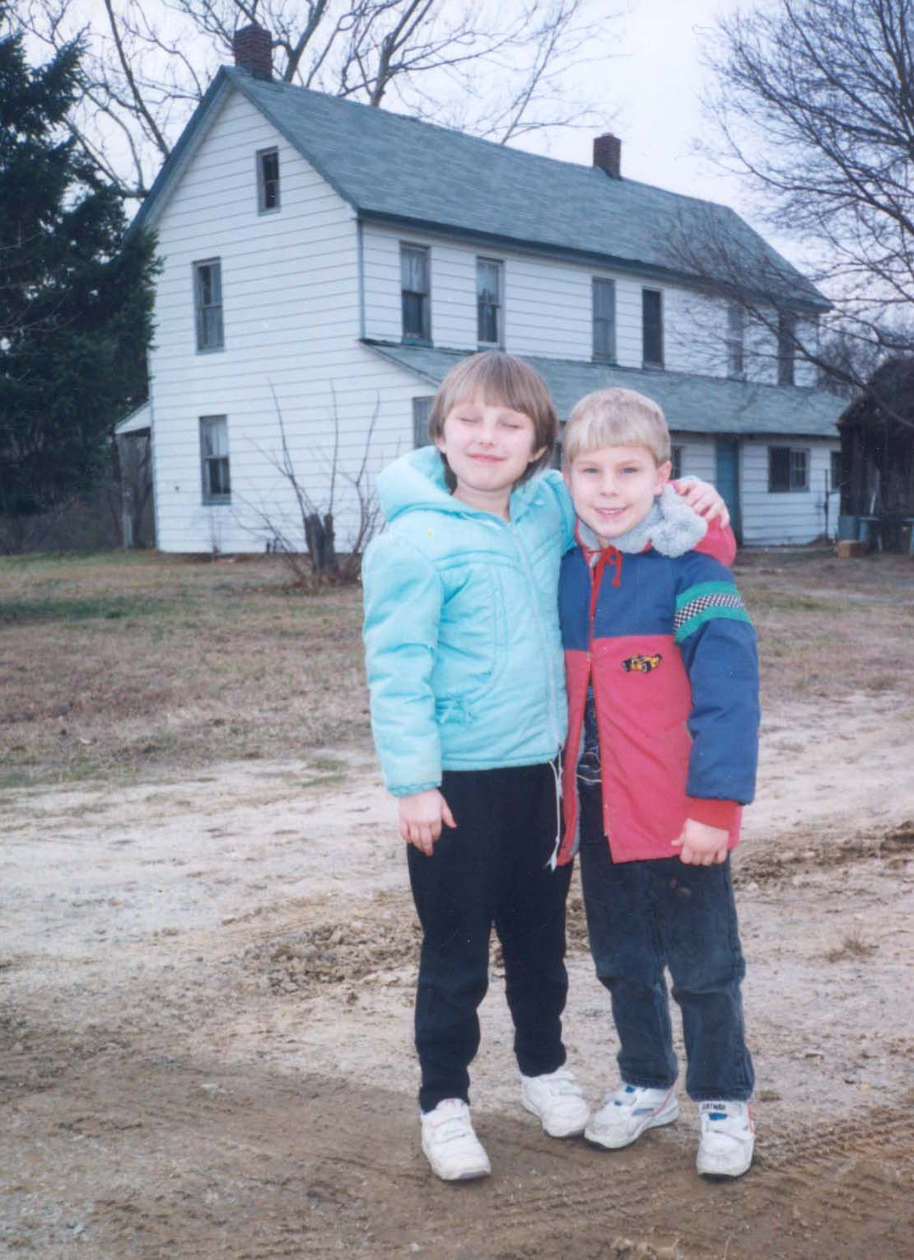
APPENDIX B
Map of Ganttown in 1845
(Courtesy of Gloucester County Historical Society, Woodbury, New Jersey)

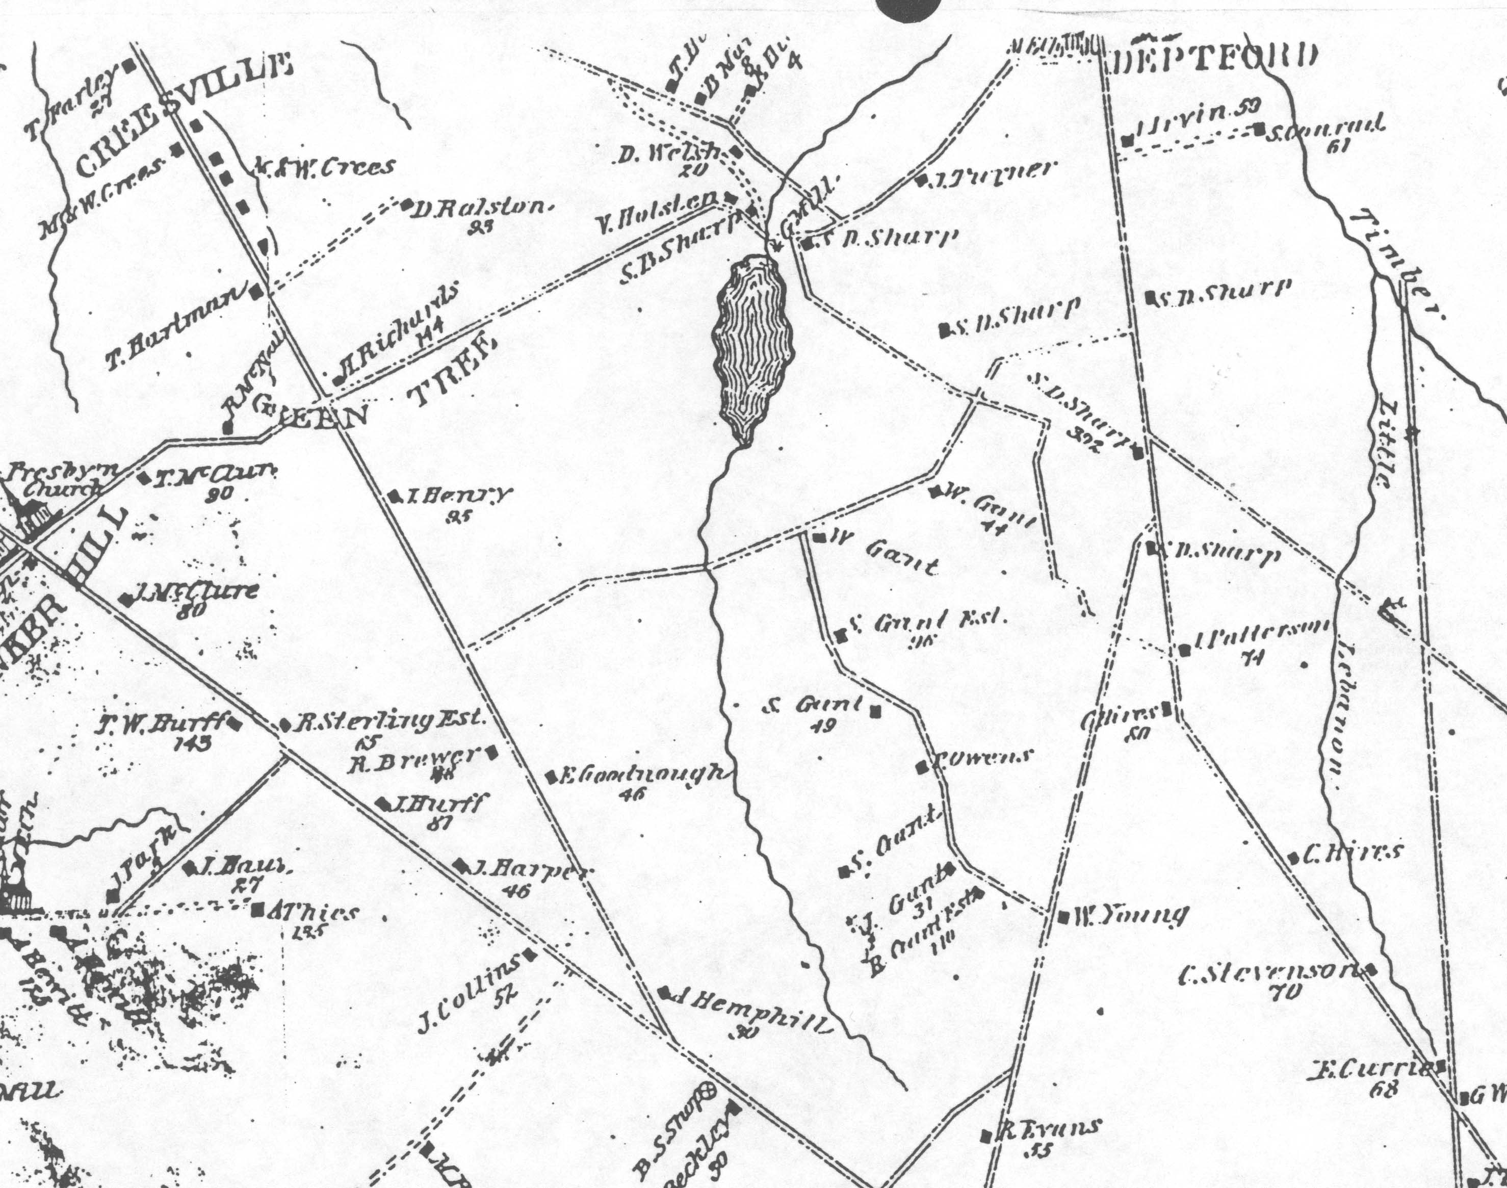
APPENDIX C
Institutional Research Board Approval, 2001

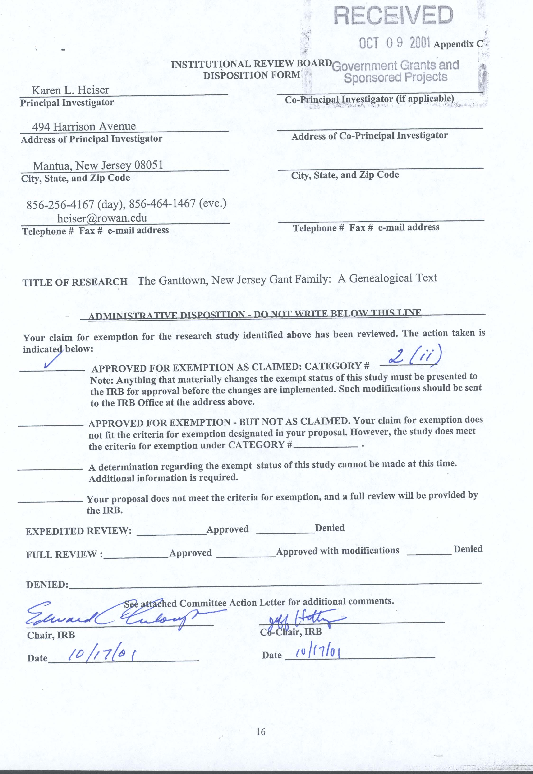
APPENDIX D
Permission Form for Interview, 2001
This form was mailed to (including a self-addressed, stamped envelope) and returned by: Gail Craver, Woodrow W. Currington, Howard U. Gant, Ruth A. Gibe (Gehring), Ella Rae Harrell, and Lois Mick.

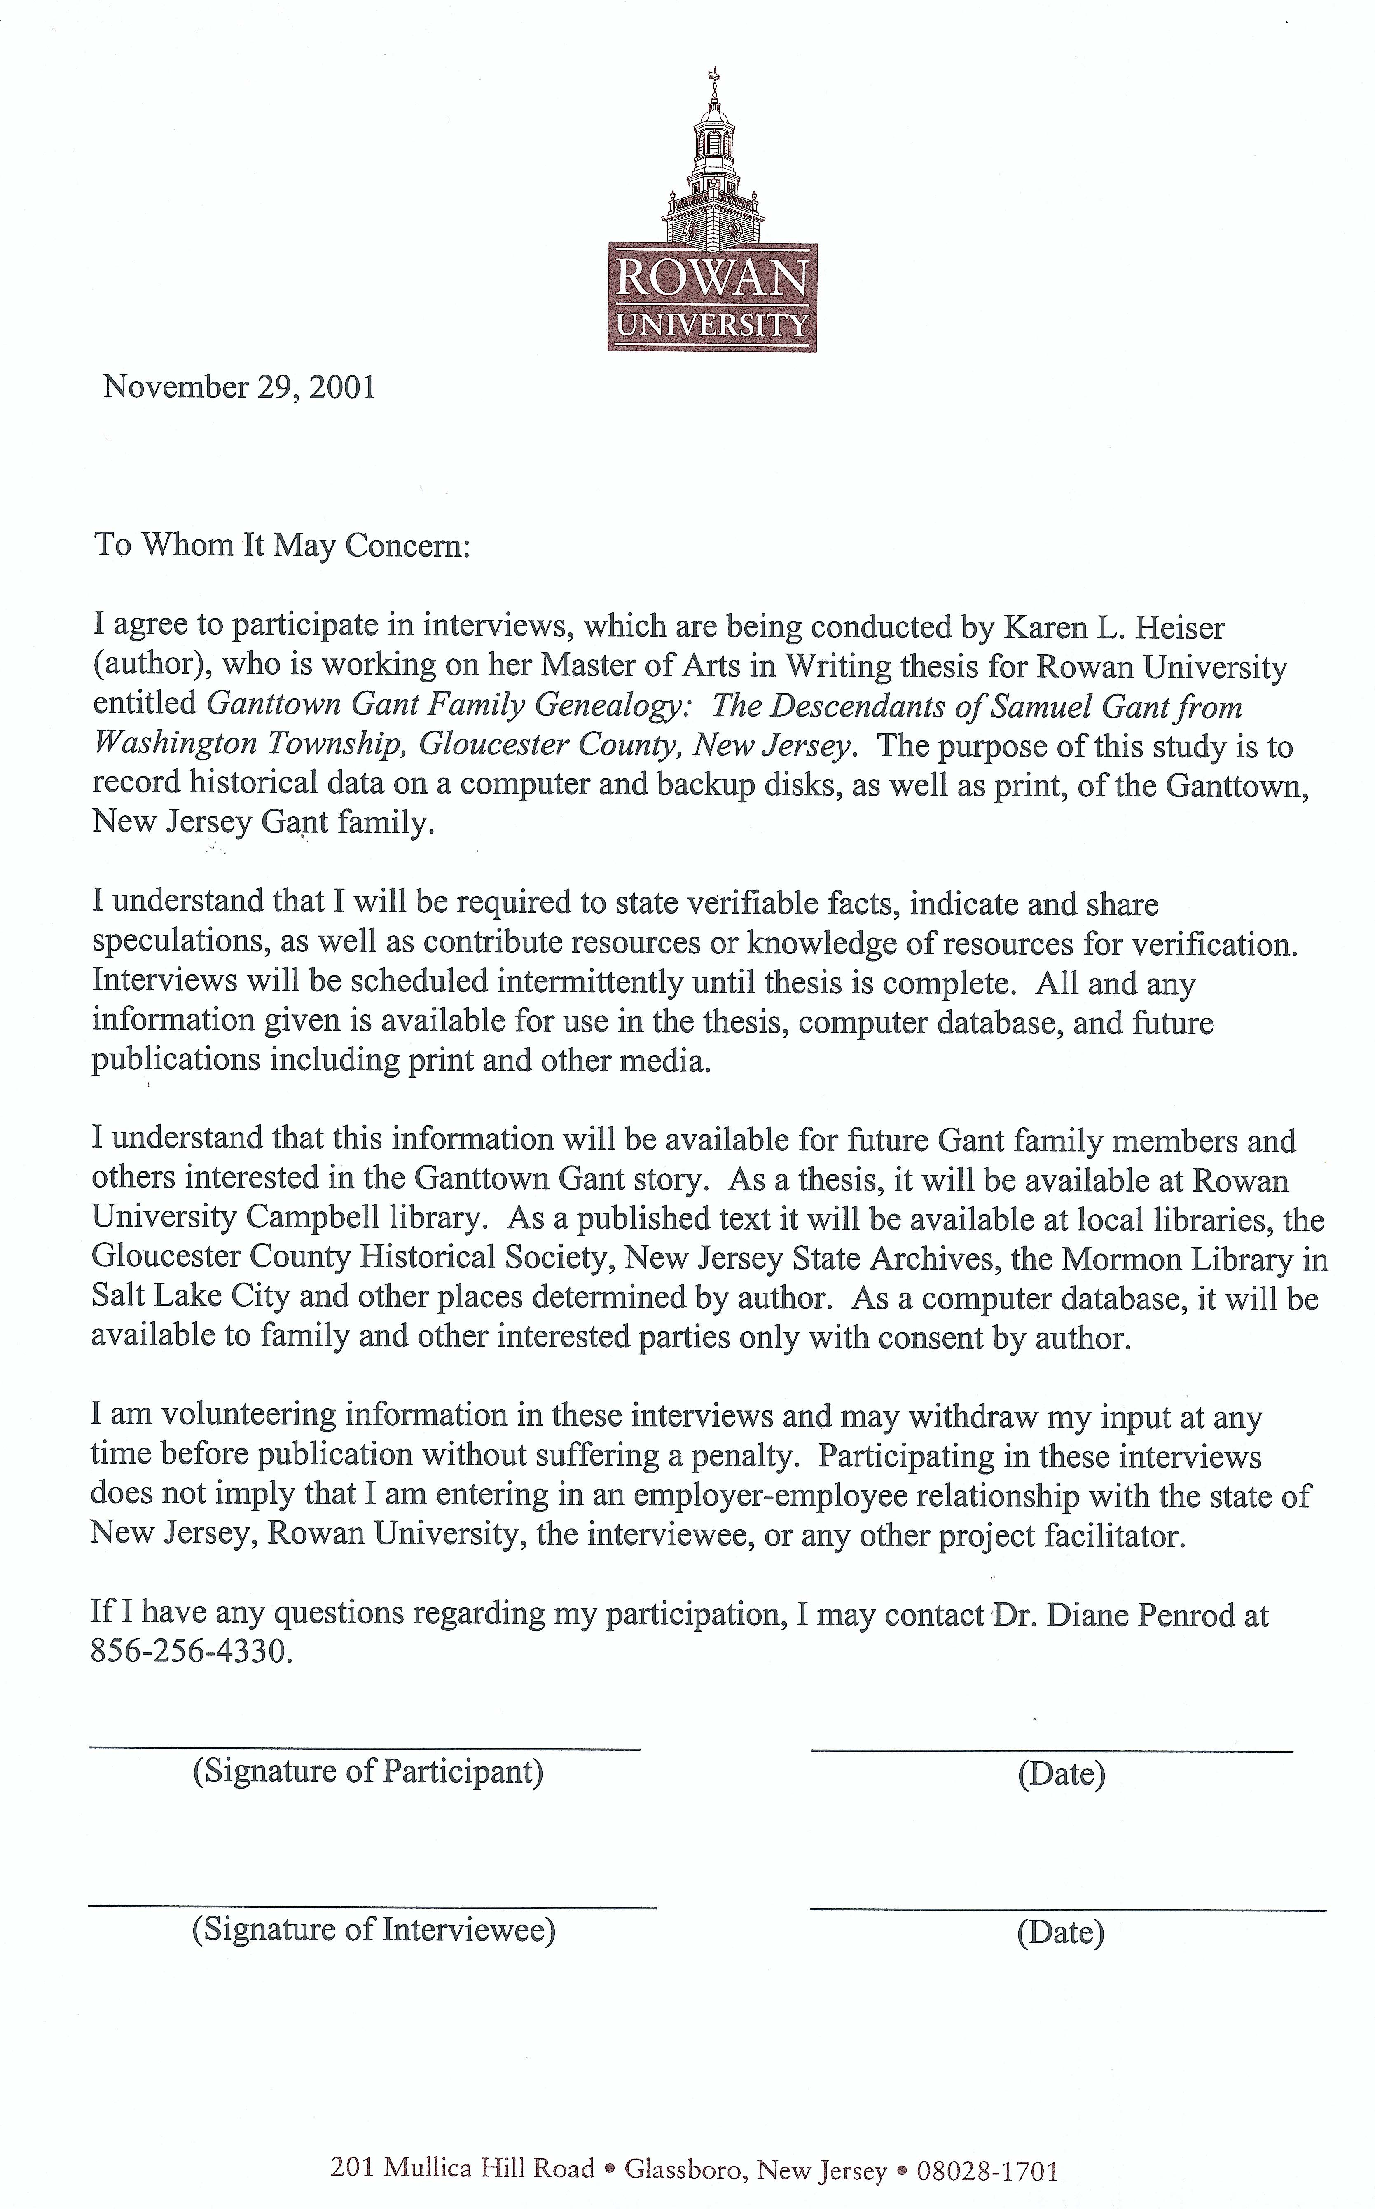
APPENDIX E
Permission Form for use of Name, 2001
This form was mailed to (including a self-addressed, stamped envelope) and returned by: Carl S. Gant, Carol Gonzalez (Gant), Edwin and Elaine Gant, and Isabel Moran (Gant).

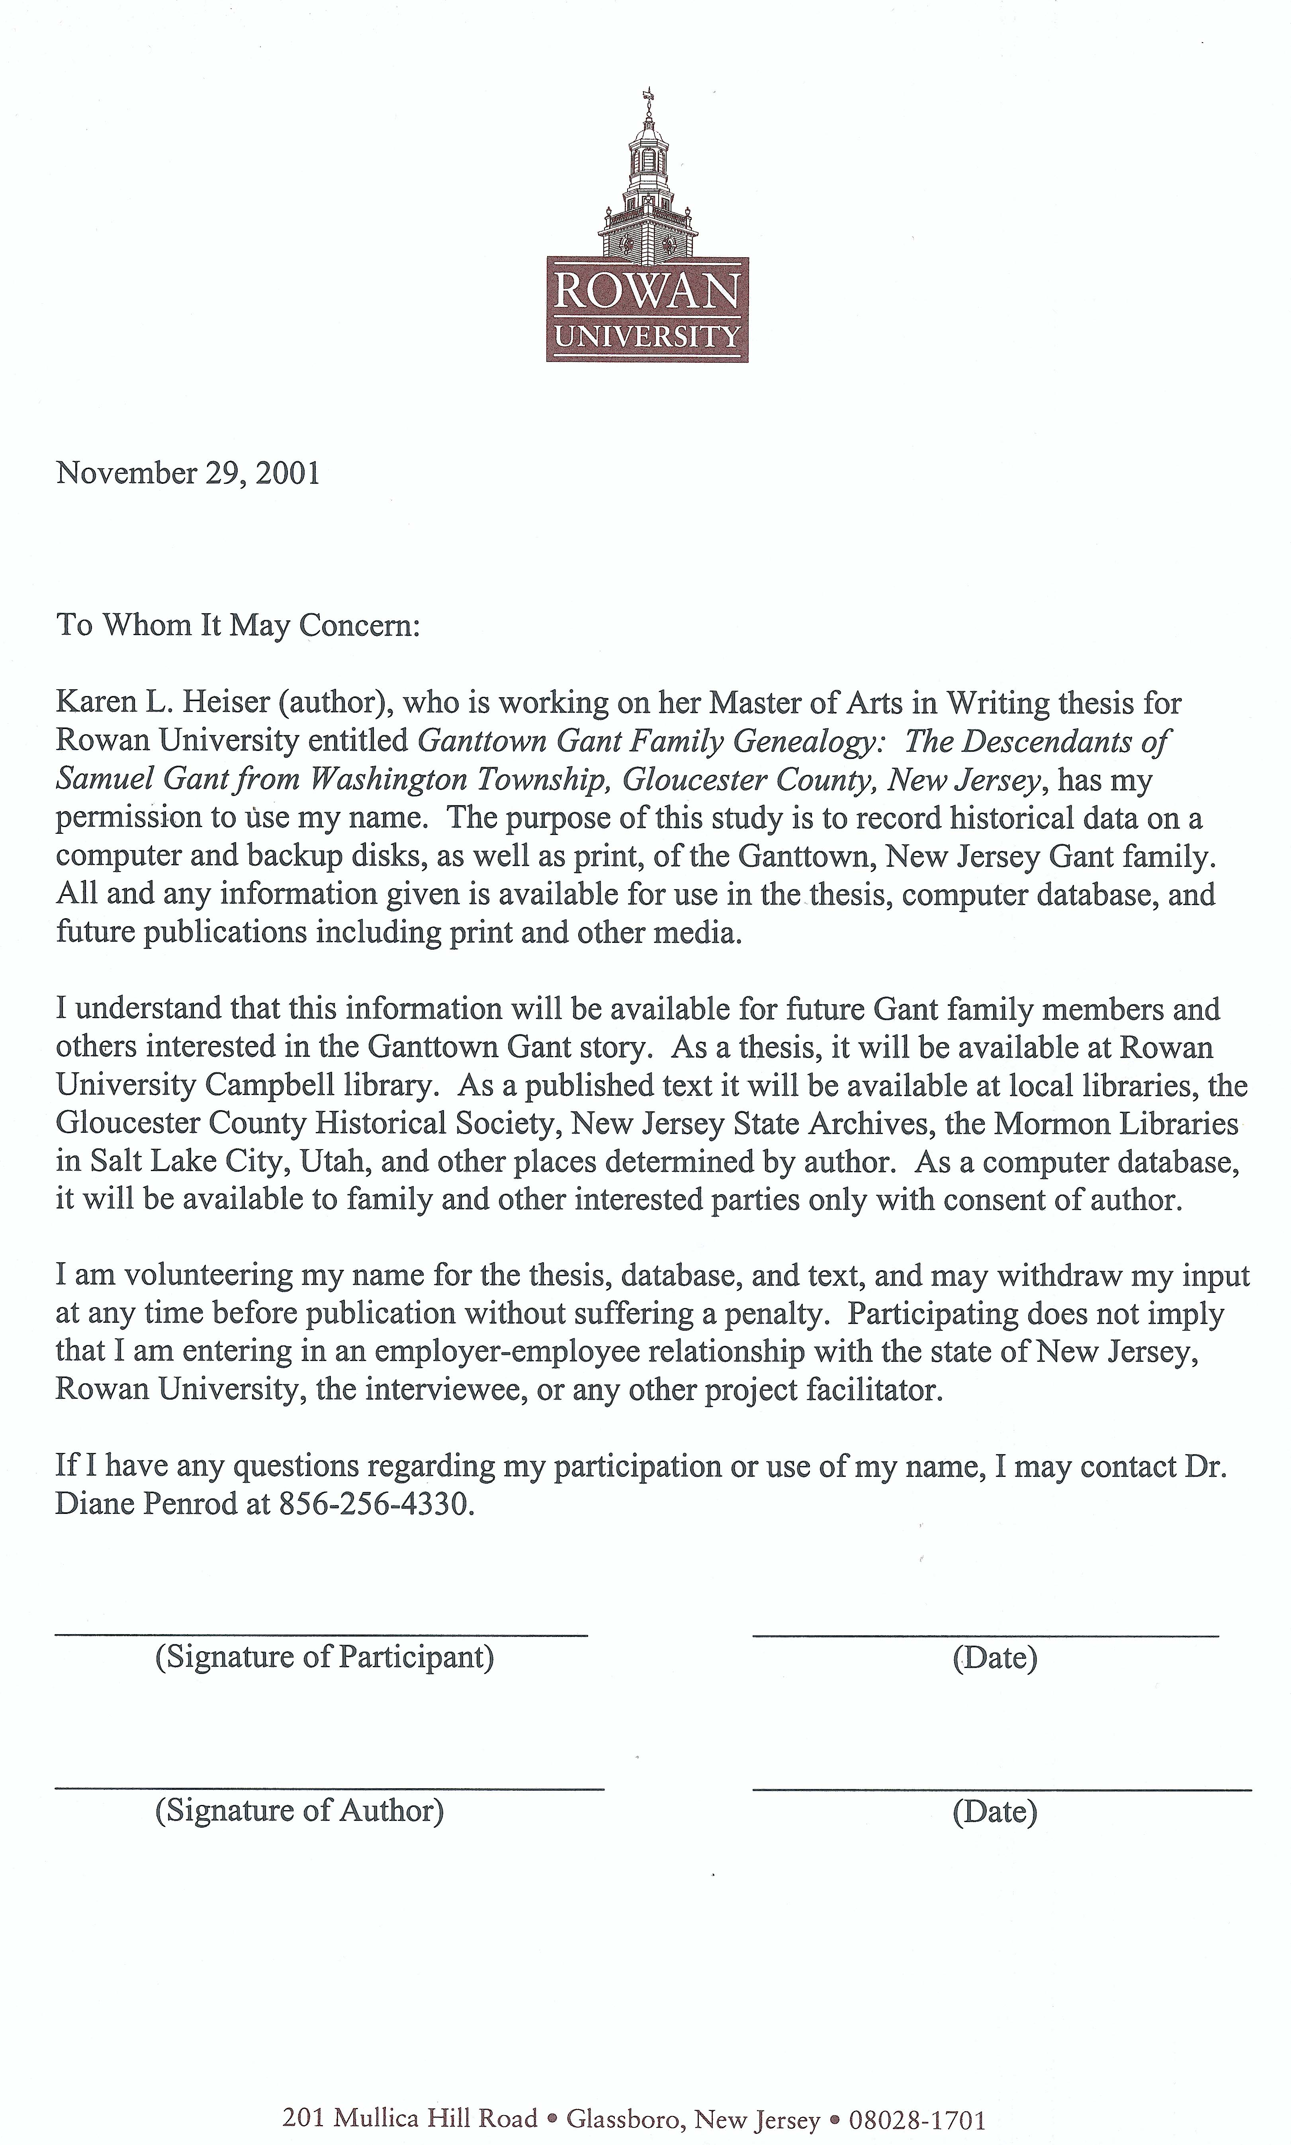
APPENDIX F
Maps of Gloucester County and Camden County
in the 1700s (Courtesy of Gloucester County Historical Society)

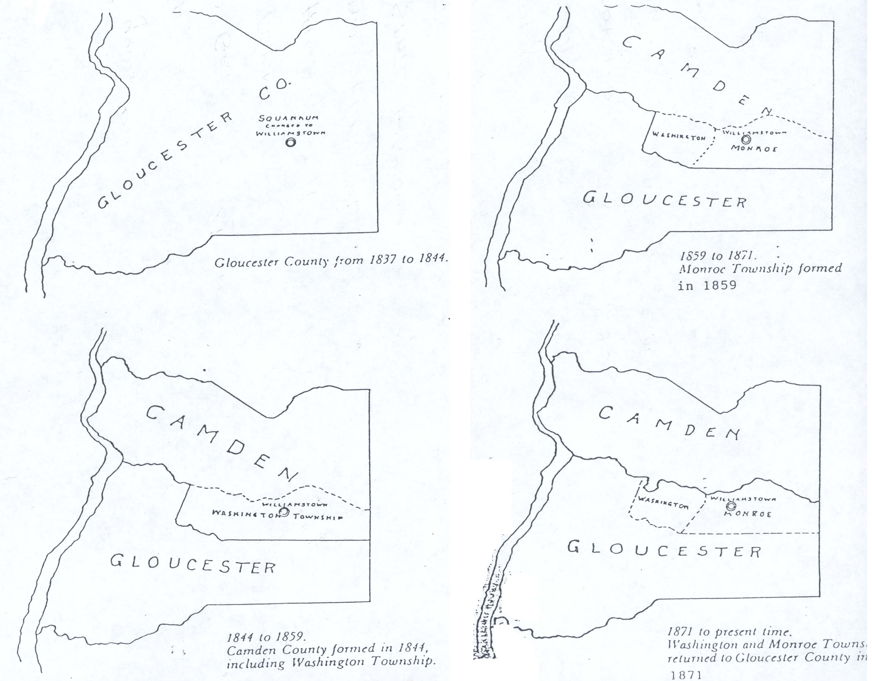
APPENDIX G
Gloucester County Historical Society Publishing Guidelines, 2001
(Courtesy of Gloucester County Historical Society, Woodbury, New Jersey)
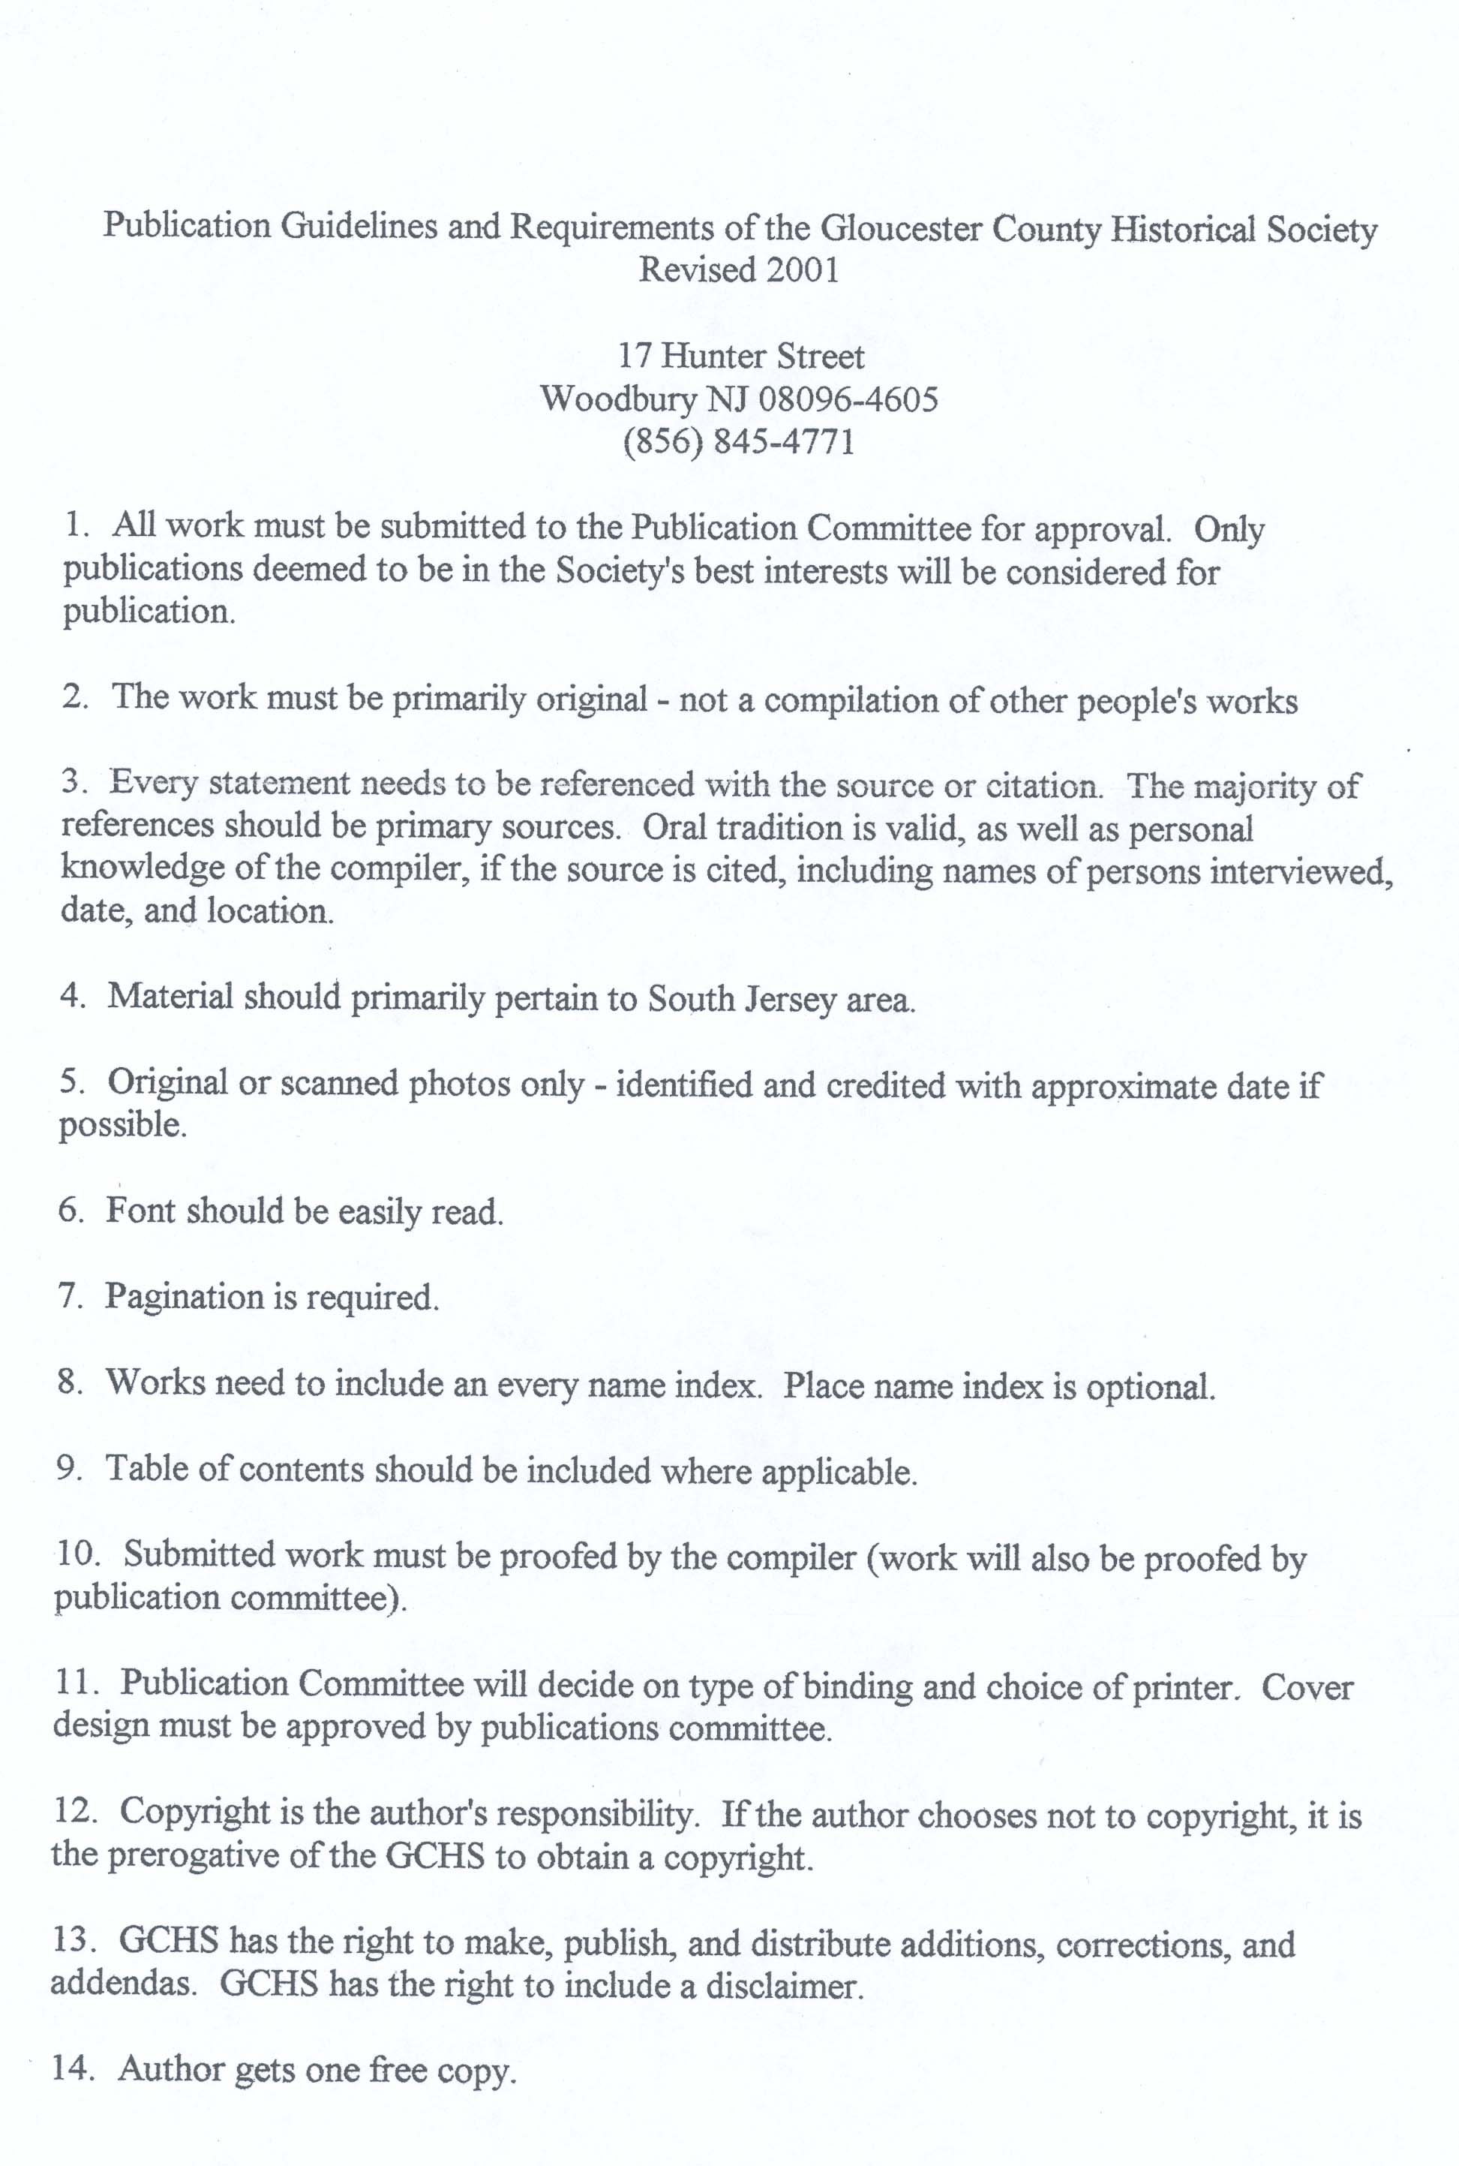
APPENDIX H
Photo of Samuel Gant’s Fifth Great-Grandchild, Steven Heiser
Howard U. Gant took this photo in March 1992 in back of Samuel Gant’s homestead and farm. A housing development was built on this land beginning in 1993.

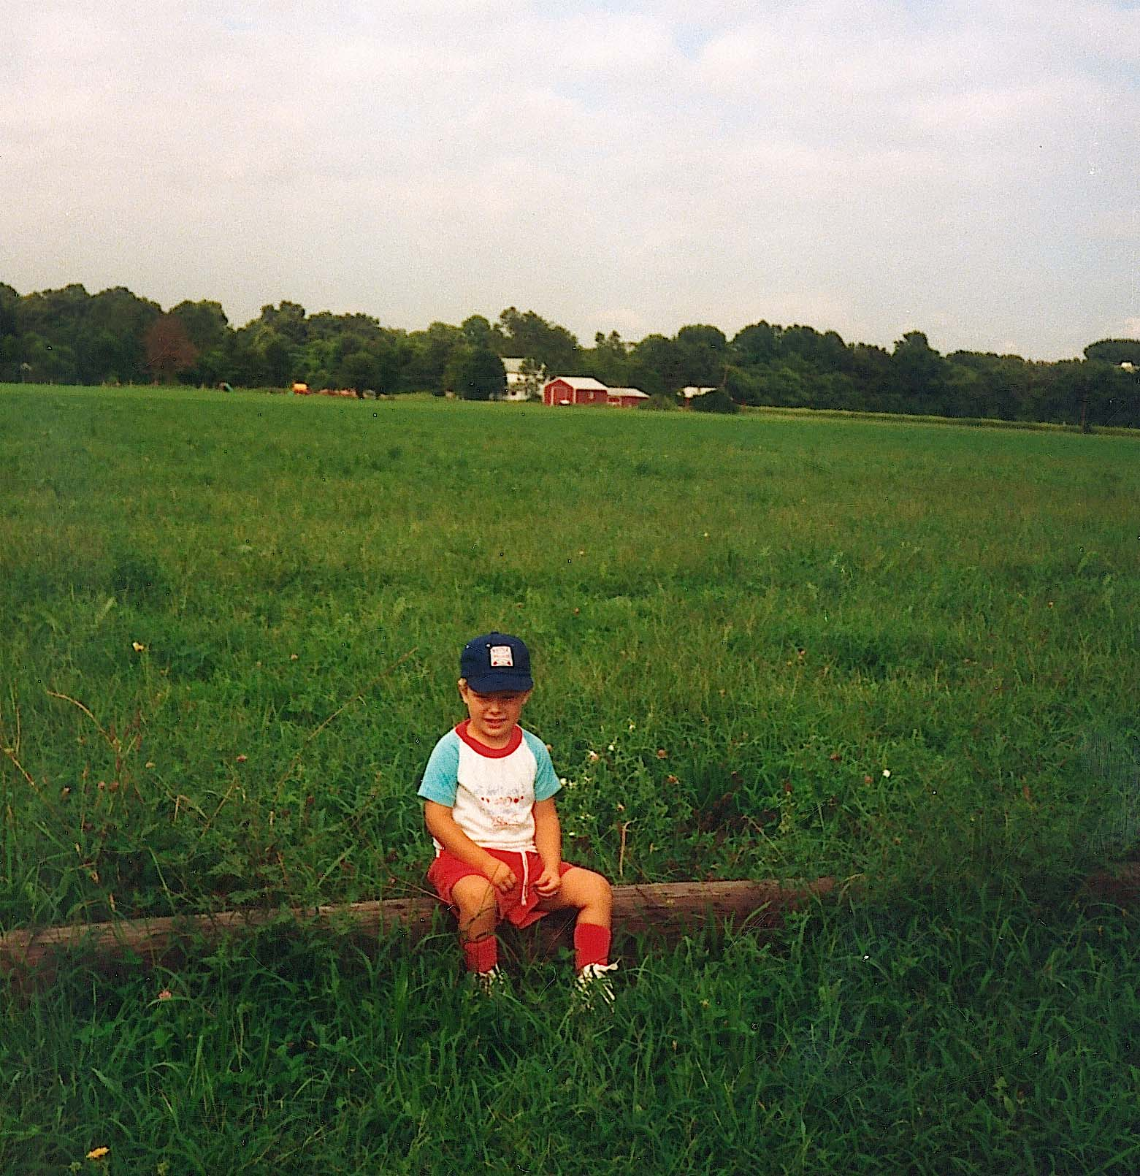

APPENDIX I
Photo of Edmund Brewer Gant and Caroline Elizabeth Gant (Scott), 1935
Lois Mick contributed this photo of her grandparents. Edmund is Samuel’s grandson and the son of Eli and Amy Gant (Nicholson).

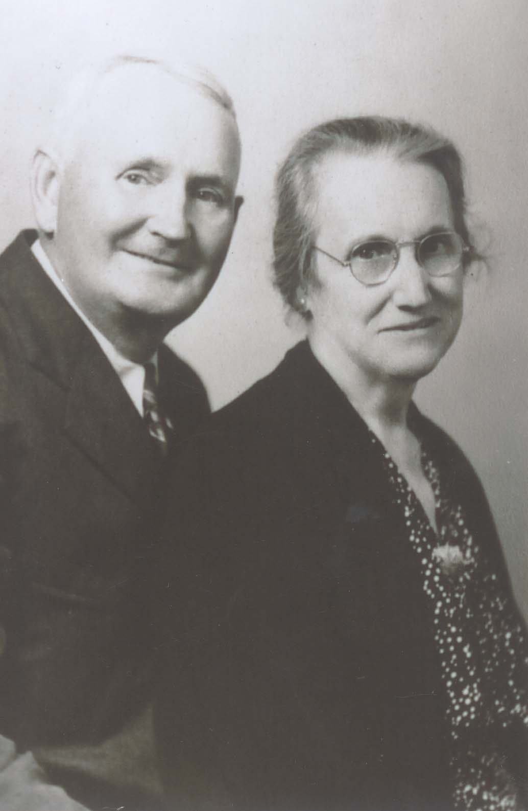
APPENDIX J
Photo of Eli Gant, 1870
Lois Mick contributed this picture of her great-grandfather, Eli Gant, the son of Samuel and Anna Mariah Gant (King).

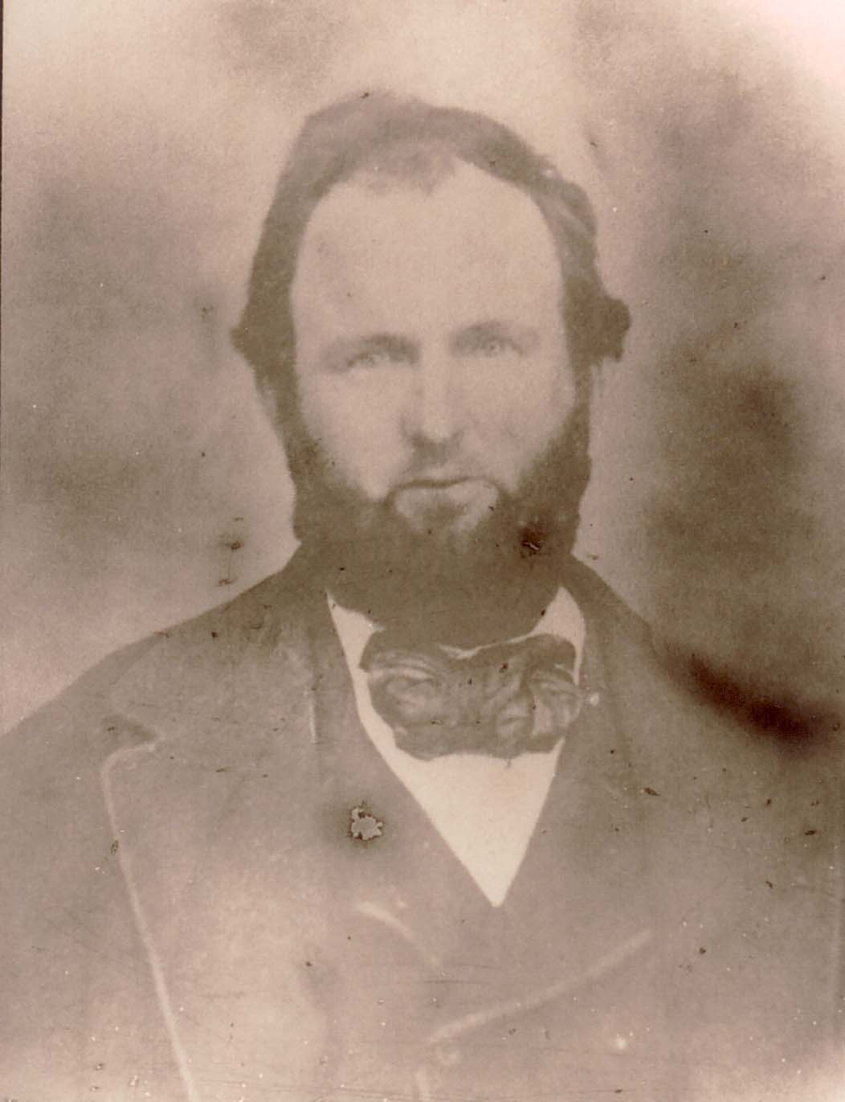
APPENDIX K
Photo of Charles Flexon, 1908
Howard U. Gant contributed the photo of Charles Flexon, taken a year before his death at age 78. Charles Flexon married Abigail Gant, daughter of Richard M. and Margaretta Gant (DeHart).

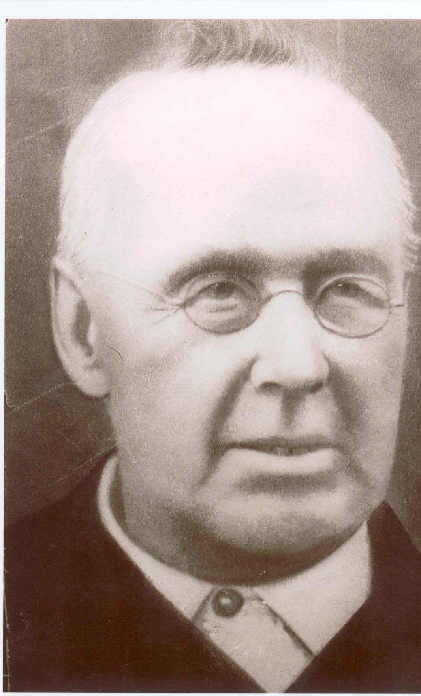
APPENDIX L
Photo of Flexon Family Picnic, 1908
Ruth A. Gibe (Gehring) contributed the photo of the Charles Flexon family picnic taken during the summer of 1908.
Top Row, L-R: James DeHart Flexon, age 53; Richard Gant Flexon, age 51; John Flexon, age 48; William Flexon, age 37; Charles Flexon, Jr., age 34.
Bottom Row, L-R: Anna Carvin, age 42; Margaret Thomas (twin), age 45; Hannah J. Langley (twin), age 45; parents Abigail Gant (Flexon), age 72 and Charles Flexon, Sr., age 78; Elizabeth Hawkey (Flexon), age 43; and Sara Jane Chew (Flexon), age 34.

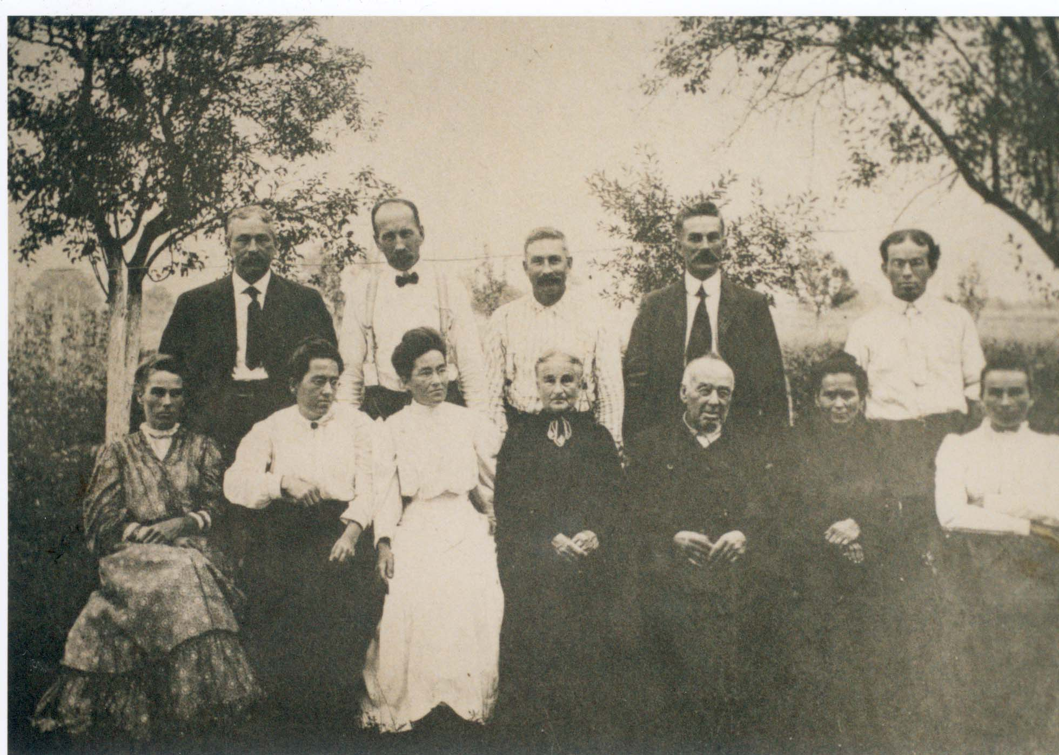
APPENDIX M
Photo of Downer School House, 1897
Ruth A. Gibe (Gehring) contributed the Downer School House photo. The school was built in 1871 and was used as a church until the Downer Methodist Episcopal Church was built.
The top row, l-r, is: (1) Elsie Gant, (2) Helen Young, (3) Hattie Flexon, (4) Laura Thomas, (5) Mark Armstrong, (6) George Metz, (7) Sammie Thomas, (8) Russel Downer, (9) Henry Flexon, (10) Josephine Downer, and (11) Reba Garvin.
The second row from top, l-r, is: (12) Ethel Downer, (13) Sara Huntsinger, (14) Lettie Young, (15) Romal Thomas, (16) Clara Flexon, (17) Mamie Langly, (18) Amanda Flexon, and (19) Arthur Downer.
The third row, l-r, is: (20) Albertha Thomas, (21) Bertha Flexon, (22) (unknown first name) Stevenson, (23) Maggie Thomas, (24) Annie Thomas, (25) Mrs. Harriet Strang (Mullica Hill), (26) (unknown first name) Stevenson, (27) Abbie Carvin, (28) Maggie Steward, and (29) Esther Steward.
The bottom, fourth row, l-r, (30) Roy Thomas, (31) Wille Downer, (32) Walter Huntsinger, (33) Eddy Thomas, and (34) (Willie or Roy) Thomas.

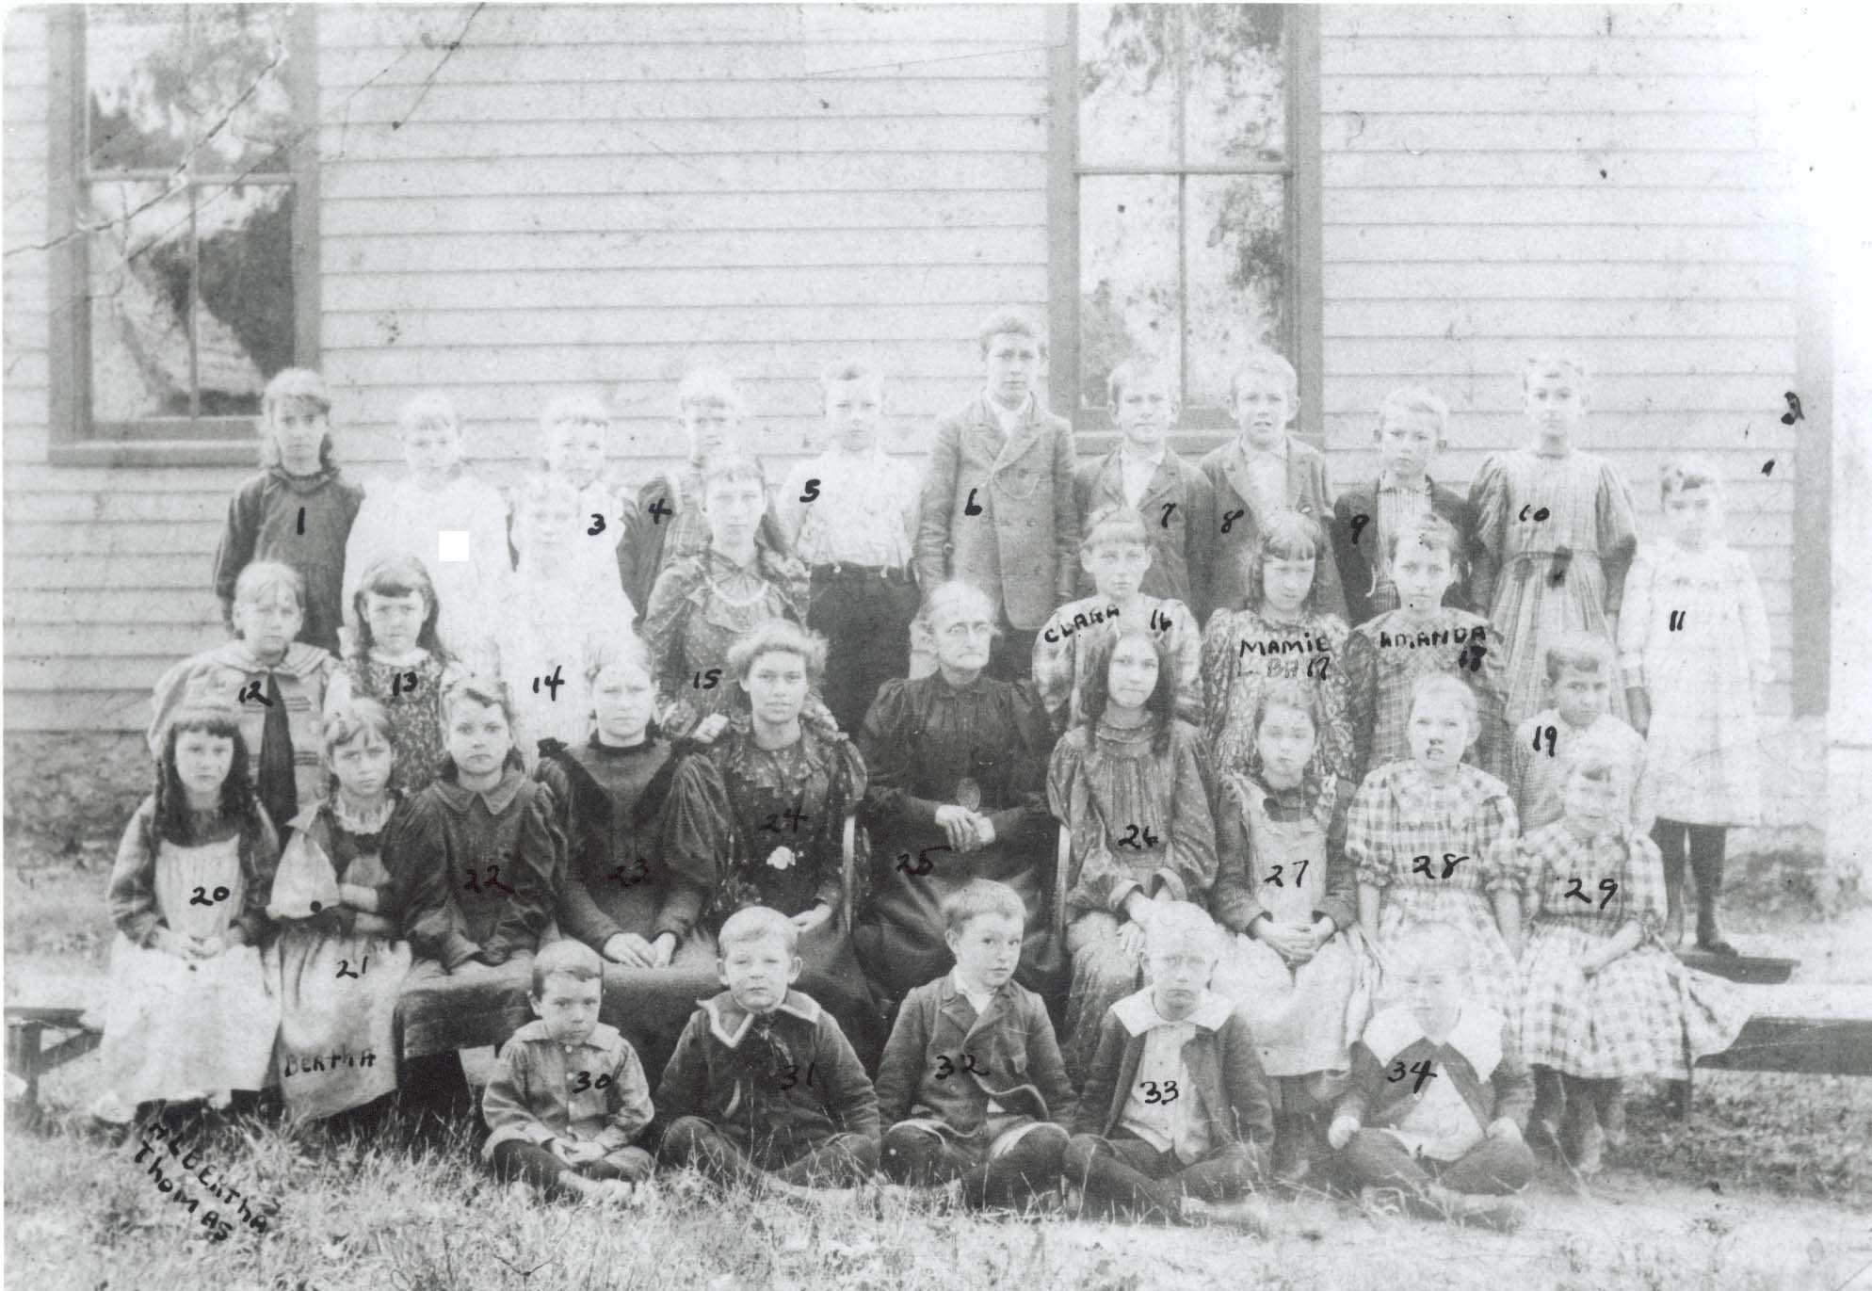
APPENDIX N
Photo of Abigail Flexon (Gant)’s Grandchildren
and Downer School Children at Flexon Farm, 1897

Photo contributed by Ruth A. Gibe (Gehring). Charles Flexon, Jr. is holding horse
reins on left.

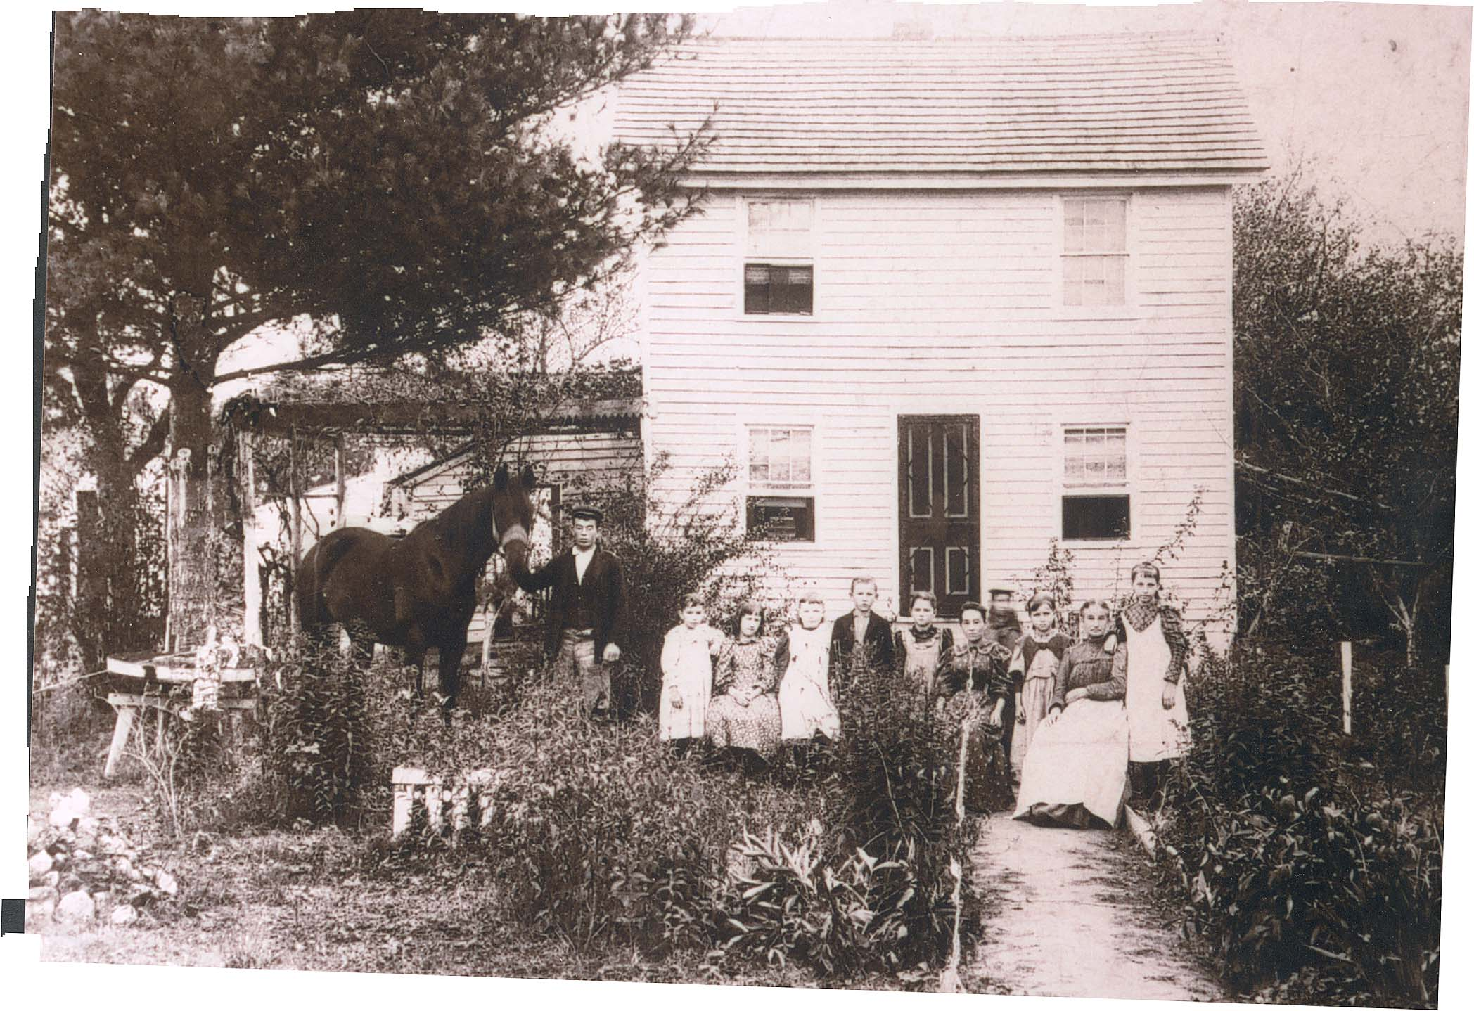

APPENDIX O
Photo of Flexon Family Reunion, 1908
Photo of Charles and Abigail Flexon (Gant)’s family during family picnic in August 1908, in Downer, New Jersey.
The top row, l-r: Samuel Thomas, Joseph Gehring, James Broadwater, Clara Johnson (Flexon), Amanda Broadwater (Flexon), Romal Thomas, Mamie Barton (Langley), Reba Carvin, Bertha Gehring (Flexon), Patty Flexon, Charles Flexon, Jr., and Reverend Abel.
The second from top row, l-r: Harry Johnson, Josie Carvin, Della Flexon, James Carvin, Richard Flexon, Albertha Thomas, Walter Flexon, Mr. Rouse (William Flexon’s father-in-law), Henry Flexon, and Samuel Thomas.
The third from top row, l-r: Lawrence Marsh, Walter Chew, Margaret Marsh (Flexon), Ella Shindler—perhaps James D. Flexon’s second wife, James D. Flexon—perhaps holding Margaret Marsh’s son, Sr., Margaret Mickle Flexon, Richard G. Flexon, Sr., John Flexon, Howard Flexon, Ida S. Flexon, William G. Flexon, Ida R. Flexon, Hannah Langley (Flexon), Sara Jane Chew (Flexon)—holding Elwood Chew.
The fourth from top row, l-r: Abbie Carvin Ingersol—holding Blanche Ingersol, Anna M. Carvin (Flexon), Margaret Hurff (Gant), Peter Gant, Priscilla Pease (Gant), Abigail Flexon (Gant), Charles Flexon, Sr., Richard Gant, Jr., Katherine B. Gant, Elizabeth Hawkey (Flexon)—holding Bessie Hawkey, and Margaret Thomas (Flexon)—holding Mary Thomas.
The bottom row, l-r: Mildred Carvin, Emma Johnson, Roy Thomas, Willie Thomas, Harold Flexon, Ernest Thomas, Clarence Chew, Floyd Flexon, Stella Chew, and Erma Chew.

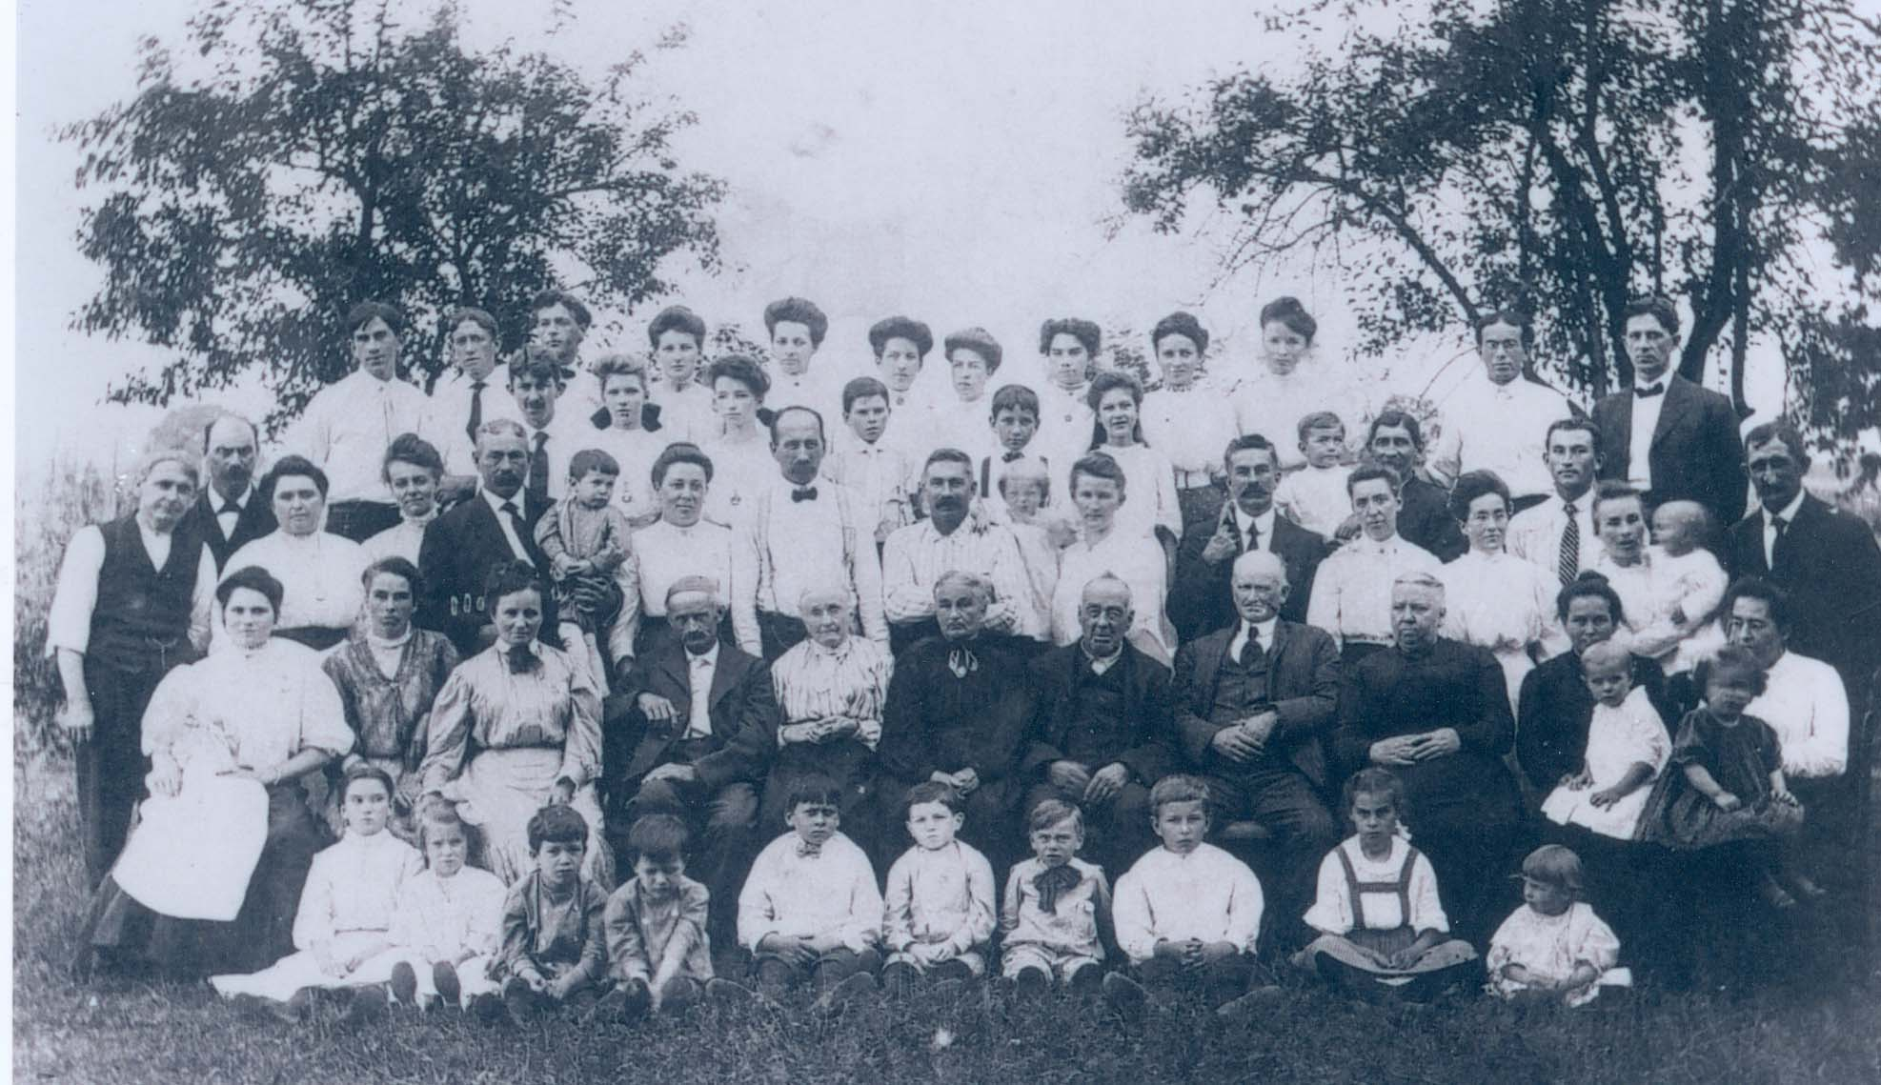
APPENDIX P
The constitution, Twelfth NJ Enlistment Members (16 Sept 1862)

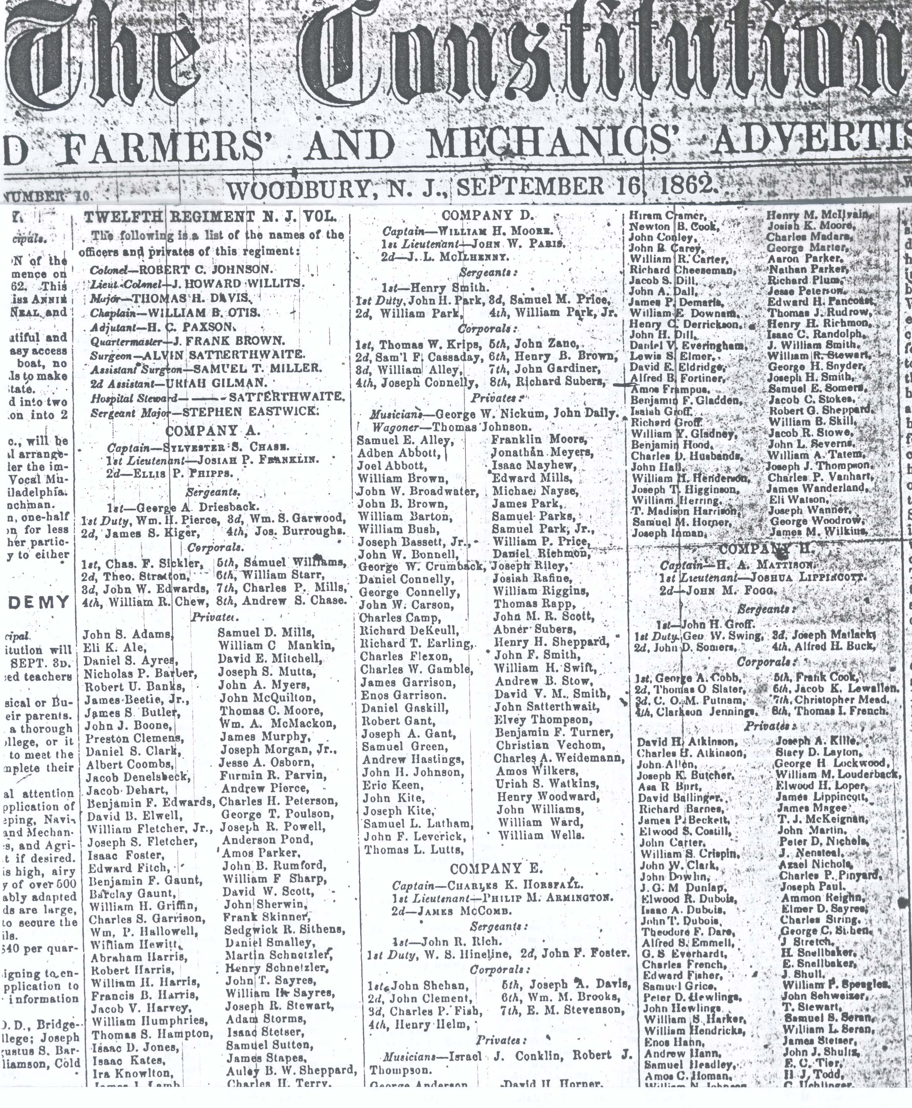
APPENDIX Q
Photo of Robert H. Gant, Samuel Gant’s Grandson, in Civil War Uniform, 1862.

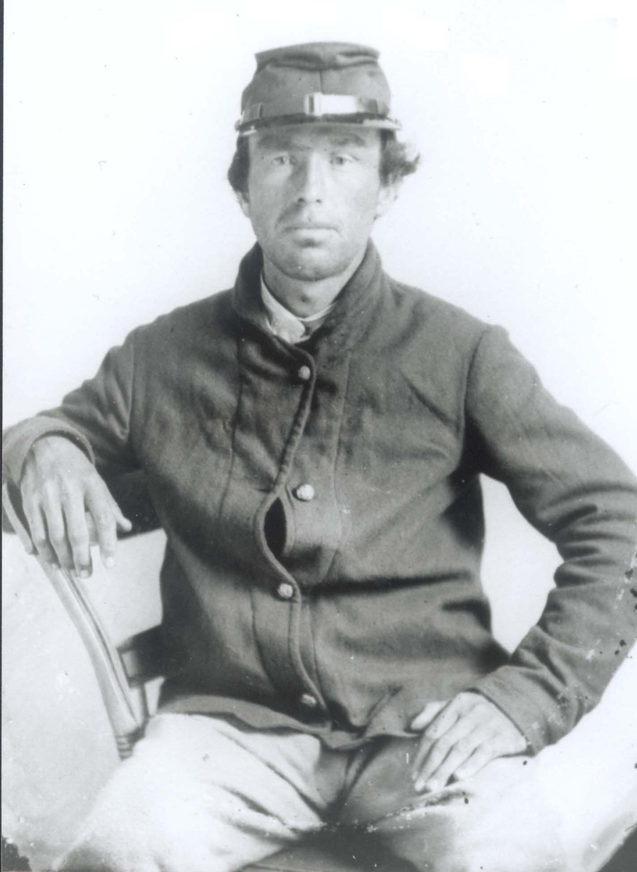
APPENDIX R
Photo of Steven Heiser, Samuel Gant’s Fifth Great-Grandchild
Standing in Front of 12th Regiment, New Jersey Volunteers Monument
at Gettysburg, PA, 1994.

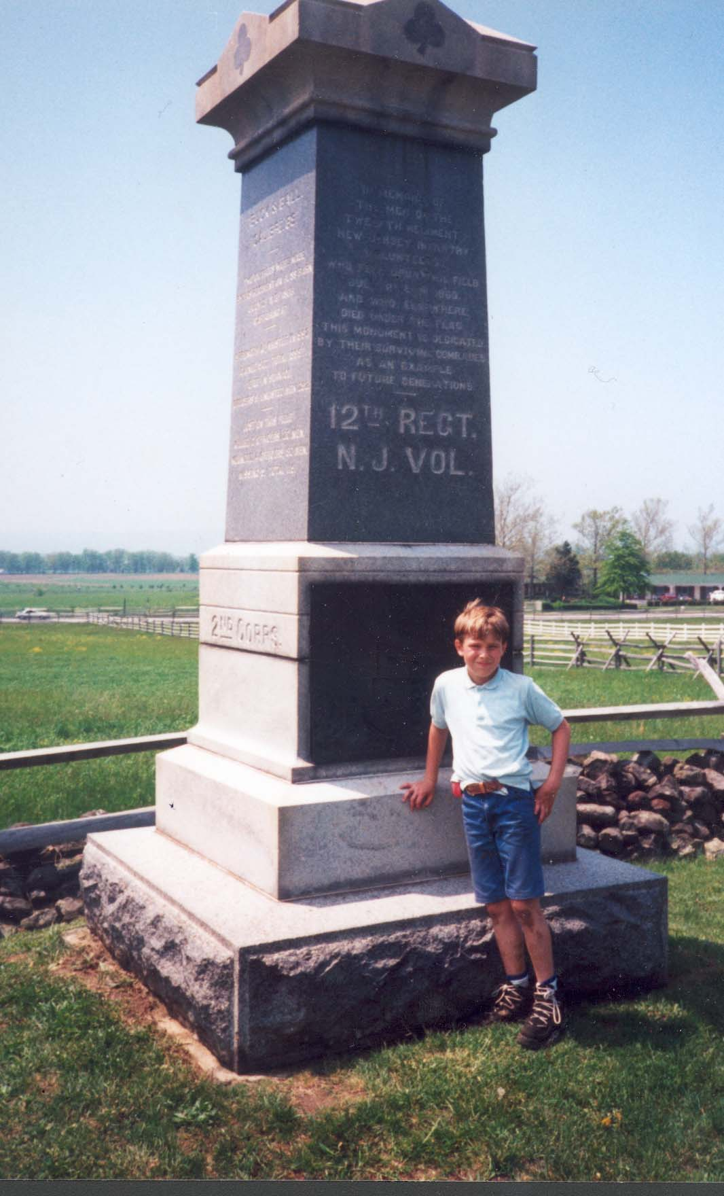
APPENDIX S
Photo of Synott H. Gant and the Little Mill Deer Hunting Club, 1931
The top row, l-r: Samuel Gant (1898-1942), Leonard Miller, Louis Mood, John Craver (1883-1954), John Savage, Tom Stafford, Jesse R. Gant (1905-1982), Synott H. Gant (1862-1944), Earl Gant (1900-1967), and William Miller, Jr.
The bottom row, l-r: Frank Courtney, William Gant (1894-1981), Carl Gant (1904-1948), William Hoffman, Peter Roussin (1894-1983), William Miller, Sr., William Currington (1891-1959), and Louis Gant (1896-1974).

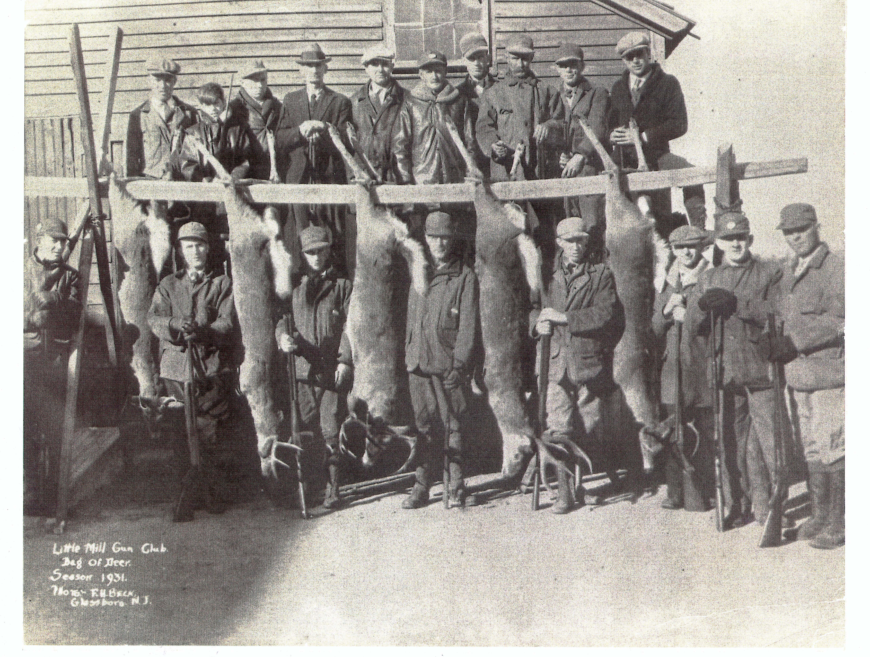
APPENDIX T
Photo of Synott H. Gant, Estelle Gant (Currington), and William Gant, 1925
Photo taken by William Currington in the Pinelands of South New Jersey. The fire tower
is in the background.

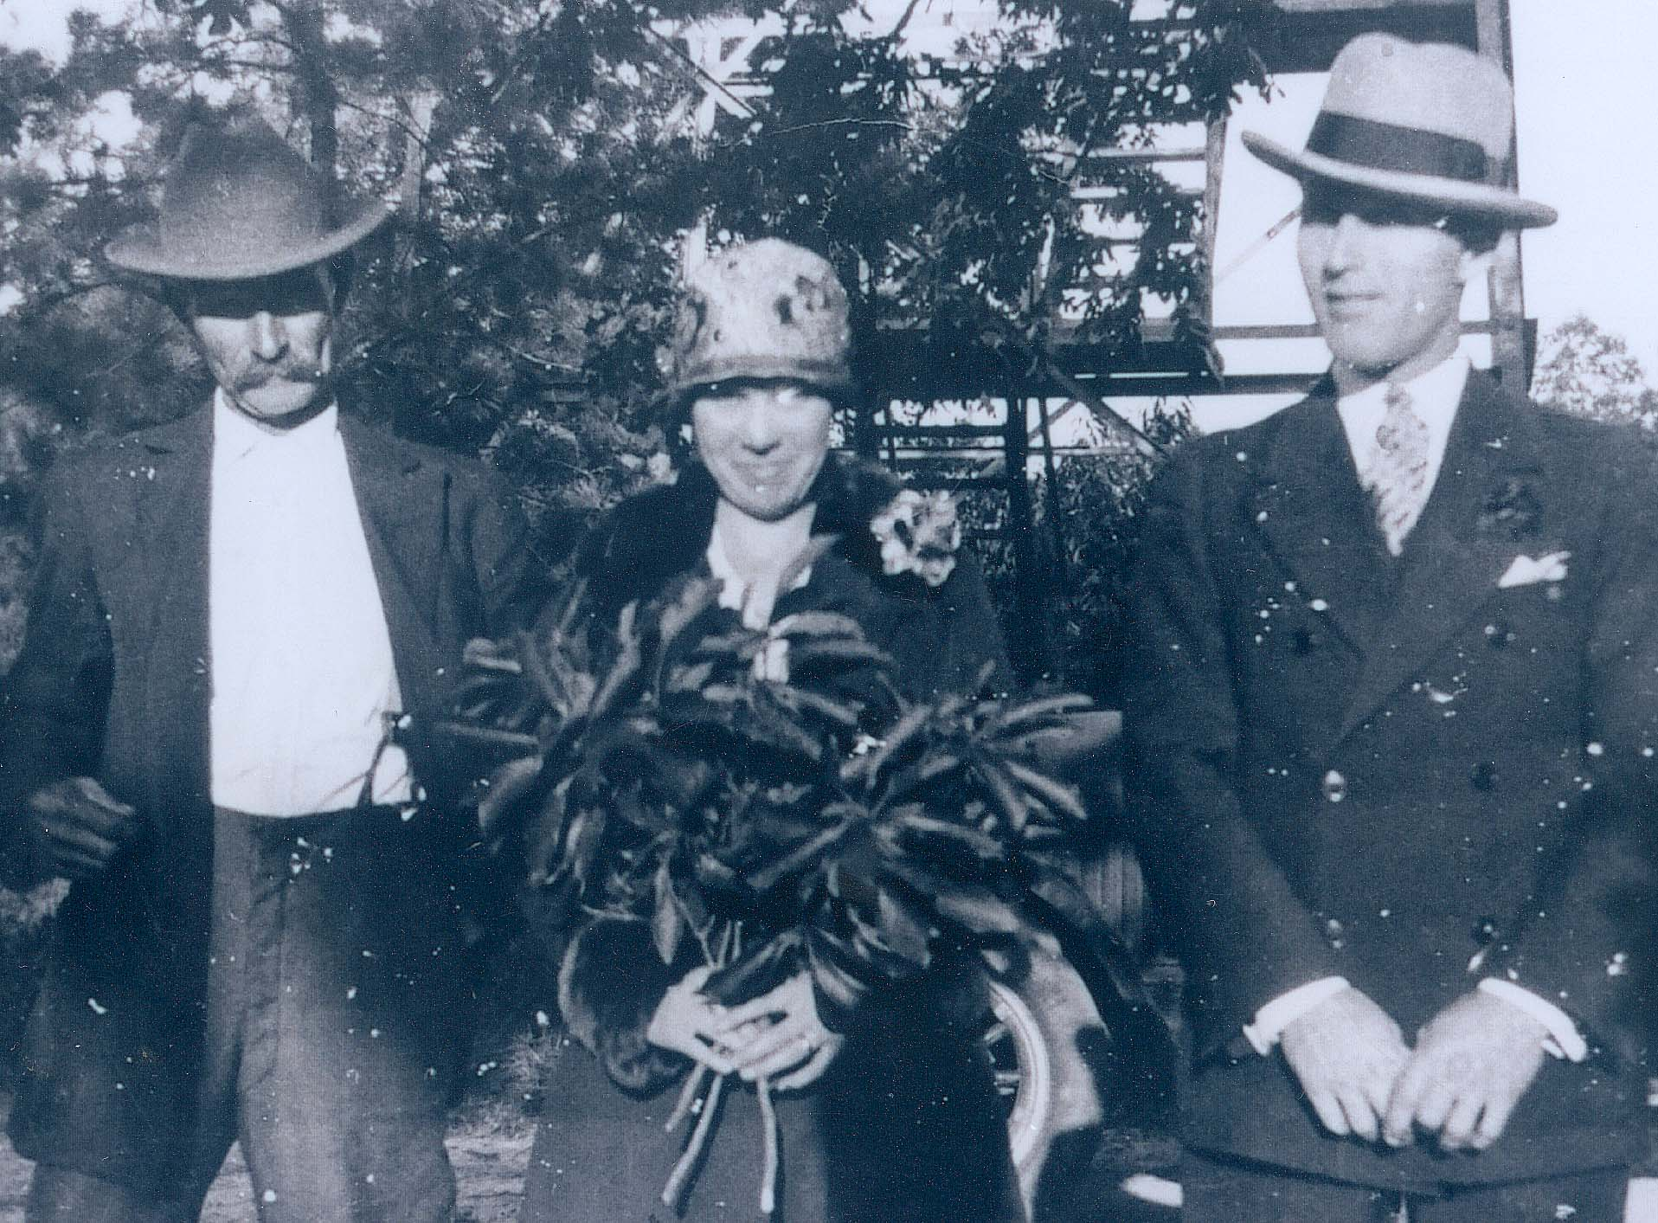
APPENDIX U
Photo of Jesse Robert Gant’s 1905 Birthplace
The old Fisler home on Aura and Glassboro Roads, Clayton, New Jersey, was the birthplace and first home of Jesse Robert Gant. Howard U. Gant contributed this photo that he took in 1943.

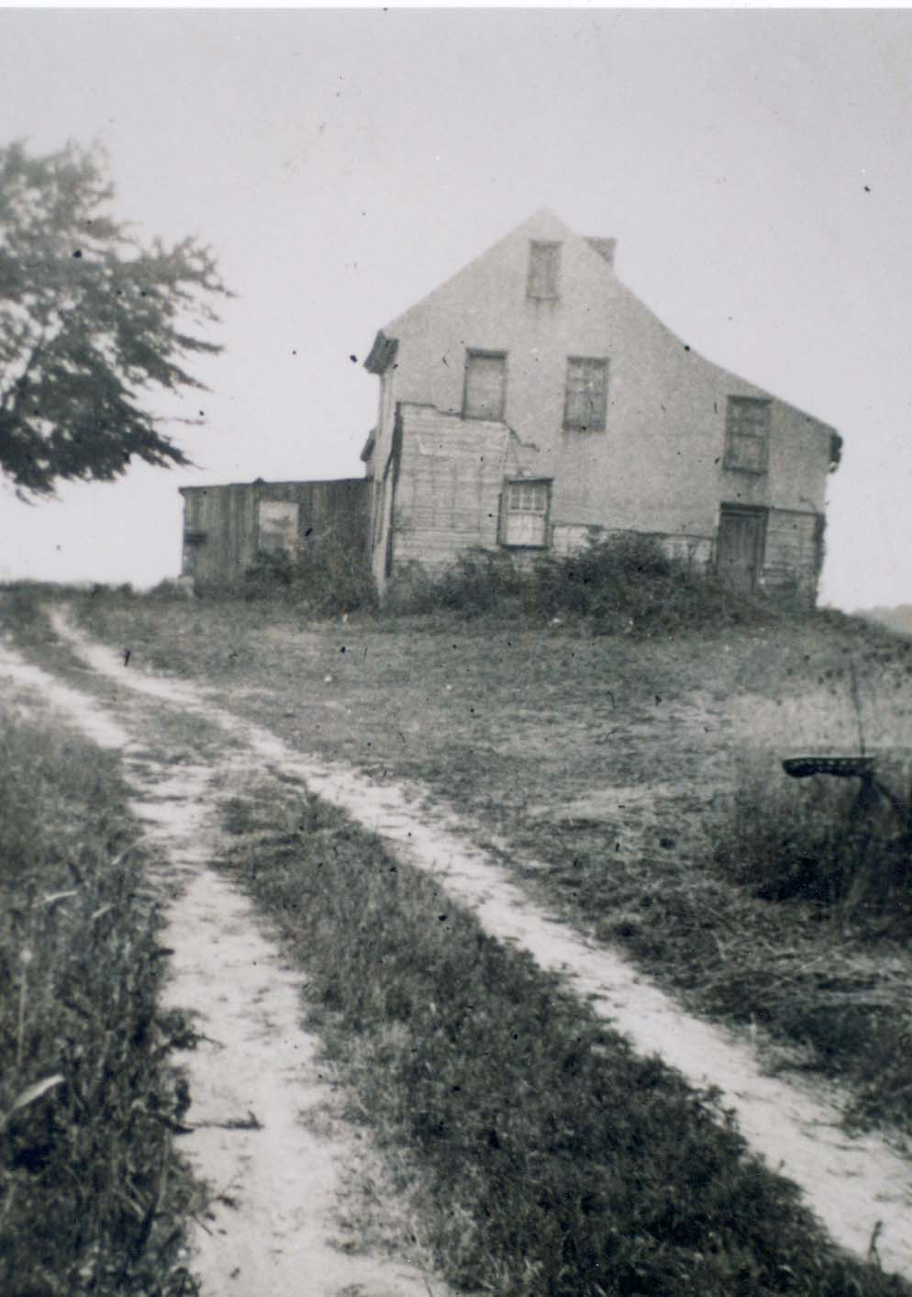
APPENDIX V
Photo of Almon D. Page, Beatrice Gant’s Father, 1930
Almon D. Page was born in Litchfield, MI on 27 Feb 1860. He retired to the Grove Lawn Estate, Clayton, New Jersey. Photo was taken in 1930. Almon D. Page is the husband of Bella A. Sawyer and grandfather of Howard U. Gant.

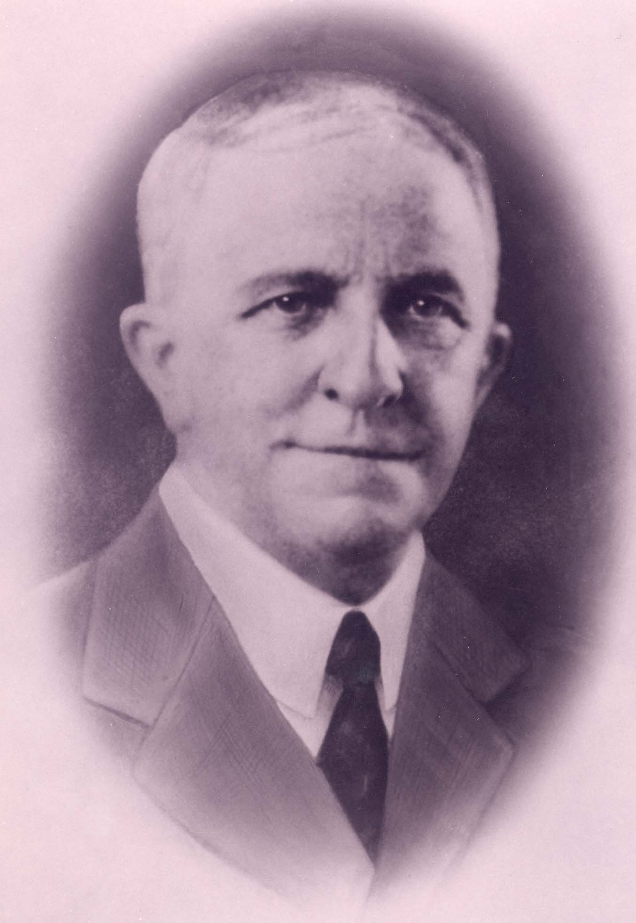
APPENDIX W
Photo of Bella Page (Sawyer), Beatrice Gant’s Mother, 1920
Bella A. Page (Sawyer) was born in Sanbornton, New Hampshire. She was 49 years old in this picture. Two years after it was taken, she moved to Clayton, New Jersey. She was the mother of four children, grandmother of 12 children, including Howard U. Gant.

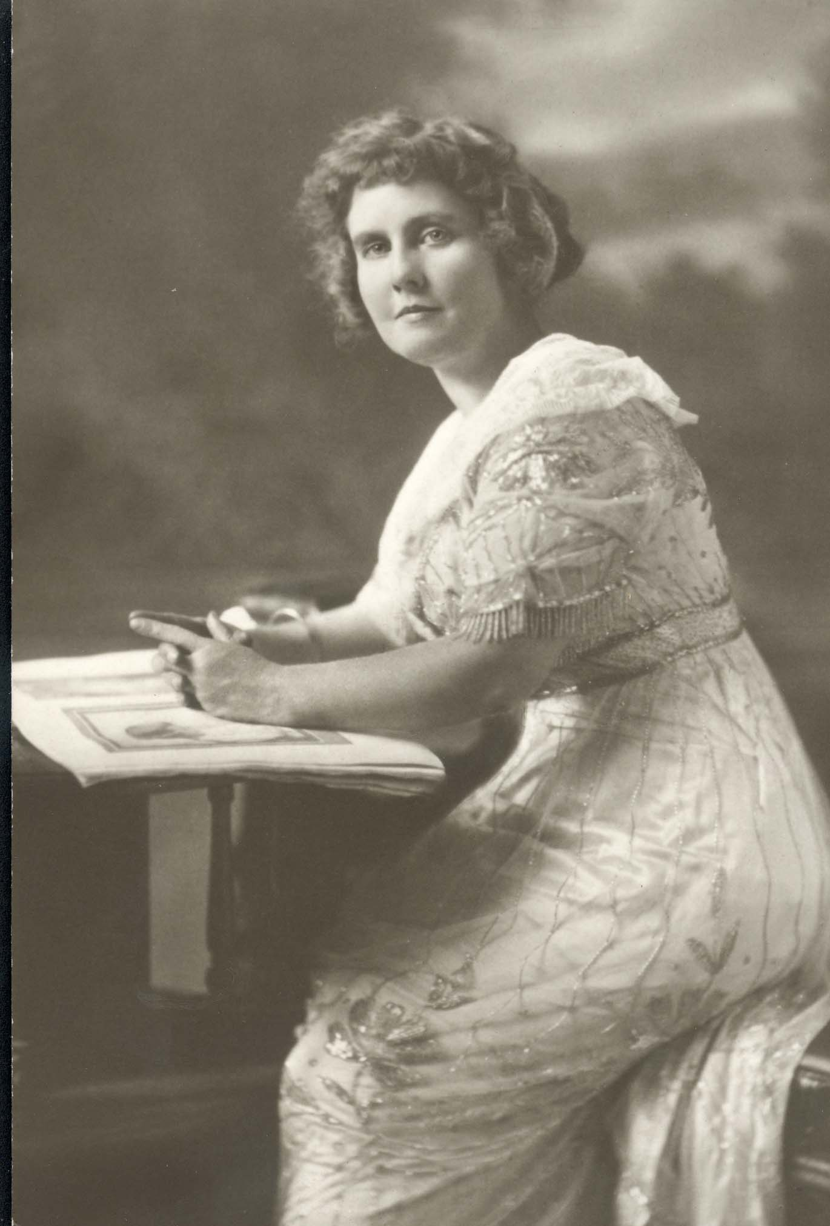
APPENDIX X
Photo of Jesse Robert Gant and Beatrice Yvonne Gant (Page), 1975
50th Wedding Anniversary, married on May 27, 1925

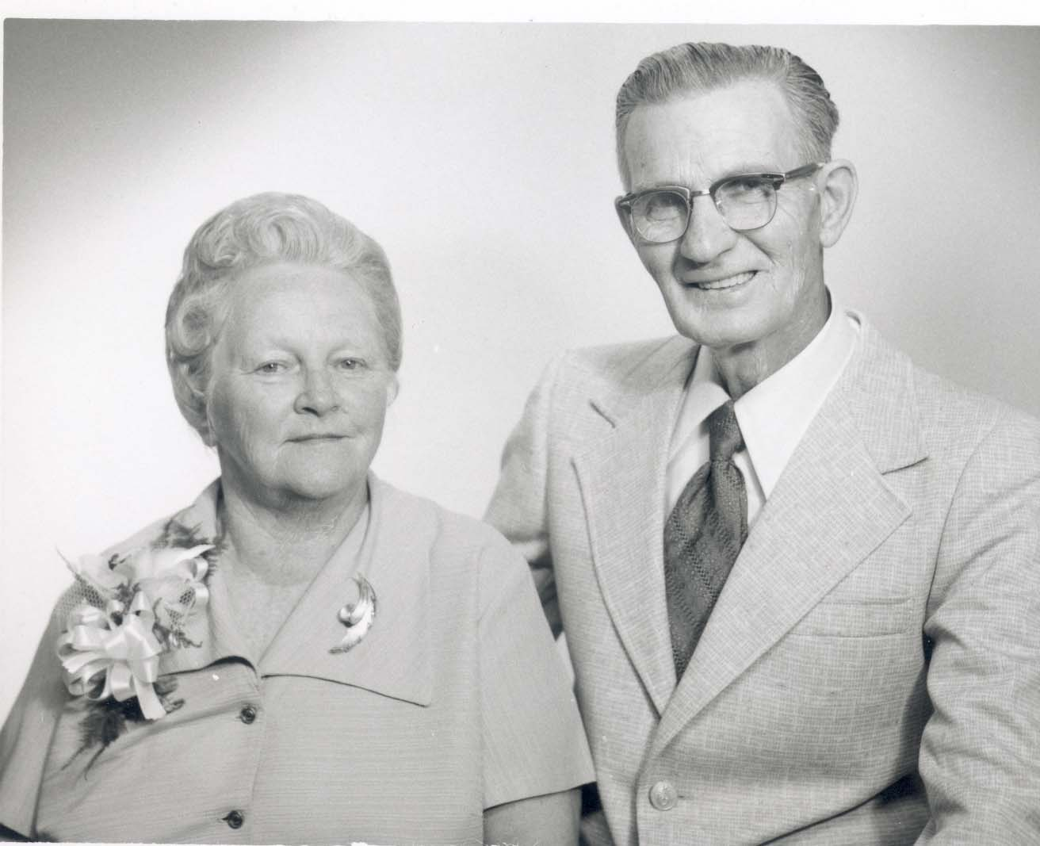

APPENDIX Y
Photo of Howard Underwood Gant and Cecelia Elizabeth Gant (Jillard)
Wedding, September 15, 1945

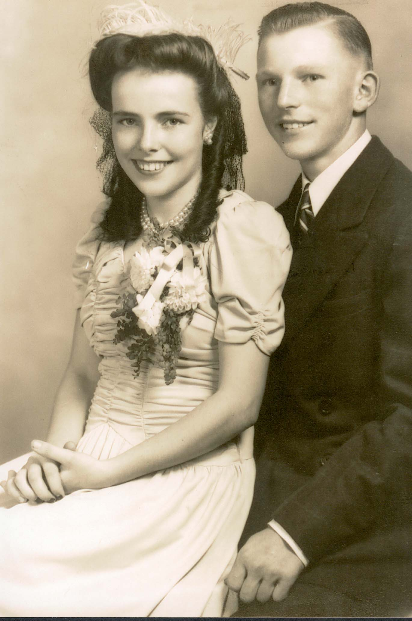
APPENDIX Z
Letter to Richard Grupenhoff, Thesis Adviser, 2002

494 Harrison Avenue
Mantua, NJ 08051
856-464-1467 (home)
856-256-4167 (work)
e-mail: heiser@rowan.edu
April 2, 2002

Richard Grupenhoff
Radio/TV/Film
Bozorth Hall
Rowan University
201 Mullica Hill Road
Glassboro, NJ 08028

Dear Richard,

Thank you for accepting the responsibility to read my thesis: Ganttown Gant Family Genealogy: The Descendants of Samuel Gant from Washington Township, Gloucester County, New Jersey. Enclosed you will find the beginning of the thesis to Chapter 3. Chapters 4 and 5 should be completed within the next three weeks, and I’ll give them to you then.

If you have any questions, please don’t hesitate to contact me. Again, thank you for your time and genealogical expertise. I look forward to your comments and suggestions.

Yours truly,

Karen L. Heiser

John W. Sparks wrote a chapter on “Gant Town.”
Since Ganttown Road and Ganttown Plaza are written as one word, this thesis will also use the town name as one word: Ganttown.
Spelling of names differed in many instances and for various reasons. Throughout the thesis the names will be listed the way they were recorded with the correct or current version of the names in brackets.
Name is in bold typeface because he is a direct ancestor of Howard Underwood Gant.
John Williams’ father was Israel Williams, who owned vast acres in Gloucester County in the 1700s.
As noted in the deed’s spelling, “Fries” Mill Road was pronounced as “freezes.” Some local people older than 50 years old still pronounce it as “freezes.” The name comes from German immigrants who settled in Salem County and branched out to Gloucester County, who pronounced their surname as, “freeze.”
Research for this study was mainly for Samuel’s 10 children and the author’s direct line. Birth, marriage, and death certificates may be available for Samuel’s grandchildren, but they were not researched before this thesis was written. Because females change their names when they marry, marriage and death records are more difficult to find.
Richard M. Gant’s name is in bold typeface because he is a direct ancestor of Howard Underwood Gant.
Many records on the DeHart family show they were glassblowers; however, a Peter DeHart is listed as the first schoolteacher found in Clayton, New Jersey (Cushing and Sheppard, 1883, p.160).
Robert H. Gant, born Jul 31, 1841, in Ganttown, New Jersey, died on Jul 8, 1863, during the Civil War at Gettysburg, Pennsylvania.
William Darrow was a member of the New Jersey Methodist Conference, so his obituary is located at Drew University Archives, Madison, New Jersey (Darrow, 1856).
Peter Owens’ gravestone has a military marker indicating he was a member of the 6th Regiment of New Jersey.
In Sep 1865, in Mullica Hill, New Jersey, Joseph married Caroline Mattson, a sister of another member of the 12th Regiment.
From 1844-1871 the Gant farm was listed under Camden County. In all other U. S. Census records it was listed in Gloucester County.
This child is only mentioned in the Williamstown Methodist Episcopal Church Baptisms compiled by J. M. Hammell (Hammell, 1999, Vol 1., p. 63).
Robert’s name is in bold typeface because he is a direct ancestor of Howard Underwood Gant
Laura Etta Doran was a granddaughter of Rev. James Down. Synott H. Gant’s wife, Mattie (Crane) Gant, was also a granddaughter of Rev. James Down.
Synott H. Gant’s name is in bold typeface because he is a direct ancestor of Howard Underwood Gant.
While searching through the 1900 U. S. Census, Synott Gaunt [Gant] has five children: A child named Earl L. was born on 23 June 1896 (birth certificate, G30), but is not listed on the U. S. Census, so perhaps he died before the 1900 U. S. Census was recorded. This child was not in family records nor mentioned in family conversations.
Jesse Robert Gant’s name is in bold typeface, because he is a direct ancestor of Howard Underwood Gant.
Because these deaths are after 1940, records are obtainable only by next of kin.
Jesse Robert Gant’s name is in bold typeface, because he is a direct ancestor of Howard Underwood Gant.
The author obtained permission to print the names of the people who are listed. However, because of the lack of time to get permission from relatives and friends, and to avoid legal issues, names are excluded from the information.

